UNITED STATES

SECURITIES AND EXCHANGE COMMISSION

Washington, D.C. 20549

FORM 6-K

REPORT OF FOREIGN PRIVATE ISSUER PURSUANT TO RULE 13a-16 OR 15d-16 OF THE SECURITIES EXCHANGE ACT OF 1934

For the month of January 2016

Commission File Number 001-36903

KORNIT DIGITAL LTD.

(Translation of Registrant’s name into English)

12 Ha’Amal Street

Park Afek

Rosh Ha’Ayin 4824096 Israel

(Address of Principal Executive Office)

Indicate by check mark whether the registrant files or will file annual reports under cover of Form 20-F or Form 40-F. Form 20-F ☒ Form 40-F o

Indicate by check mark if the registrant is submitting the Form 6-K in paper as permitted by Regulation S-T Rule 101(b)(1): o

Indicate by check mark if the registrant is submitting the Form 6-K in paper as permitted by Regulation S-T Rule 101(b)(7): o

EXPLANATORY NOTE

On January 11, 2016, Kornit Digital Ltd. released an updated investor presentation and issued a press release entitled “Kornit Digital Releases Updated Investor Presentation.” A copy of the investor presentation is furnished as Exhibit 99.1 hereto and the press release is furnished as Exhibit 99.2 hereto.

2

SIGNATURES

Pursuant to the requirements of the Securities Exchange Act of 1934, the registrant has duly caused this report to be signed on its behalf by the undersigned, thereunto duly authorized.

KORNIT DIGITAL LTD.

Date: January 11, 2016 By: /s/ Guy Avidan

Name: Guy Avidan

Title: Chief Financial Officer

3

 |  | Exhibit Index
Exhibit No. |  | Description
99.1 |  | Investor Presentation – January 2016
99.2 | Press release dated January 11, 2016 entitled “Kornit Digital Releases Updated Investor Presentation”
 | 4

Exhibit 99.1
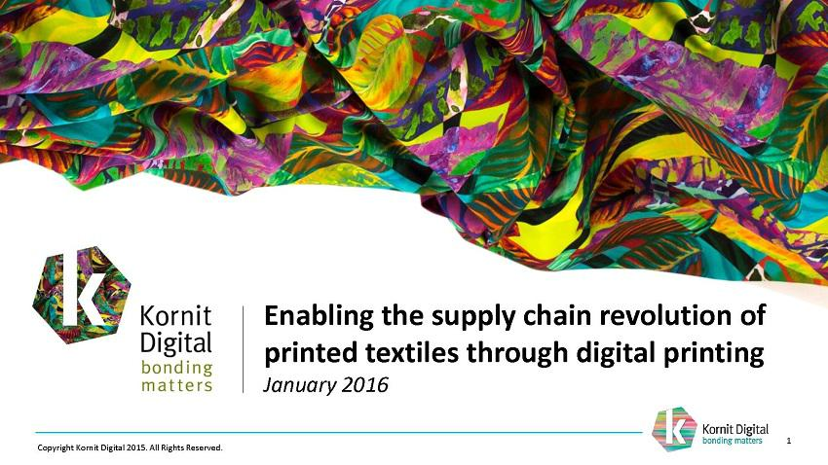

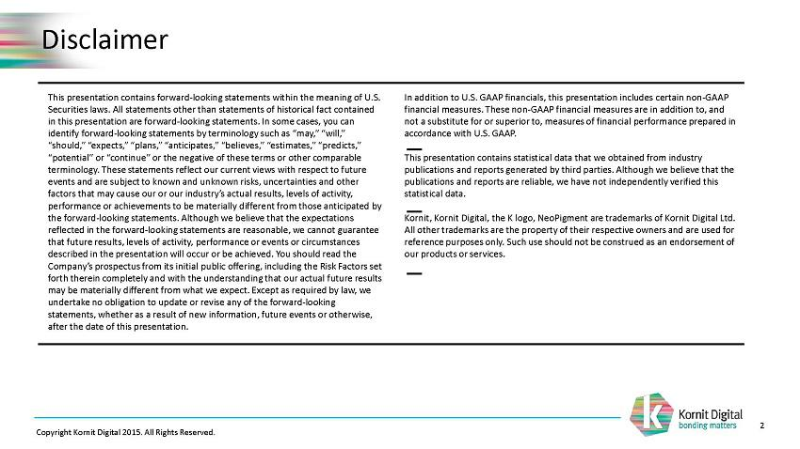

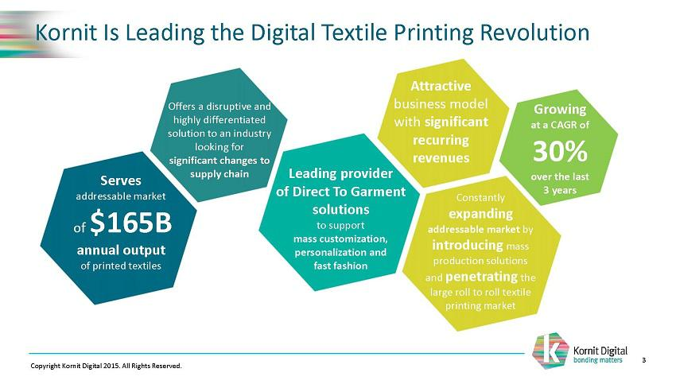

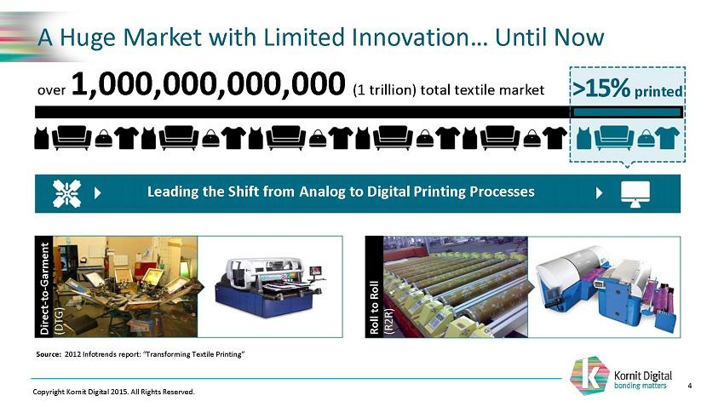

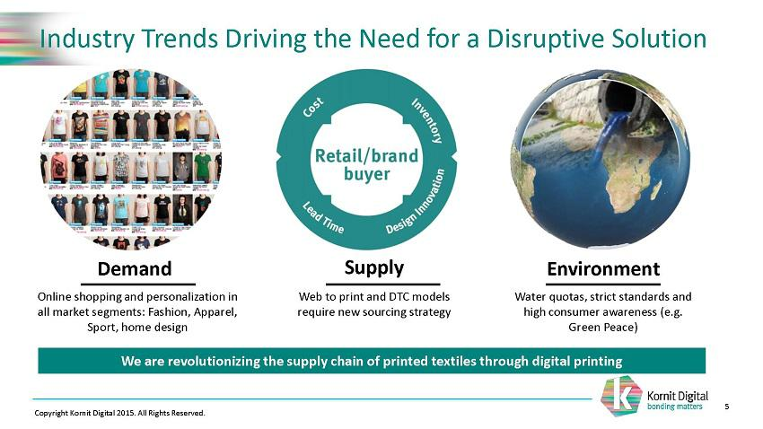



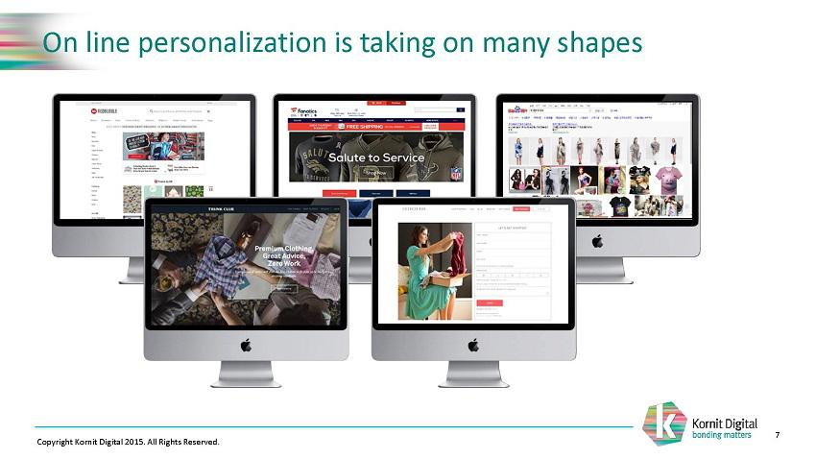

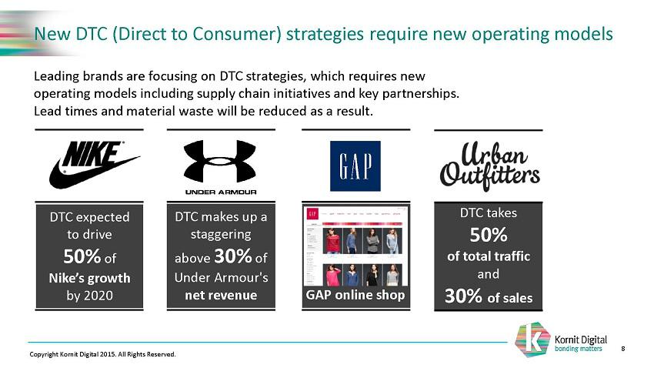

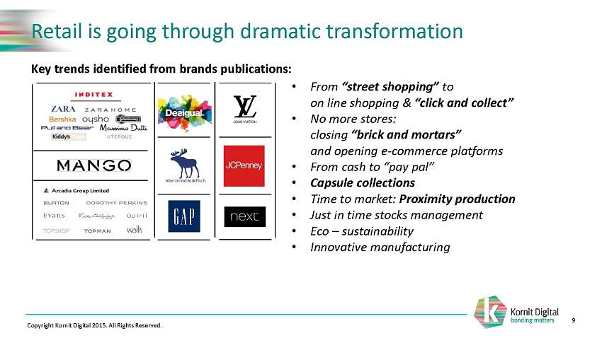

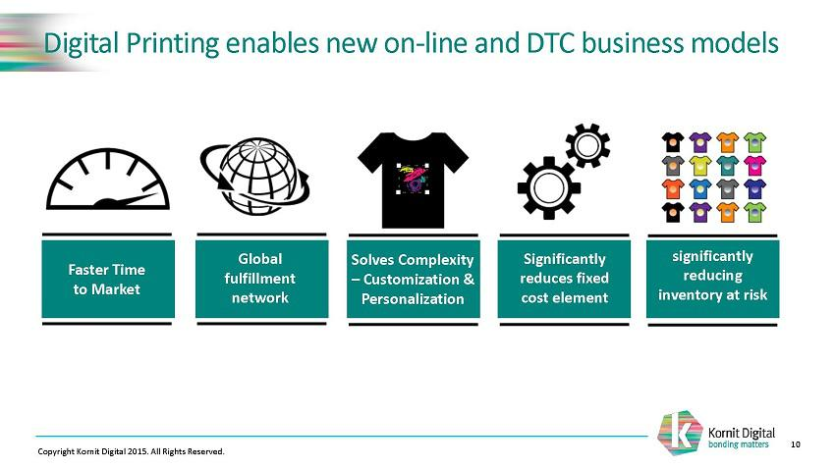

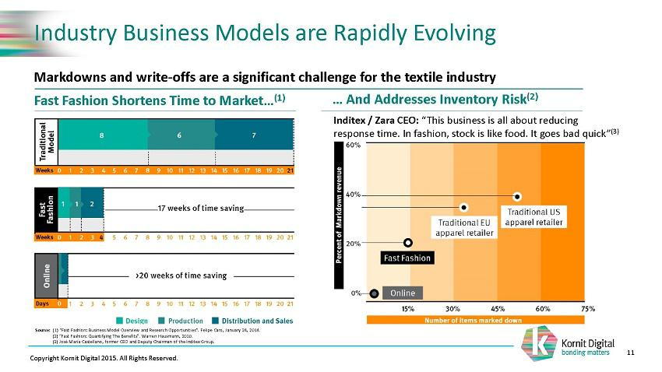

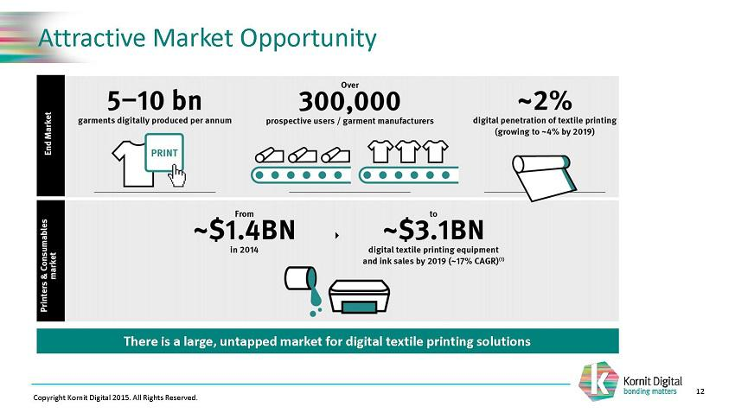

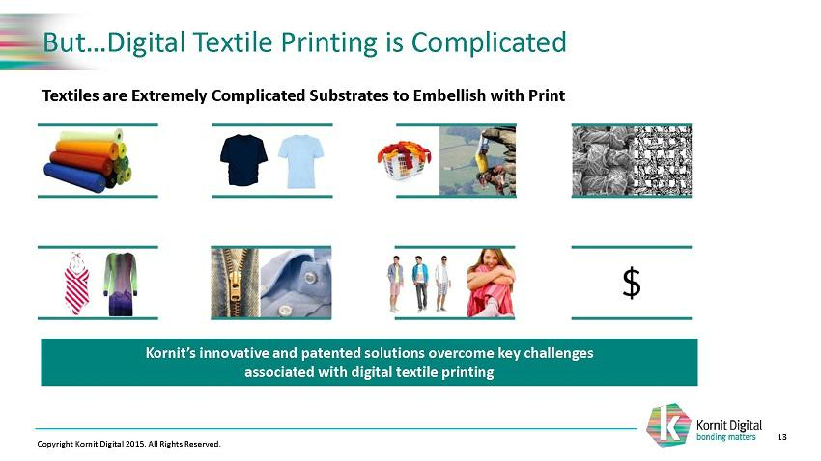

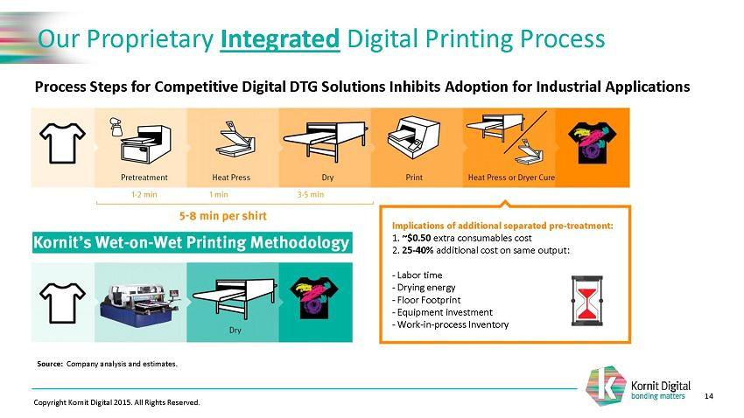

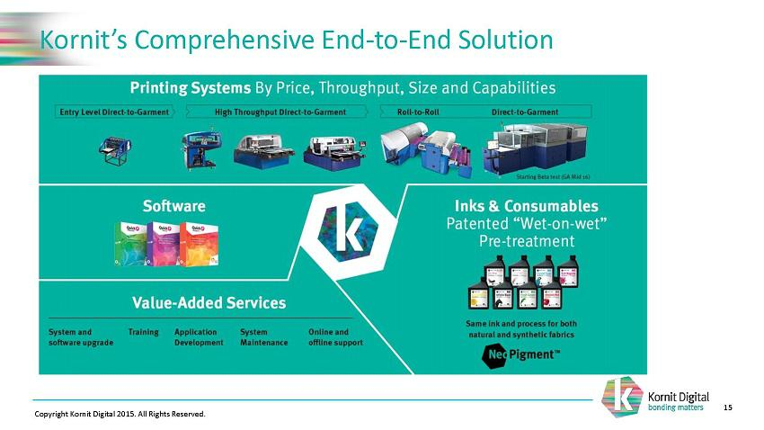

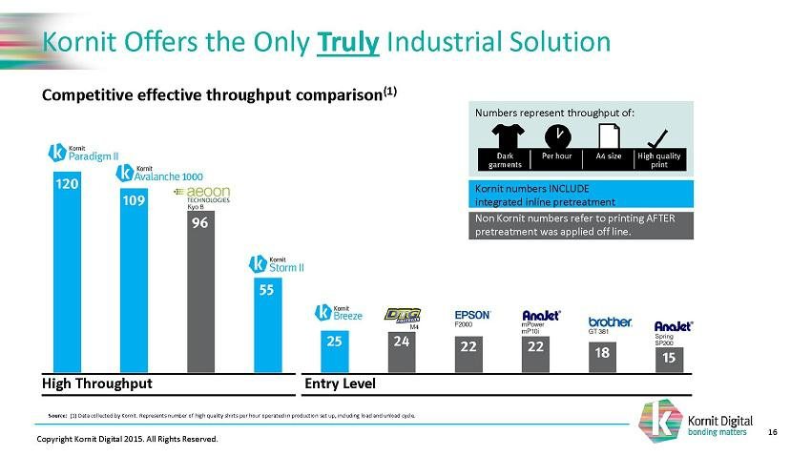

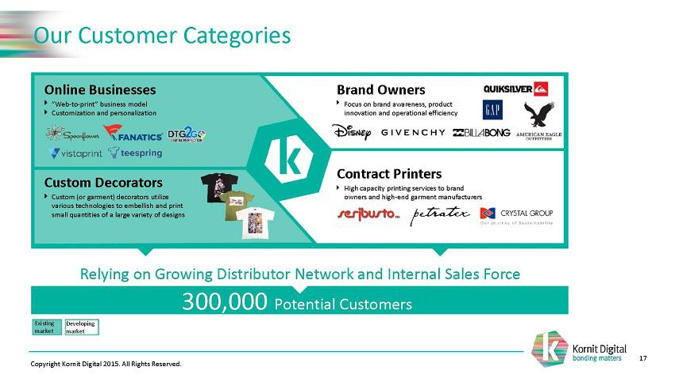

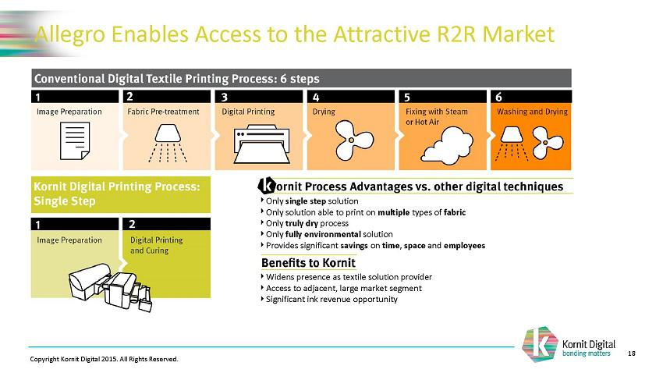

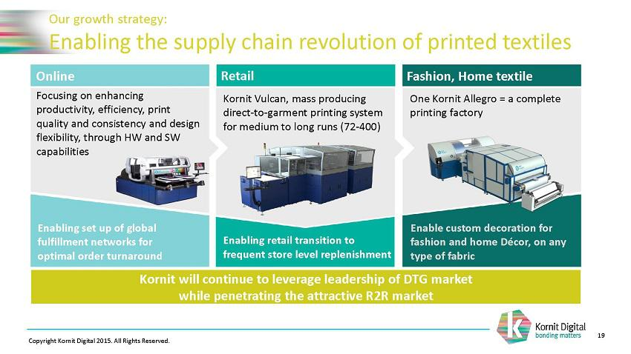

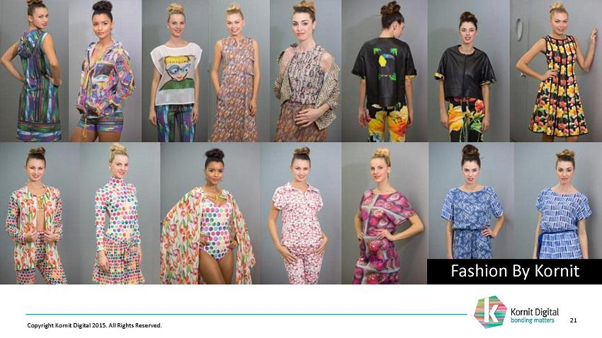

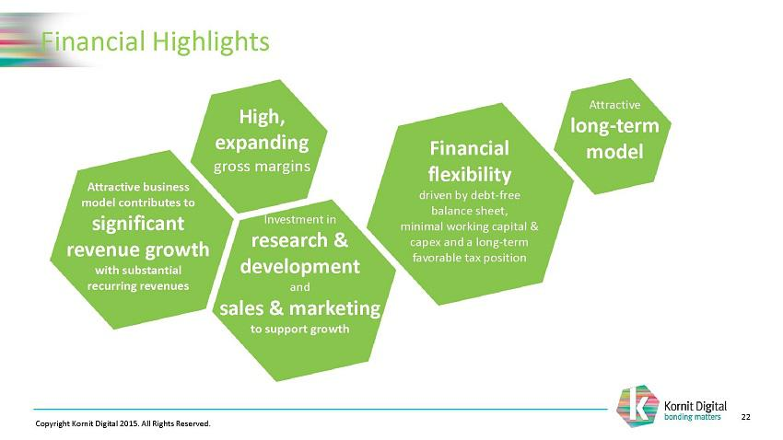

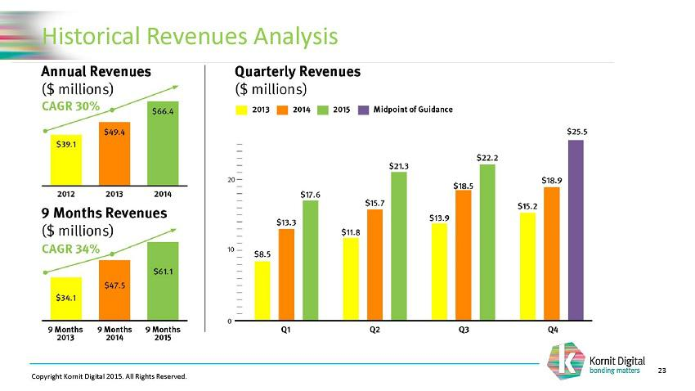

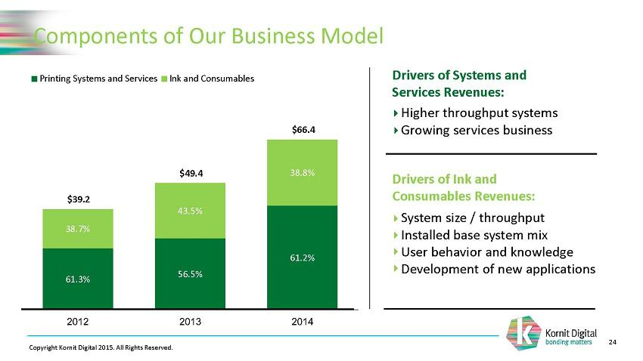

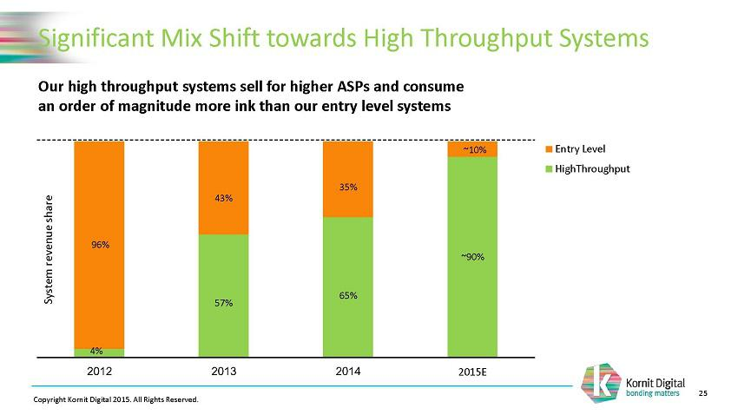

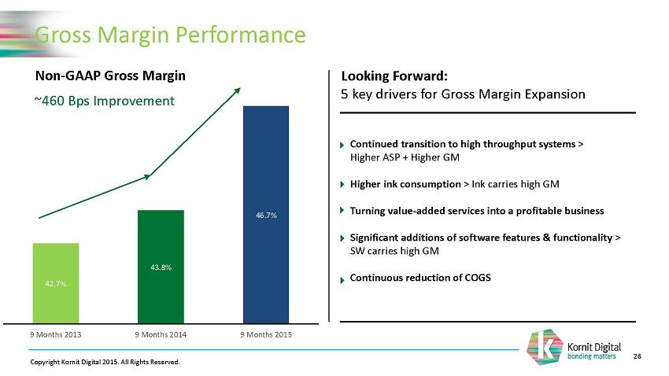

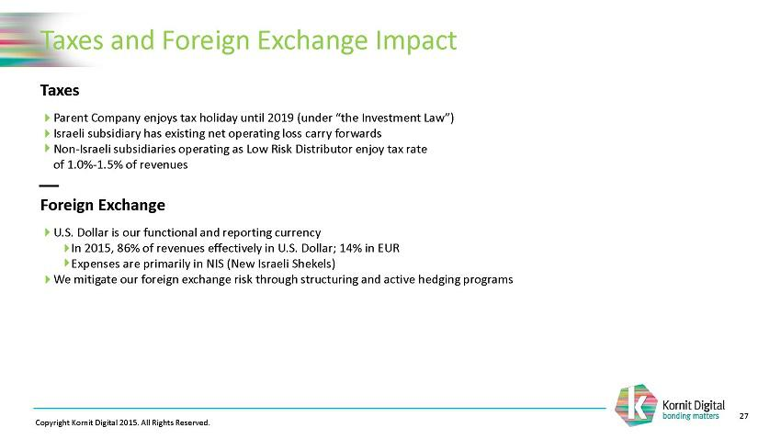

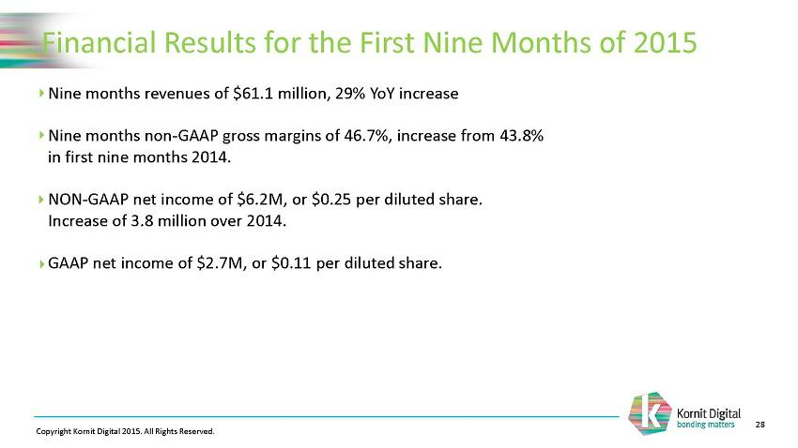

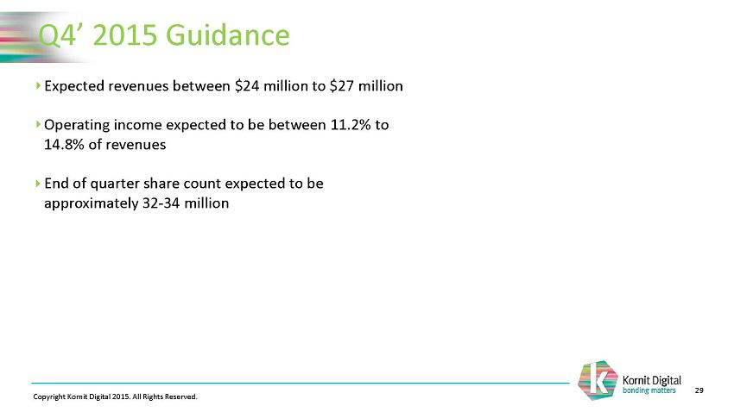

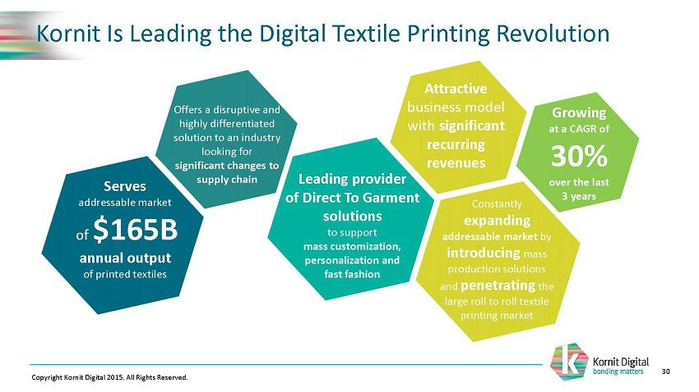

Exhibit 99.2

Investor contact:

Michael Callahan, ICR

- 682-8311 Michael.Callahan@icrinc.com
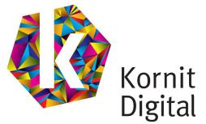

Kornit Digital Releases Updated Investor Presentation

Rosh-Ha`Ayin, Israel – January 11, 2016 – Kornit Digital Ltd. (NASDAQ:KRNT), a company that develops, designs and markets innovative digital printing solutions for the global printed textile industry today announced the filing of a Form 6-K with the U.S. Securities and Exchange Commission (the “SEC”), relating to the release of an updated investor presentation. The presentation is also available on Kornit’s investor relations website under the Events and Presentations tab.

Gabi Seligsohn, the Company’s Chief Executive Officer will present this updated presentation to investors today in New York City, and will be participating in the 2016 Needham Growth Conference on January 12th and January 13th. A live webcast of the presentation will be available on Tuesday, January 12th at 11:20 a.m. eastern time. During the presentation, management will provide an update on the industry and discuss current and developing trends impacting the business.

The live webcast of the presentation will be accessible at ir.kornit.com in the “Events & Presentations” section. Interested parties unable to listen to the live webcast can access an archived version of the webcast on the Company’s website for approximately 90 days.

About Kornit

Kornit (NASDAQ:KRNT) develops, designs and markets innovative digital printing solutions for the global printed textile industry. Kornit’s solution includes its proprietary digital printing systems, ink and other consumables, associated software and value added services. Kornit’s vision is to revolutionize the textile industry by facilitating the transition from analog processes that have not evolved for decades to digital methods of production that address contemporary supply, demand and environmental dynamics. Kornit is a global company headquartered in Rosh-Ha`Ayin, Israel, with U.S. offices in Mequon, Wisconsin and additional sales, support and marketing offices in Germany and Hong Kong.

