UNITED STATES
SECURITIES AND EXCHANGE COMMISSION
Washington, D.C. 20549

FORM 6-K

REPORT OF FOREIGN PRIVATE ISSUER

PURSUANT TO RULE 13a-16 OR 15d-16 OF
THE SECURITIES EXCHANGE ACT OF 1934

For the month of May 2024

Commission File Number 001-36903

KORNIT DIGITAL LTD.
(Translation of Registrant’s name into English)

12 Ha’Amal Street
Park Afek
Rosh Ha’Ayin 4824096 Israel
(Address of Principal Executive Office)

Indicate by check mark whether the registrant files or will file annual reports under cover of Form 20-F or Form 40-F.

Form 20-F ☒ Form 40-F ☐

CONTENTS

Results of Operations and Financial Condition- Quarter Ended March 31, 2024

On May 8, 2024, Kornit Digital Ltd. (“Kornit”) issued a press release entitled “Kornit Digital Reports First Quarter 2024 Results,” in which Kornit reported its results of operations for the quarter ended March 31, 2024. A copy of that press release is furnished as Exhibit 99.1 hereto.

Kornit is holding a conference call on May 8, 2024 to discuss its quarterly results for the quarter ended March 31, 2024 and, in connection with that call, will make available to its investors a slide presentation to provide additional information regarding its business and its financial results. That slide presentation is attached as Exhibit 99.2 to this Report of Foreign Private Issuer on Form 6-K (this “Form 6-K”) and is incorporated herein by reference.

Incorporation by Reference

The U.S. GAAP financial information contained in the (i) consolidated balance sheets, (ii) consolidated statements of operations and (iii) consolidated statements of cash flows included in the press release attached as Exhibit 99.1 to this Report of Foreign Private Issuer on Form 6-K is hereby incorporated by reference into Kornit’s Registration Statements on Form S-8 (File No.’s 333-203970, 333-214015, 333-217039, 333-223794, 333-230567, 333-237346, 333-254749, and 333-263975).

1

SIGNATURES

Pursuant to the requirements of the Securities Exchange Act of 1934, the registrant has duly caused this report to be signed on its behalf by the undersigned, thereunto duly authorized.

 | KORNIT DIGITAL LTD.
Date: May 8, 2024 | By: | /s/ Lauri Hanover
 | Name: | Lauri Hanover
 | Title: | Chief Financial Officer

2

Exhibit Index

Exhibit No. |  | Description
99.1 |  | Press release, dated May 8, 2024, titled “Kornit Digital Reports First Quarter 2024 Results”
99.2 |  | Slide presentation for conference call of Kornit held on May 8 2024 discussing Kornit’s quarterly financial results for the first quarter of 2024

3

Exhibit 99.1

Investor Contact:
Jared Maymon
Global Head of Investor Relations & Strategic Finance
Jared.Maymon@Kornit.com



Kornit Digital Reports First Quarter 2024 Results

● | First quarter revenues of $43.8 million, in line with previous guidance
● | First quarter GAAP net loss of $13.2 million; non-GAAP net loss of $5.3 million
● | Generated positive cash flow from operations for the first quarter of 2024
● | Successfully concluded Apollo beta with all three customers and built a healthy pipeline
● | Significant interest from new and existing customers on the all-inclusive click (“AIC”) model

Rosh-Ha’Ayin, Israel – May 8, 2024 – Kornit Digital Ltd. (“Kornit” or the “Company”) (Nasdaq: KRNT), a worldwide market leader in sustainable, on-demand, digital fashionX and textile production technologies, reported today its results for the first quarter ended March 31, 2024.

“Despite enduring macroeconomic challenges, we saw success with the strategic initiatives we implemented in Q4 and early this quarter.” said Ronen Samuel, Kornit’s Chief Executive Officer. Mr. Samuel continued, “Our pipeline for the Apollo has already been filled for 2024 by customers addressing both existing and target markets, and we are now building our pipeline for 2025. Additionally, in the first quarter of the AIC pilot on Apollo, the model generated highly positive feedback and drove multiple orders.”

Mr. Samuel concluded, “As we look ahead, we are dedicating our attention and resources to ensuring that we have put all the necessary pieces in place to deliver on our vision of transitioning long-run production to sustainable, on-demand digital production, globally.”

First Quarter 2024 Results of Operations

 | ● | Total revenue for the first quarter of 2024 was $43.8 million compared with $47.8 million in the prior year period, due primarily to lower systems revenues.

 | ● | GAAP gross profit margin for the first quarter of 2024 was 32.3% compared with 27.4% in the prior year period. On a non-GAAP basis, gross profit margin was 37.5% compared with 30.2% in the prior year period.

 | ● | GAAP operating expenses for the first quarter of 2024 were $32.4 million compared with $37.2 million in the prior year period. On a non-GAAP basis, operating expenses decreased by 16.6% to $27.1 million compared with the prior year period.

 | ● | GAAP net loss for the first quarter of 2024 was $13.2 million, or ($0.28) per basic share, compared with net loss of $18.9 million, or ($0.38) per basic share, for the first quarter of 2023.

 | ● | Non-GAAP net loss for the first quarter of 2024 was $5.3 million, or ($0.11) per basic share, compared with non-GAAP net loss of $13.4 million, or ($0.27) per basic share, for the first quarter of 2023.

 | ● | Adjusted EBITDA loss for the first quarter of 2024 was $7.8 million compared with adjusted EBITDA loss of $14.7 million for the first quarter of 2023. Adjusted EBITDA margin for the first quarter of 2024 was -17.9% compared with -30.8% for the first quarter of 2023.

Second Quarter 2024 Guidance

For the second quarter of 2024, the Company expects revenues to be in the range of $47 million to $52 million and adjusted EBITDA margin between –10% to 0%.

First Quarter Earnings Conference Call Information

The Company will host a conference call today at 8:30 a.m. ET, or 3:30 p.m. Israel time, to discuss the results, followed by a question-and-answer session with the investor community.

A live webcast of the call can be accessed at ir.kornit.com. To access the call, participants may dial toll-free at 1-800-717-1738 or 1-646-307-1865. The toll-free Israeli number is 972 3 384 8161. The conference confirmation code is 61743.

To listen to a replay of the conference call, dial toll-free 1-844-512-2921 or 1-412-317-6671 (international) and enter confirmation code 1161743. The telephonic replay will be available approximately three hours after the completion of the live call until 11:59 pm ET on May 22, 2024. The call will also be available for replay via the webcast link on Kornit’s Investor Relations website.

About Kornit Digital

Kornit Digital (NASDAQ: KRNT) is a worldwide market leader in sustainable, on-demand, digital fashionx and textile production technologies. The Company is writing the operating system for fashion with end-to-end solutions including digital printing systems, inks, consumables, and an entire global ecosystem that manages workflows and fulfillment. Headquartered in Israel with offices in the USA, Europe, and Asia Pacific, Kornit Digital serves customers in more than 100 countries and states worldwide. To learn more about how Kornit Digital is boldly transforming the world of fashion and textiles, visit www.kornit.com.

2

Forward Looking Statements

Certain statements in this press release are “forward-looking statements” within the meaning of the Private Securities Litigation Reform Act of 1995 and other U.S. securities laws. Forward-looking statements are characterized by the use of forward-looking terminology such as “will,” “expects,” “anticipates,” “continue,” “believes,” “should,” “intended,” “guidance,” “preliminary,” “future,” “planned,” or other words. These forward-looking statements include, but are not limited to, statements relating to the Company’s objectives, plans and strategies, statements of preliminary or projected results of operations or of financial condition and all statements that address activities, events, or developments that the Company intends, expects, projects, believes or anticipates will or may occur in the future. Forward-looking statements are not guarantees of future performance and are subject to risks and uncertainties. The Company has based these forward-looking statements on assumptions and assessments made by its management in light of their experience and their perception of historical trends, current conditions, expected future developments and other factors they believe to be appropriate. Important factors that could cause actual results, developments and business decisions to differ materially from those anticipated in these forward-looking statements include, among other things: the duration and severity of adverse macro-economic headwinds that were caused by inflationary pressures and higher interest rates, which have impacted, and may continue to impact, in an adverse manner, the Company’s operations, financial position and cash flows, in part due to the adverse impact on the Company’s customers and suppliers; the Company’s degree of success in developing, introducing and selling new or improved products and product enhancements including specifically the Company’s Poly Pro and Presto products, and the Company’s Apollo direct-to-garment platform; the extent of the Company’s ability to consummate sales to large accounts with multi-system delivery plans; the degree of the Company’s ability to fill orders for its systems and consumables; the extent of the Company’s ability to increase sales of its systems, ink and consumables; the extent of the Company’s ability to leverage its global infrastructure build-out; the development of the market for digital textile printing; the availability of alternative ink; competition; sales concentration; changes to the Company’s relationships with suppliers; the extent of the Company’s success in marketing; and those additional factors referred to under “Risk Factors” in Item 3.D of the Company’s Annual Report on Form 20-F for the year ended December 31, 2023, filed with the SEC on March 28, 2024. Any forward-looking statements in this press release are made as of the date hereof, whether as a result of new information, future events or otherwise, except as required by law.

Non-GAAP Discussion Disclosure

The Company presents certain non-GAAP financial measures, in this press release and in the accompanying conference call to discuss the Company’s quarterly results. These non-GAAP financial measures reflect adjustments to corresponding GAAP financial measures in order to exclude the impact of the following: share-based compensation expenses; amortization of intangible assets; restructuring expenses; foreign exchange differences associated with ASC 842; and non-cash deferred tax income.

The Company defines “Adjusted EBITDA” as non-GAAP operating income (loss), which reflects the adjustments described in the preceding paragraph, as further adjusted to exclude depreciation expense.

The purpose of the foregoing non-GAAP financial measures is to convey the Company’s performance exclusive of non-cash charges and other items that are considered by management to be outside of the Company’s core operating results. These non-GAAP measures are among the primary factors management uses in planning for and forecasting future periods. Furthermore, the non-GAAP measures are regularly used internally to understand, manage, and evaluate the Company’s business and make operating decisions, and the Company believes that they are useful to investors as a consistent and comparable measure of the ongoing performance of the Company’s business. The Company’s non-GAAP financial measures are not meant to be considered in isolation or as a substitute for comparable GAAP measures and should be read only in conjunction with the Company’s consolidated financial statements prepared in accordance with GAAP. Additionally, these non-GAAP financial measures may differ materially from the non-GAAP financial measures used by other companies.

The reconciliation tables included below present a reconciliation of our non-GAAP financial measures to the most directly comparable GAAP financial measures.

3

KORNIT DIGITAL LTD.
AND ITS SUBSIDIARIES
CONSOLIDATED BALANCE SHEETS
(U.S. dollars in thousands)

 |  | March 31, |  |  |  | December 31,
 |  | 2024 |  |  |  | 2023
 |  | (Unaudited) |  |  |  | (Audited)
ASSETS
CURRENT ASSETS:
Cash and cash equivalents |  | $ | 6,501 |  |  | $ | 39,605
Short-term bank deposit |  |  | 259,997 |  |  |  | 235,600
Marketable securities |  |  | 107,401 |  |  |  | 57,292
Trade receivables, net |  |  | 80,727 |  |  |  | 93,632
Inventory |  |  | 67,016 |  |  |  | 67,712
Other accounts receivable and prepaid expenses |  |  | 28,032 |  |  |  | 28,546
Total current assets |  |  | 549,674 |  |  |  | 522,387
LONG-TERM ASSETS:
Marketable securities |  |  | 177,518 |  |  |  | 223,203
Deposits and other long-term assets |  |  | 8,917 |  |  |  | 8,209
Severance pay fund |  |  | 289 |  |  |  | 283
Property, plant and equipment, net |  |  | 49,948 |  |  |  | 50,905
Operating lease right-of-use assets |  |  | 20,348 |  |  |  | 23,782
Intangible assets, net |  |  | 7,134 |  |  |  | 7,647
Goodwill |  |  | 29,164 |  |  |  | 29,164
Total long-term assets |  |  | 293,318 |  |  |  | 343,193
Total assets |  |  | 842,992 |  |  |  | 865,580
LIABILITIES AND SHAREHOLDERS’ EQUITY
CURRENT LIABILITIES:
Trade payables |  |  | 2,949 |  |  |  | 6,936
Employees and payroll accruals |  |  | 10,375 |  |  |  | 12,121
Deferred revenues and advances from customers |  |  | 1,850 |  |  |  | 2,158
Operating lease liabilities |  |  | 3,682 |  |  |  | 5,073
Other payables and accrued expenses |  |  | 21,997 |  |  |  | 23,814
Total current liabilities |  |  | 40,853 |  |  |  | 50,102
LONG-TERM LIABILITIES:
Accrued severance pay |  |  | 1,054 |  |  |  | 1,080
Operating lease liabilities |  |  | 16,403 |  |  |  | 18,533
Other long-term liabilities |  |  | 112 |  |  |  | 198
Total long-term liabilities |  |  | 17,569 |  |  |  | 19,811
SHAREHOLDERS’ EQUITY |  |  | 784,570 |  |  |  | 795,667
Total liabilities and shareholders’ equity |  | $ | 842,992 |  |  | $ | 865,580

4

KORNIT DIGITAL LTD.
AND ITS SUBSIDIARIES
CONSOLIDATED STATEMENTS OF OPERATIONS
(U.S. dollars in thousands, except share and per share data)

 |  | Three Months Ended
 |  | March 31,
 |  | 2024 |  |  |  | 2023
 |  | (Unaudited)
Revenues
Products |  | $ | 29,013 |  |  | $ | 31,903
Services |  |  | 14,763 |  |  |  | 15,875
Total revenues |  |  | 43,776 |  |  |  | 47,778
Cost of revenues
Products |  |  | 15,691 |  |  |  | 20,379
Services |  |  | 13,946 |  |  |  | 14,327
Total cost of revenues |  |  | 29,637 |  |  |  | 34,706
Gross profit |  |  | 14,139 |  |  |  | 13,072
Operating expenses:
Research and development, net |  |  | 11,352 |  |  |  | 13,082
Sales and marketing |  |  | 13,796 |  |  |  | 15,183
General and administrative |  |  | 7,277 |  |  |  | 8,948
Total operating expenses |  |  | 32,425 |  |  |  | 37,213
Operating loss |  |  | (18,286 | ) |  |  | (24,141 | )
Financial income, net |  |  | 5,346 |  |  |  | 5,404
Loss before taxes on income |  |  | (12,940 | ) |  |  | (18,737 | )
Taxes on income |  |  | 259 |  |  |  | 194
Net loss |  | $ | (13,199 | ) |  | $ | (18,931 | )
Basic loss per share |  | $ | (0.28 | ) |  | $ | (0.38 | )
Weighted average number of shares used in computing basic net loss per share |  |  | 47,611,456 |  |  |  | 49,887,982
Diluted net loss per share |  | $ | (0.28 | ) |  | $ | (0.38 | )
Weighted average number of shares used in computing diluted net loss per share |  |  | 47,611,456 |  |  |  | 49,887,982

5

KORNIT DIGITAL LTD.
AND ITS SUBSIDIARIES
RECONCILIATION OF GAAP TO NON-GAAP CONSOLIDATED STATEMENTS OF OPERATIONS
(U.S. dollars in thousands, except share and per share data)

 |  | Three Months Ended
 |  | March 31,
 |  | 2024 |  |  |  | 2023
 |  | (Unaudited)
Revenues |  | $ | 43,776 |  |  | $ | 47,778
GAAP cost of revenues |  | $ | 29,637 |  |  | $ | 34,706
Cost of product recorded for share-based compensation (1) |  |  | (502 | ) |  |  | (507 | )
Cost of service recorded for share-based compensation (1) |  |  | (419 | ) |  |  | (351 | )
Intangible assets amortization on cost of product (2) |  |  | (265 | ) |  |  | (263 | )
Intangible assets amortization on cost of service (2) |  |  | (160 | ) |  |  | (160 | )
Restructuring expenses (3) |  |  | (914 | ) |  |  | (89 | )
Non-GAAP cost of revenues |  | $ | 27,377 |  |  | $ | 33,336
GAAP gross profit |  | $ | 14,139 |  |  | $ | 13,072
Gross profit adjustments |  |  | 2,260 |  |  |  | 1,370
Non-GAAP gross profit |  | $ | 16,399 |  |  | $ | 14,442
GAAP operating expenses |  | $ | 32,425 |  |  | $ | 37,213
Share-based compensation (1) |  |  | (4,527 | ) |  |  | (4,387 | )
Intangible assets amortization (2) |  |  | (88 | ) |  |  | (188 | )
Restructuring expenses (3) |  |  | (757 | ) |  |  | (206 | )
Non-GAAP operating expenses |  | $ | 27,053 |  |  | $ | 32,432
GAAP Financial income, net |  | $ | 5,346 |  |  | $ | 5,404
Foreign exchange losses associated with ASC 842 |  |  | 385 |  |  |  | (376 | )
Non-GAAP Financial income , net |  | $ | 5,731 |  |  | $ | 5,028
GAAP Taxes on income |  | $ | 259 |  |  | $ | 194
Non-cash deferred tax income |  | $ | 87 |  |  | $ | 221
Non-GAAP Taxes on income |  | $ | 346 |  |  | $ | 415
GAAP net loss |  | $ | (13,199 | ) |  | $ | (18,931 | )
Share-based compensation (1) |  |  | 5,448 |  |  |  | 5,245
Intangible assets amortization (2) |  |  | 513 |  |  |  | 611
Restructuring expenses (3) |  |  | 1,671 |  |  |  | 295
Foreign exchange losses associated with ASC 842 |  |  | 385 |  |  |  | (376 | )
Non-cash deferred tax income |  |  | (87 | ) |  |  | (221 | )
Non-GAAP net loss |  | $ | (5,269 | ) |  | $ | (13,377 | )
GAAP diluted loss per share |  | $ | (0.28 | ) |  | $ | (0.38 | )
Non-GAAP diluted loss per share |  | $ | (0.11 | ) |  | $ | (0.27 | )
Weighted average number of shares
Shares used in computing GAAP diluted net loss per share |  |  | 47,611,456 |  |  |  | 49,887,982
Shares used in computing Non-GAAP diluted net loss per share |  |  | 47,611,456 |  |  |  | 49,887,982
(1) Share-based compensation
Cost of product revenues |  | $ | 502 |  |  | $ | 507
Cost of service revenues |  | $ | 419 |  |  |  | 351
Research and development |  | $ | 1,295 |  |  |  | 1,351
Sales and marketing |  | $ | 1,582 |  |  |  | 1,363
General and administrative |  | $ | 1,650 |  |  |  | 1,673
 |  | $ | 5,448 |  |  | $ | 5,245
(2) Intangible assets amortization
Cost of product revenues |  | $ | 265 |  |  | $ | 263
Cost of service revenues |  | $ | 160 |  |  |  | 160
Sales and marketing |  | $ | 88 |  |  |  | 188
 |  | $ | 513 |  |  | $ | 611
(3) Restructuring expenses
Cost of product revenues |  | $ | 865 |  |  | $ | 89
Cost of service revenues |  | $ | 49 |  |  |  | -
Research and development |  | $ | 235 |  |  |  | 20
Sales and marketing |  | $ | 190 |  |  |  | 186
General and administrative |  | $ | 332 |  |  |  | -
 |  | $ | 1,671 |  |  | $ | 295
6

KORNIT DIGITAL LTD.
AND ITS SUBSIDIARIES
CONSOLIDATED STATEMENTS OF CASH FLOWS
(U.S. dollars in thousands)

 |  | Three Months Ended
 |  | March 31,
 |  | 2024 |  |  |  | 2023
 |  | (Unaudited)
Cash flows from operating activities:
Net loss |  | $ | (13,199 | ) |  | $ | (18,931 | )
Adjustments to reconcile net loss to net cash used in operating activities:
Depreciation and amortization |  |  | 3,324 |  |  |  | 3,873
Fair value of warrants deducted from revenues |  |  | 3,586 |  |  |  | 2,344
Share-based compensation |  |  | 5,448 |  |  |  | 5,245
Amortization of premium and accretion of discount on marketable securities, net |  |  | (7 | ) |  |  | 323
Realized loss on sale and redemption of marketable securities |  |  | - |  |  |  | 40
Change in operating assets and liabilities:
Trade receivables, net |  |  | 12,905 |  |  |  | (5,608 | )
Other accounts receivables and prepaid expenses |  |  | 514 |  |  |  | 916
Inventory |  |  | (96 | ) |  |  | (3,023 | )
Operating leases right-of-use assets and liabilities, net |  |  | (87 | ) |  |  | (457 | )
Deposits and other long term assets |  |  | (708 | ) |  |  | (1,027 | )
Trade payables |  |  | (3,765 | ) |  |  | (1,477 | )
Employees and payroll accruals |  |  | (1,152 | ) |  |  | 737
Deferred revenues and advances from customers |  |  | (308 | ) |  |  | (1,038 | )
Other payables and accrued expenses |  |  | (2,313 | ) |  |  | 4,340
Accrued severance pay, net |  |  | (32 | ) |  |  | 99
Other long - term liabilities |  |  | (86 | ) |  |  | (360 | )
Net cash provided by (used in) operating activities |  | $ | 4,024 |  |  | $ | (14,004 | )
Cash flows from investing activities:
Purchase of property, plant and equipment |  | $ | (1,284 | ) |  | $ | (3,278 | )
Proceeds from (investment in) short-term bank deposits, net |  |  | (24,397 | ) |  |  | 274,932
Proceeds from sales and redemption of marketable securities |  |  | 3,494 |  |  |  | 4,000
Proceeds from maturities of marketable securities |  |  | 11,298 |  |  |  | 3,572
Investment in marketable securities |  |  | (18,017 | ) |  |  | (10,024 | )
Net cash provided by (used in) investing activities |  | $ | (28,906 | ) |  | $ | 269,202
Cash flows from financing activities:
Exercise of employee stock options |  | $ | - |  |  | $ | 42
Payments related to shares withheld for taxes |  |  | (594 | ) |  |  | (135 | )
Repurchase of ordinary shares |  |  | (7,628 | ) |  |  | (6,752 | )
Net cash used in financing activities |  | $ | (8,222 | ) |  | $ | (6,845 | )
Increase (decrease) in cash and cash equivalents |  | $ | (33,104 | ) |  | $ | 248,353
Cash and cash equivalents at the beginning of the period |  |  | 39,605 |  |  |  | 104,597
Cash and cash equivalents at the end of the period |  | $ | 6,501 |  |  | $ | 352,950
Non-cash investing and financing activities:
Purchase of property and equipment on credit |  |  | 92 |  |  |  | 173
Inventory transferred to be used as property and equipment |  |  | 946 |  |  |  | 365
Property, plant and equipment transferred to be used as inventory |  |  | 154 |  |  |  | 653
Lease liabilities arising from obtaining right-of-use assets |  |  | (1,746 | ) |  |  | 6,037

7

KORNIT DIGITAL LTD.
AND ITS SUBSIDIARIES
RECONCILIATION OF GAAP NET INCOME TO ADJUSTED EBITDA
(U.S. dollars in thousands, except share and per share data)

 |  | Three Months Ended
 |  | March 31,
 |  | 2024 |  |  |  | 2023
 |  | (Unaudited)
GAAP Revenues |  | $ | 43,776 |  |  | $ | 47,778
GAAP Net Loss |  |  | (13,199 | ) |  |  | (18,931 | )
Taxes on income |  |  | 259 |  |  |  | 194
Financial income |  |  | (5,346 | ) |  |  | (5,404 | )
Share-based compensation |  |  | 5,448 |  |  |  | 5,245
Intangible assets amortization |  |  | 513 |  |  |  | 611
Restructuring expenses |  |  | 1,671 |  |  |  | 295
Non-GAAP Operating Loss |  |  | (10,654 | ) |  |  | (17,990 | )
Depreciation |  |  | 2,811 |  |  |  | 3,262
Adjusted EBITDA |  | $ | (7,843 | ) |  | $ | (14,728 | )

8

Exhibit 99.2

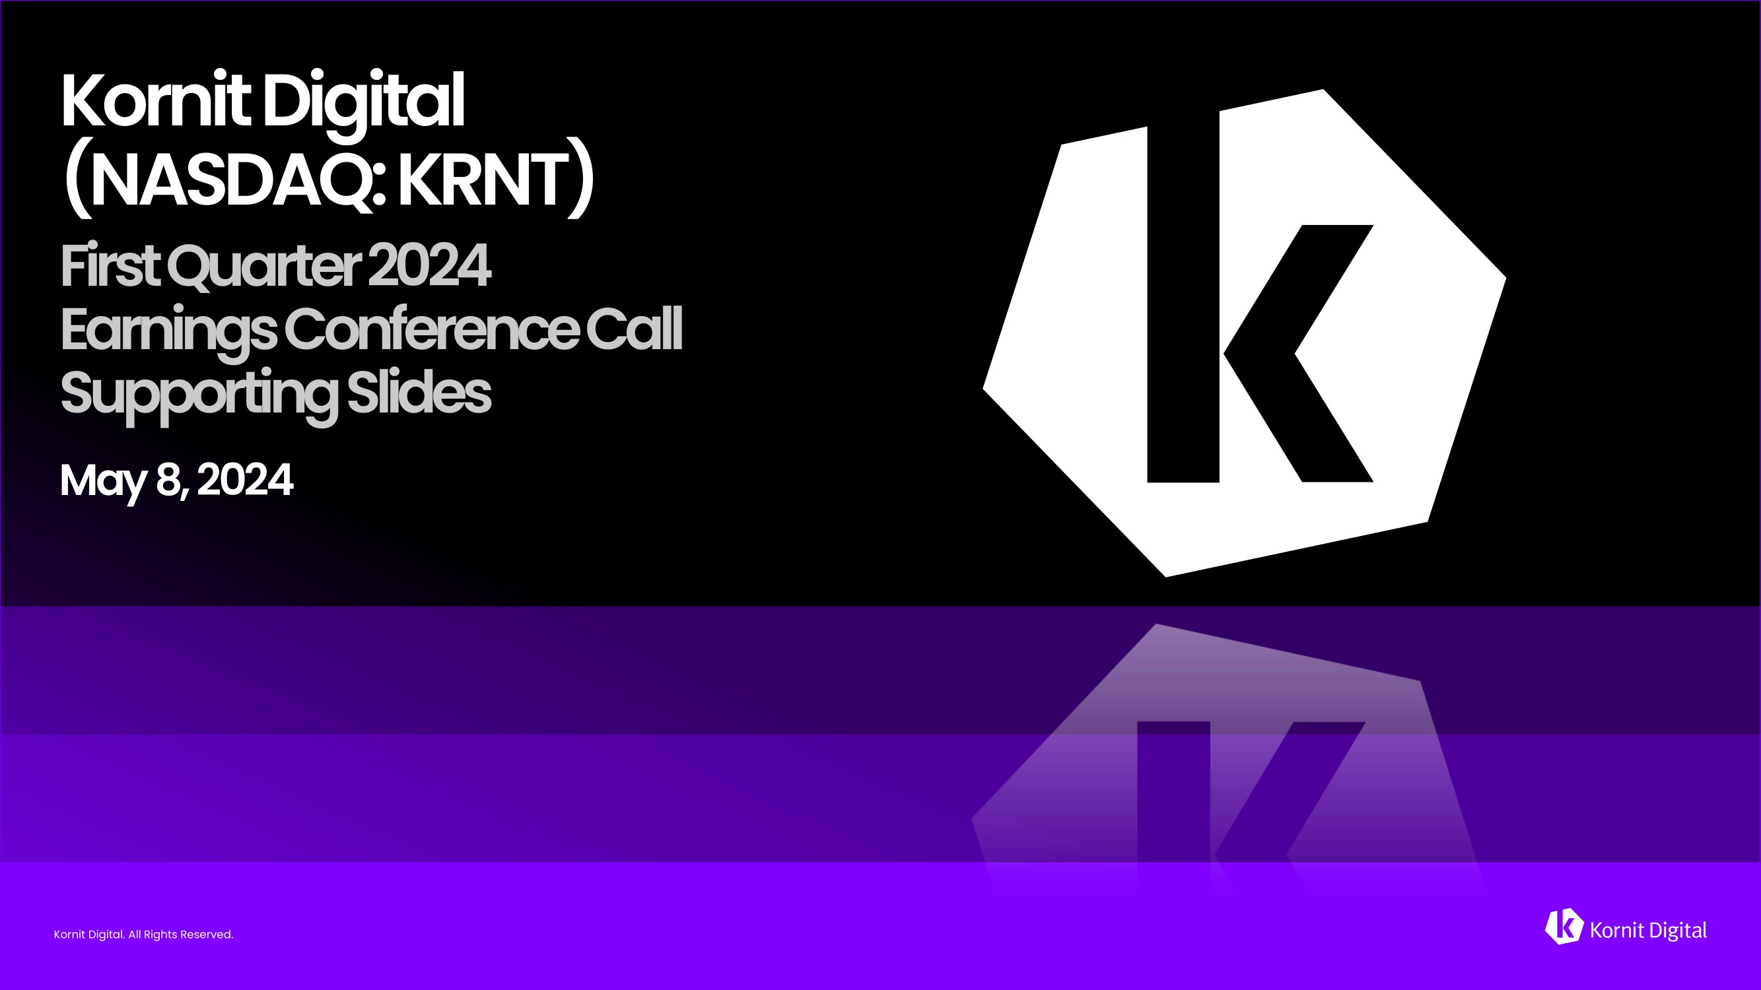
Kornit Digital. All Rights Reserved. Kornit Digital. All Rights Reserved. Kornit Digital (NASDAQ: KRNT) First Quarter 2024 Earnings Conference Call Supporting Slides May 8, 2024 Kornit Digital. All Rights Reserved.


Kornit Digital. All Rights Reserved. On Today’s Call Ronen Samuel CEO Lauri Hanover CFO Jared Maymon Investor Relations

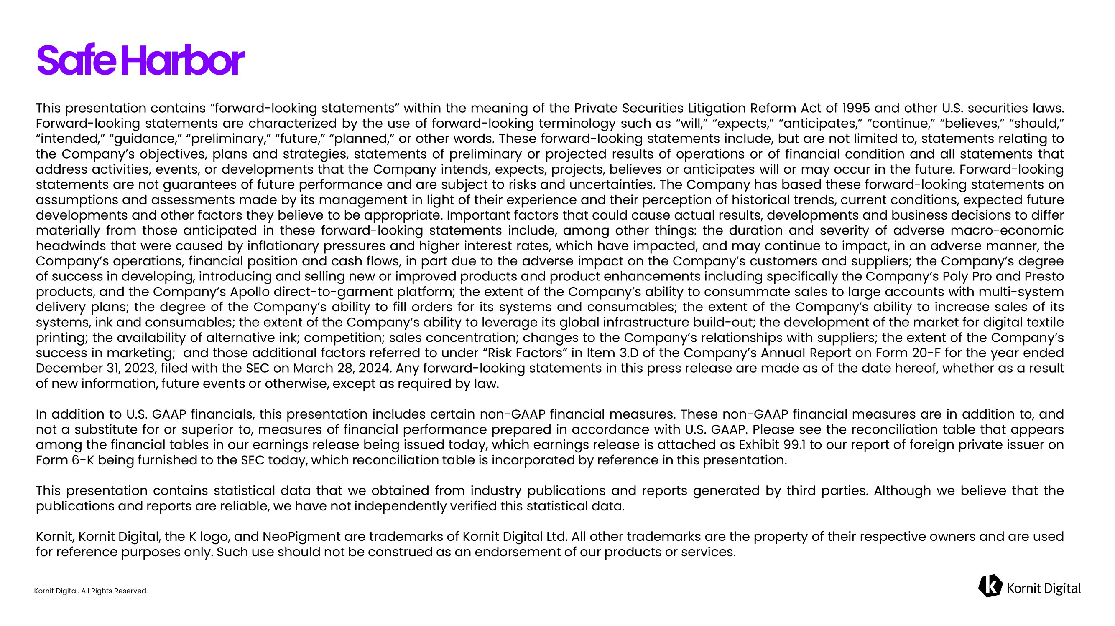
Kornit Digital. All Rights Reserved. Safe Harbor This presentation contains “forward - looking statements” within the meaning of the Private Securities Litigation Reform Act of 1995 and other U . S . securities laws . Forward - looking statements are characterized by the use of forward - looking terminology such as “will,” “expects,” “anticipates,” “continue,” “believes,” “should,” “intended,” “guidance,” “preliminary,” “future,” “planned,” or other words . These forward - looking statements include, but are not limited to, statements relating to the Company’s objectives, plans and strategies, statements of preliminary or projected results of operations or of financial condition and all statements that address activities, events, or developments that the Company intends, expects, projects, believes or anticipates will or may occur in the future . Forward - looking statements are not guarantees of future performance and are subject to risks and uncertainties . The Company has based these forward - looking statements on assumptions and assessments made by its management in light of their experience and their perception of historical trends, current conditions, expected future developments and other factors they believe to be appropriate . Important factors that could cause actual results, developments and business decisions to differ materially from those anticipated in these forward - looking statements include, among other things : the duration and severity of adverse macro - economic headwinds that were caused by inflationary pressures and higher interest rates, which have impacted, and may continue to impact, in an adverse manner, the Company’s operations, financial position and cash flows, in part due to the adverse impact on the Company’s customers and suppliers ; the Company’s degree of success in developing, introducing and selling new or improved products and product enhancements including specifically the Company’s Poly Pro and Presto products, and the Company’s Apollo direct - to - garment platform ; the extent of the Company’s ability to consummate sales to large accounts with multi - system delivery plans ; the degree of the Company’s ability to fill orders for its systems and consumables ; the extent of the Company’s ability to increase sales of its systems, ink and consumables ; the extent of the Company’s ability to leverage its global infrastructure build - out ; the development of the market for digital textile printing ; the availability of alternative ink ; competition ; sales concentration ; changes to the Company’s relationships with suppliers ; the extent of the Company’s success in marketing ; and those additional factors referred to under “Risk Factors” in Item 3 . D of the Company’s Annual Report on Form 20 - F for the year ended December 31 , 2023 , filed with the SEC on March 28 , 2024 . Any forward - looking statements in this press release are made as of the date hereof, whether as a result of new information, future events or otherwise, except as required by law . In addition to U . S . GAAP financials, this presentation includes certain non - GAAP financial measures . These non - GAAP financial measures are in addition to, and not a substitute for or superior to, measures of financial performance prepared in accordance with U . S . GAAP . Please see the reconciliation table that appears among the financial tables in our earnings release being issued today, which earnings release is attached as Exhibit 99 . 1 to our report of foreign private issuer on Form 6 - K being furnished to the SEC today, which reconciliation table is incorporated by reference in this presentation . This presentation contains statistical data that we obtained from industry publications and reports generated by third parties . Although we believe that the publications and reports are reliable, we have not independently verified this statistical data . Kornit, Kornit Digital, the K logo, and NeoPigment are trademarks of Kornit Digital Ltd . All other trademarks are the property of their respective owners and are used for reference purposes only . Such use should not be construed as an endorsement of our products or services .


Kornit Digital. All Rights Reserved. Business Highlights

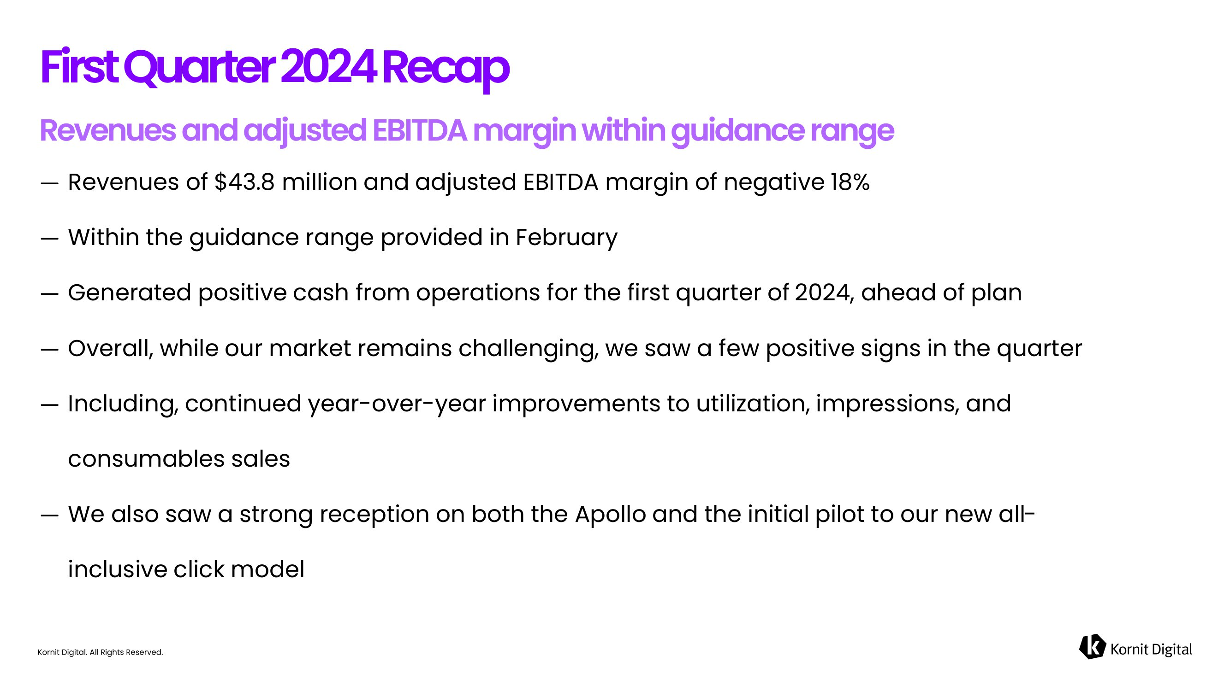
Kornit Digital. All Rights Reserved. ― Revenues of $43.8 million and adjusted EBITDA margin of negative 18% ― Within the guidance range provided in February ― Generated positive cash from operations for the first quarter of 2024, ahead of plan ― Overall, while our market remains challenging, we saw a few positive signs in the quarter ― Including, continued year - over - year improvements to utilization, impressions, and consumables sales ― We also saw a strong reception on both the Apollo and the initial pilot to our new all - inclusive click model First Quarter 2024 Recap

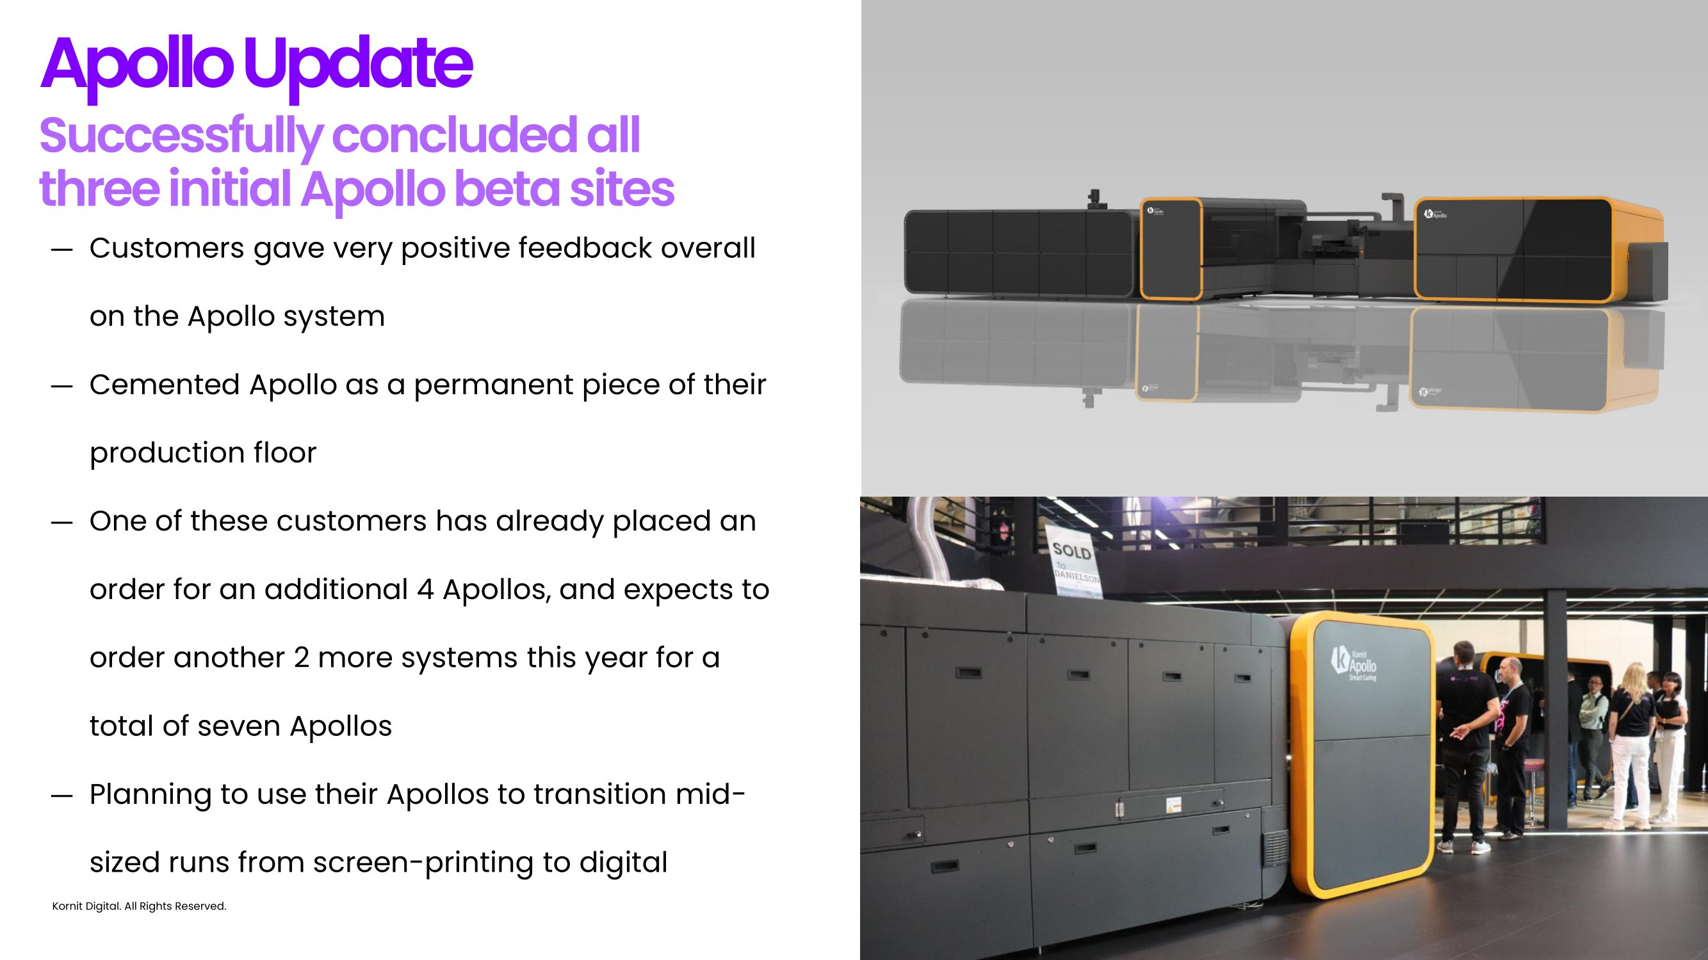
Kornit Digital. All Rights Reserved. ― Customers gave very positive feedback overall on the Apollo system ― Cemented Apollo as a permanent piece of their production floor ― One of these customers has already placed an order for an additional 4 Apollos, and expects to order another 2 more systems this year for a total of seven Apollos ― Planning to use their Apollos to transition mid - sized runs from screen - printing to digital Apollo Update

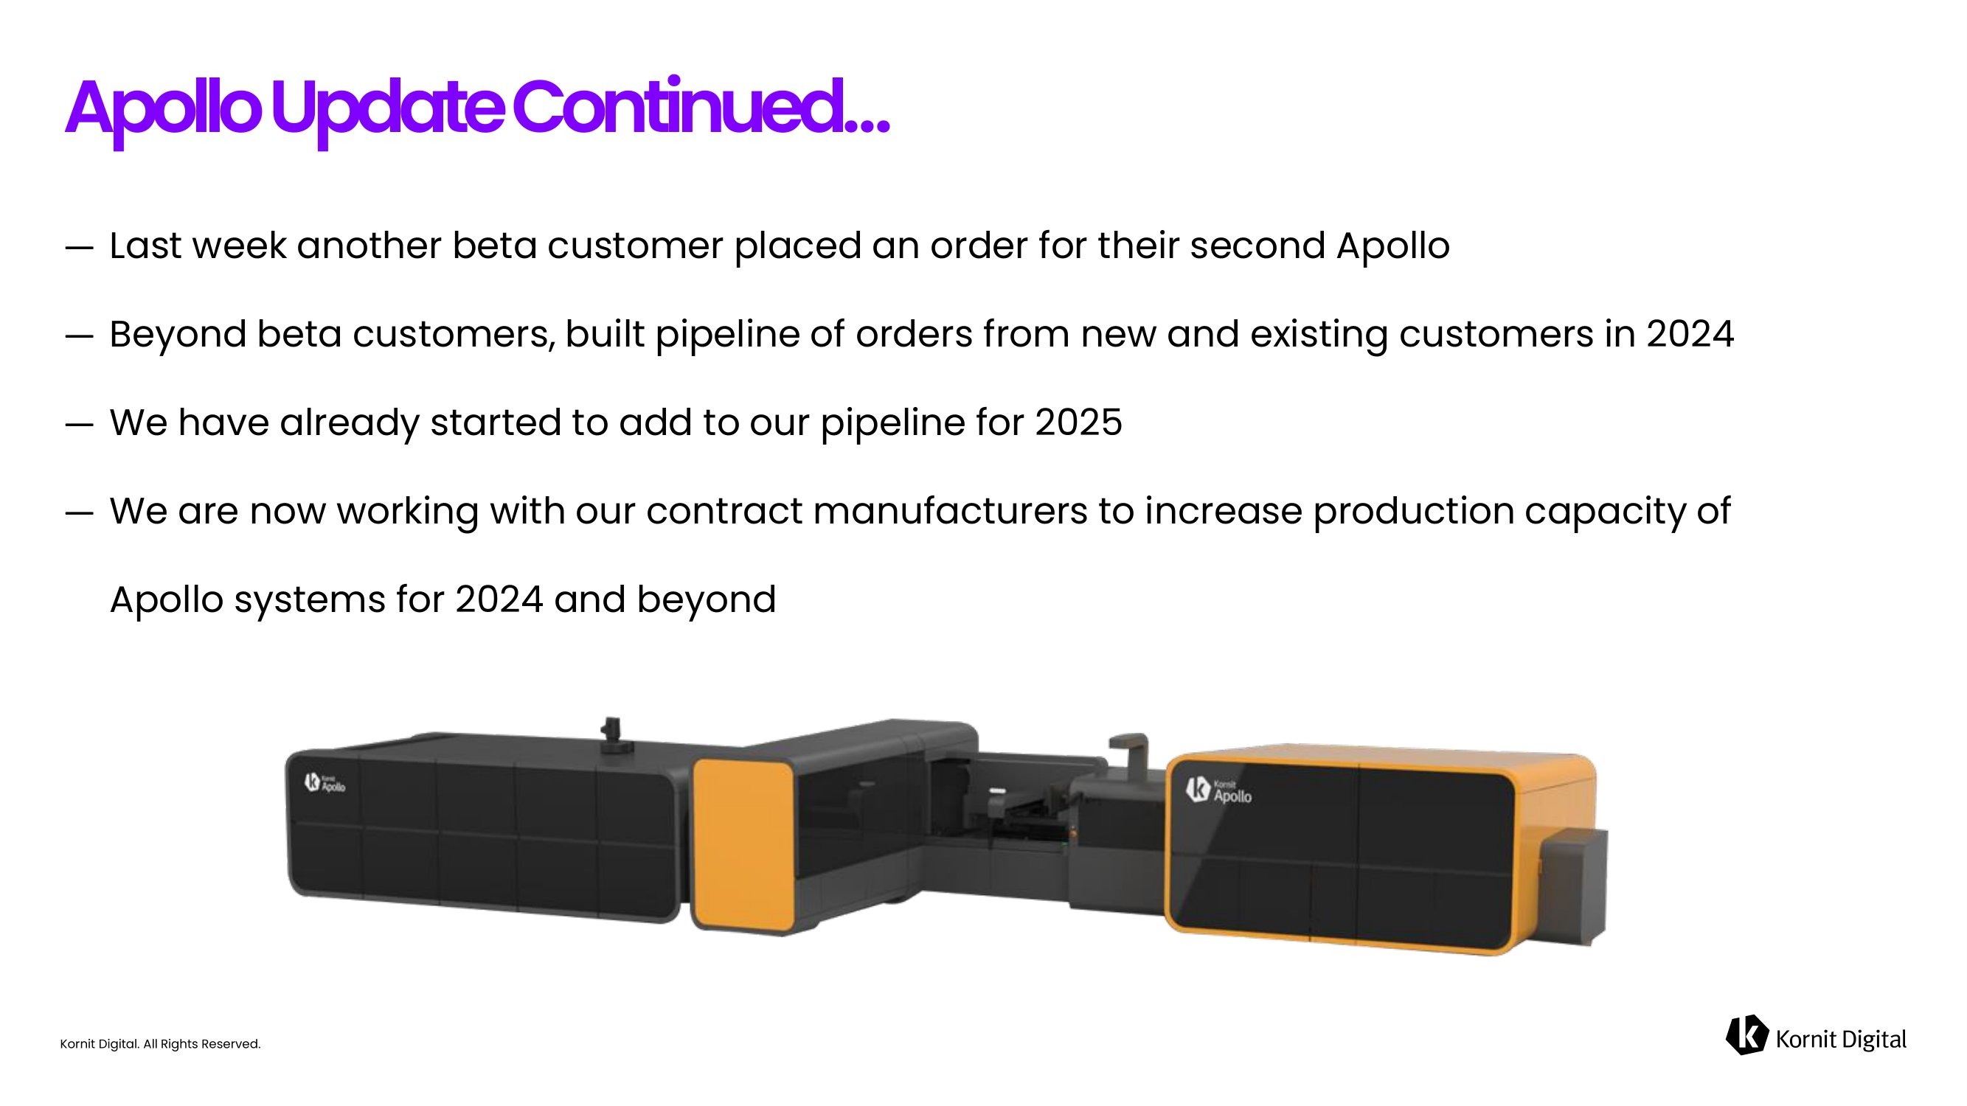
Kornit Digital. All Rights Reserved. ― Last week another beta customer placed an order for their second Apollo ― Beyond beta customers, built pipeline of orders from new and existing customers in 2024 ― We have already started to add to our pipeline for 2025 ― We are now working with our contract manufacturers to increase production capacity of Apollo systems for 2024 and beyond Apollo Update Continued…

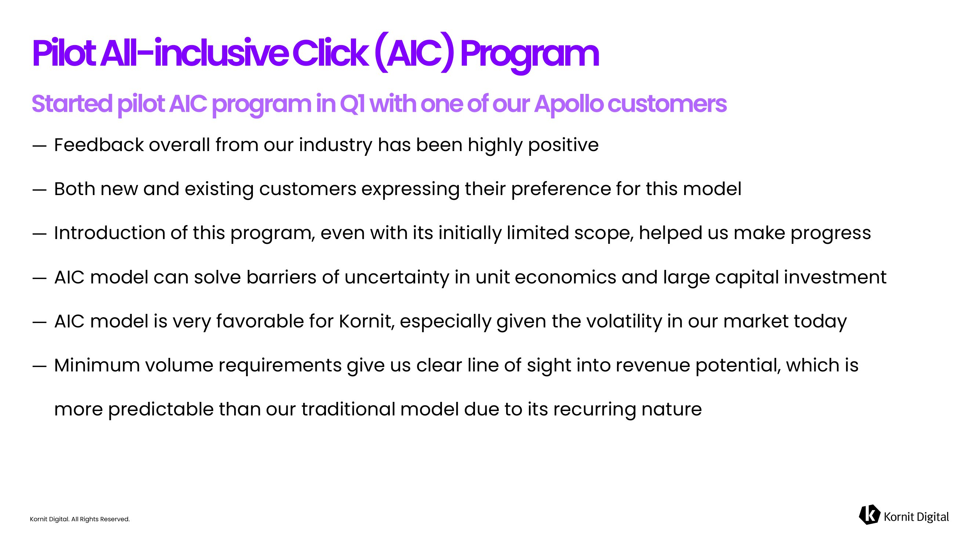
Kornit Digital. All Rights Reserved. ― Feedback overall from our industry has been highly positive ― Both new and existing customers expressing their preference for this model ― Introduction of this program, even with its initially limited scope, helped us make progress ― AIC model can solve barriers of uncertainty in unit economics and large capital investment ― AIC model is very favorable for Kornit, especially given the volatility in our market today ― Minimum volume requirements give us clear line of sight into revenue potential, which is more predictable than our traditional model due to its recurring nature Pilot All - inclusive Click (AIC) Program

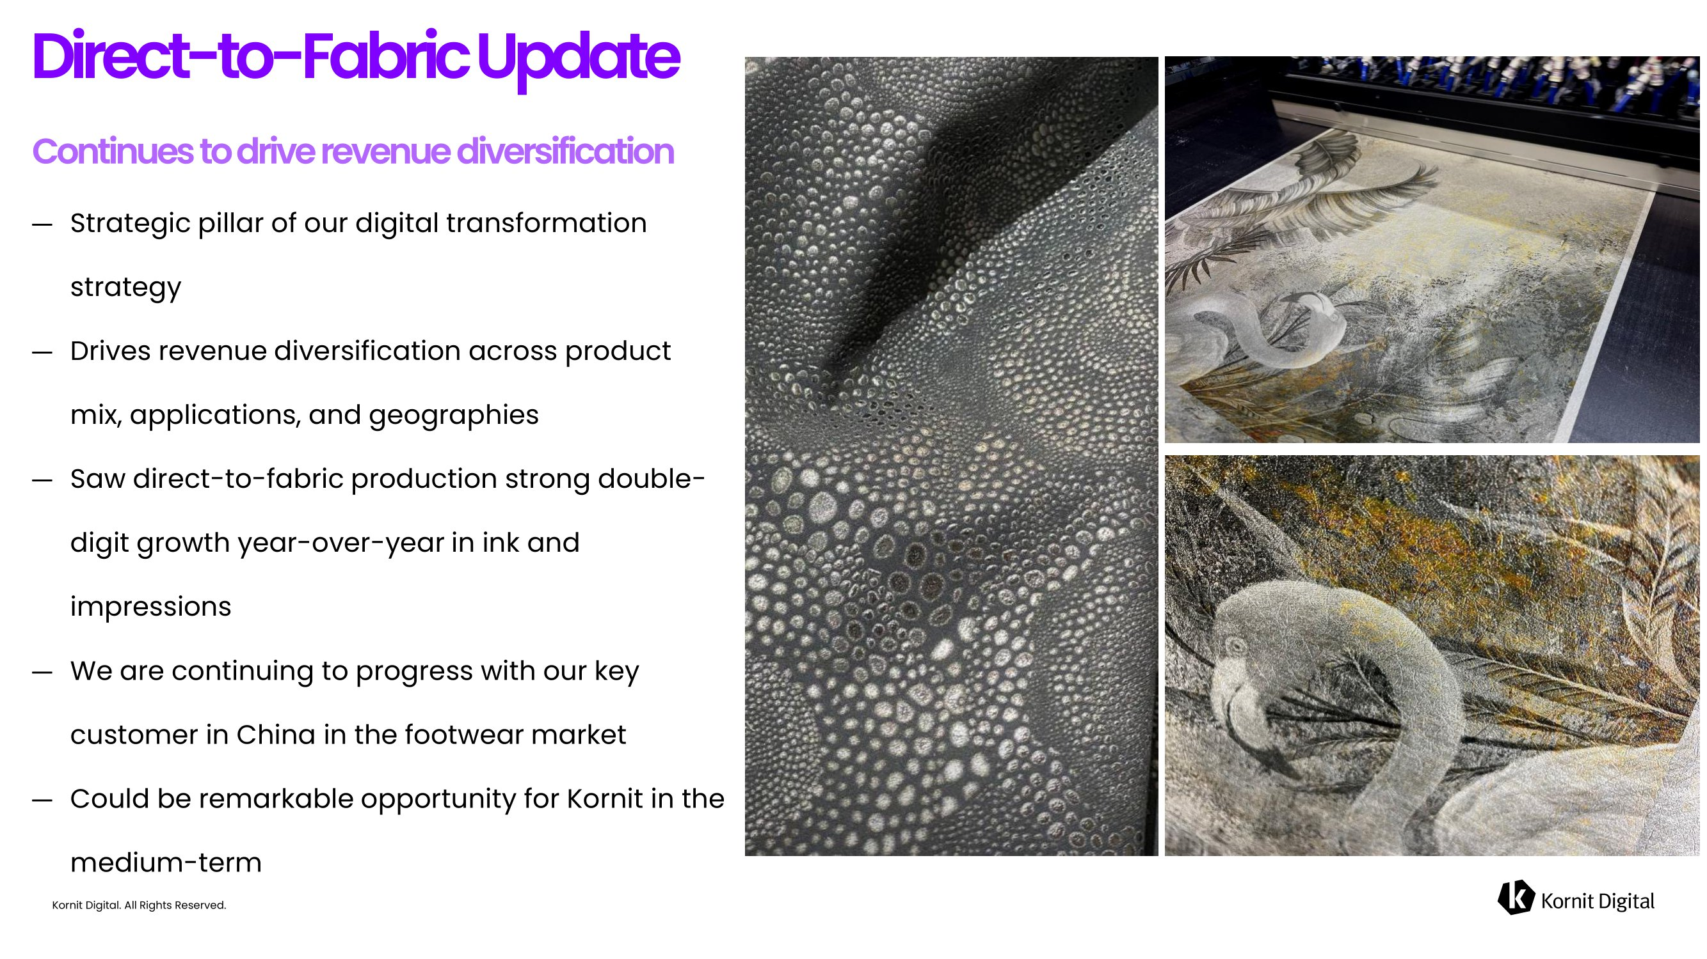
Kornit Digital. All Rights Reserved. ― Strategic pillar of our digital transformation strategy ― Drives revenue diversification across product mix, applications, and geographies ― Saw direct - to - fabric production strong double - digit growth year - over - year in ink and impressions ― We are continuing to progress with our key customer in China in the footwear market ― Could be remarkable opportunity for Kornit in the medium - term Direct - to - Fabric Update

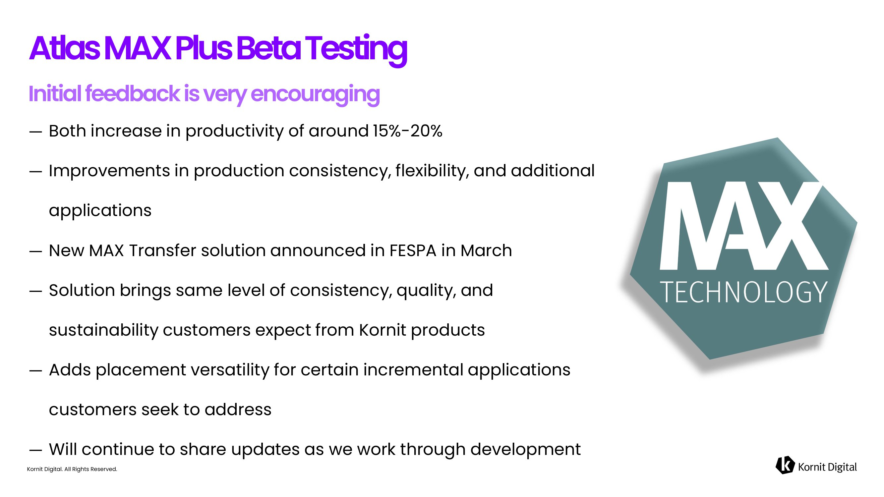
Kornit Digital. All Rights Reserved. ― Both increase in productivity of around 15% - 20% ― Improvements in production consistency, flexibility, and additional applications ― New MAX Transfer solution announced in FESPA in March ― Solution brings same level of consistency, quality, and sustainability customers expect from Kornit products ― Adds placement versatility for certain incremental applications customers seek to address ― Will continue to share updates as we work through development Atlas MAX Plus Beta Testing

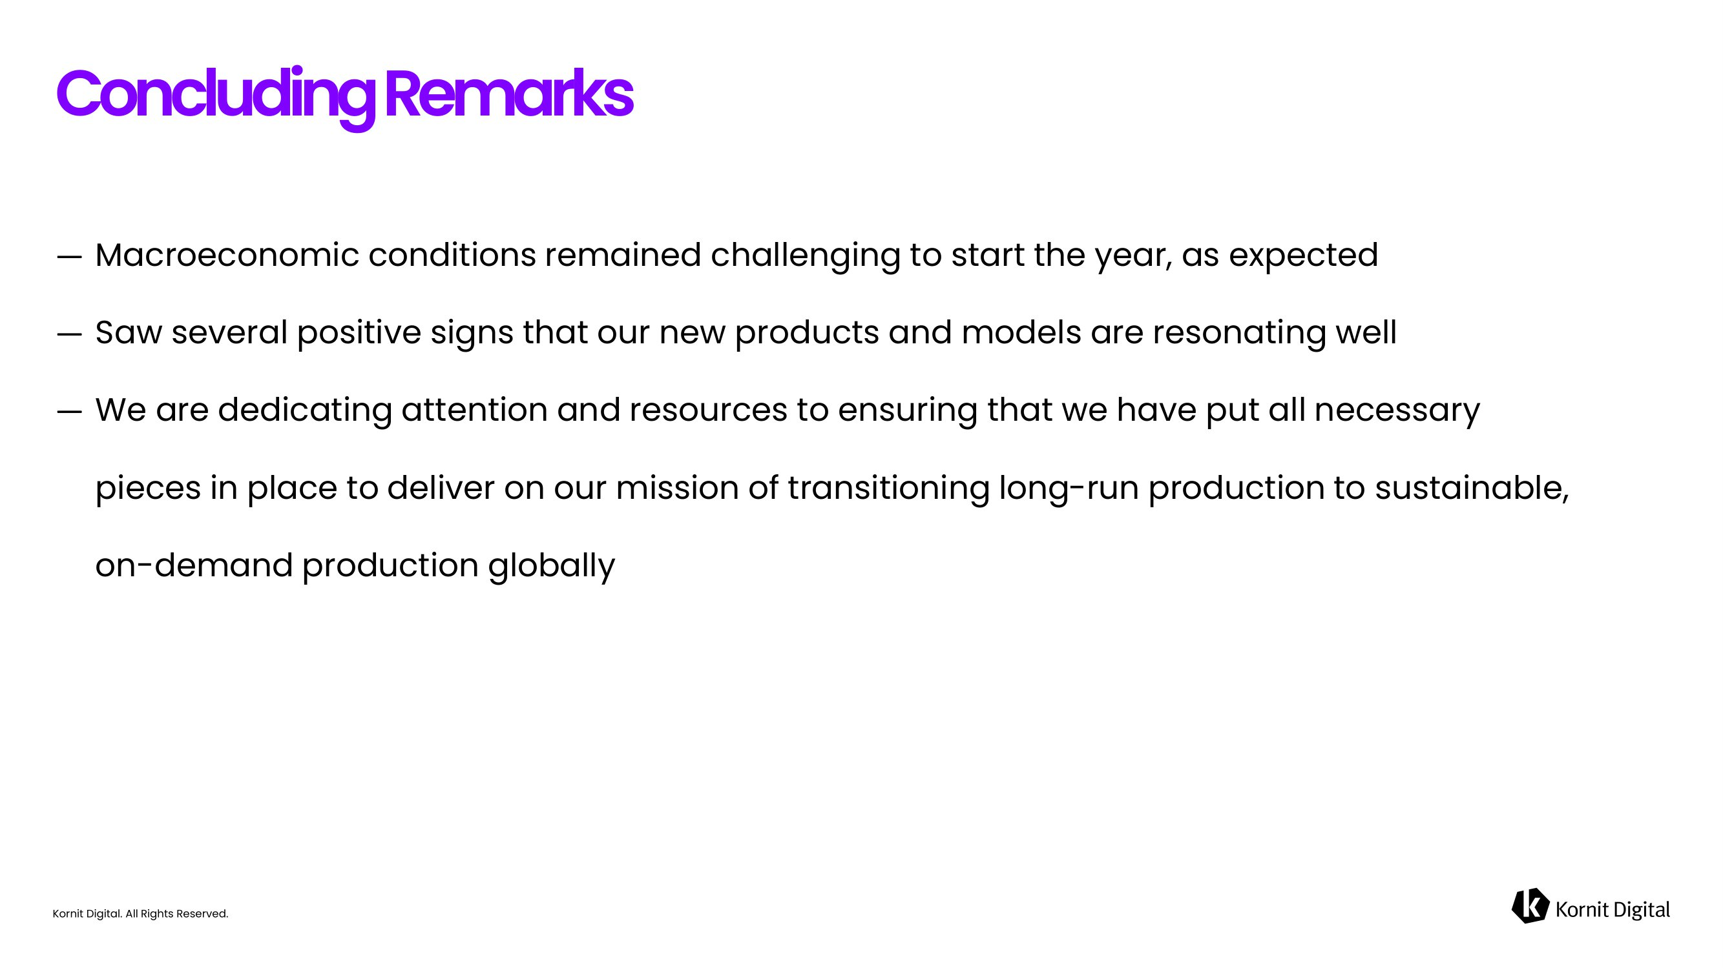
Kornit Digital. All Rights Reserved. ― Macroeconomic conditions remained challenging to start the year, as expected ― Saw several positive signs that our new products and models are resonating well ― We are dedicating attention and resources to ensuring that we have put all necessary pieces in place to deliver on our mission of transitioning long - run production to sustainable, on - demand production globally Concluding Remarks


Kornit Digital. All Rights Reserved. Financial Highlights

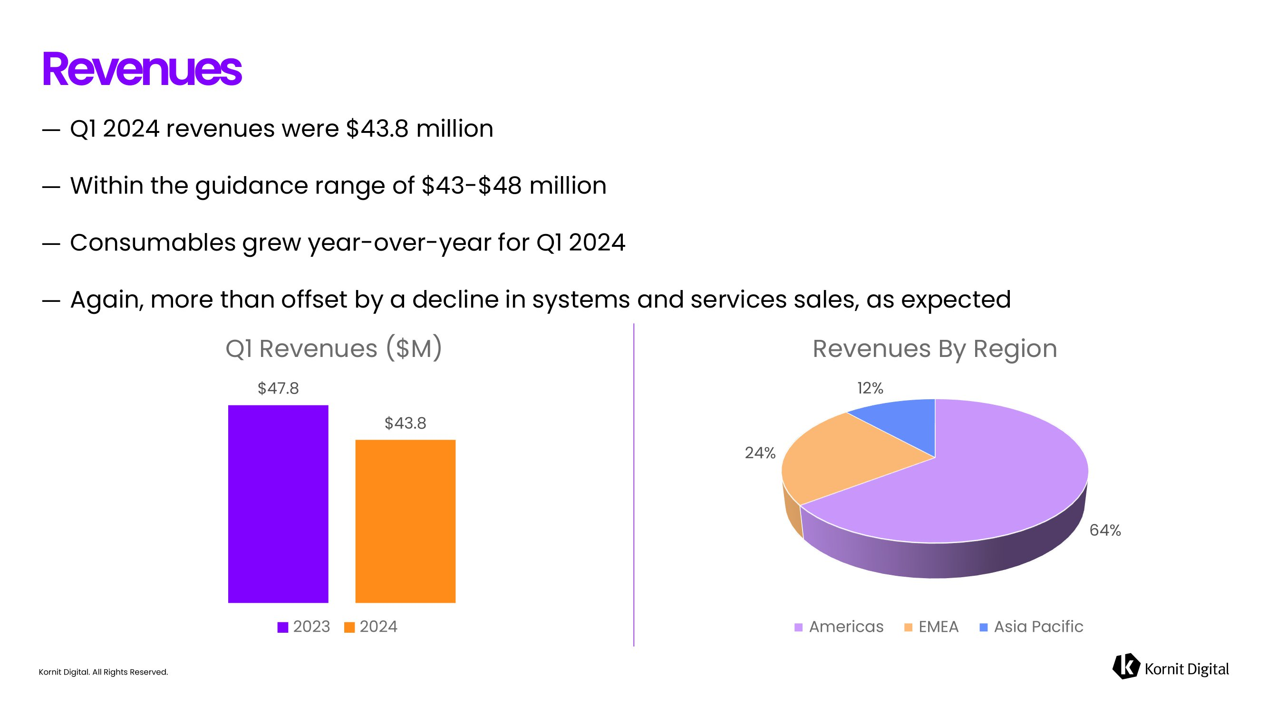
Kornit Digital. All Rights Reserved. ― Q1 2024 revenues were $43.8 million ― Within the guidance range of $43 - $48 million ― Consumables grew year - over - year for Q1 2024 ― Again, more than offset by a decline in systems and services sales, as expected Revenues $47.8 $43.8 Q1 Revenues ($M) 2023 2024 64% 24% 12% Revenues By Region Americas EMEA Asia Pacific

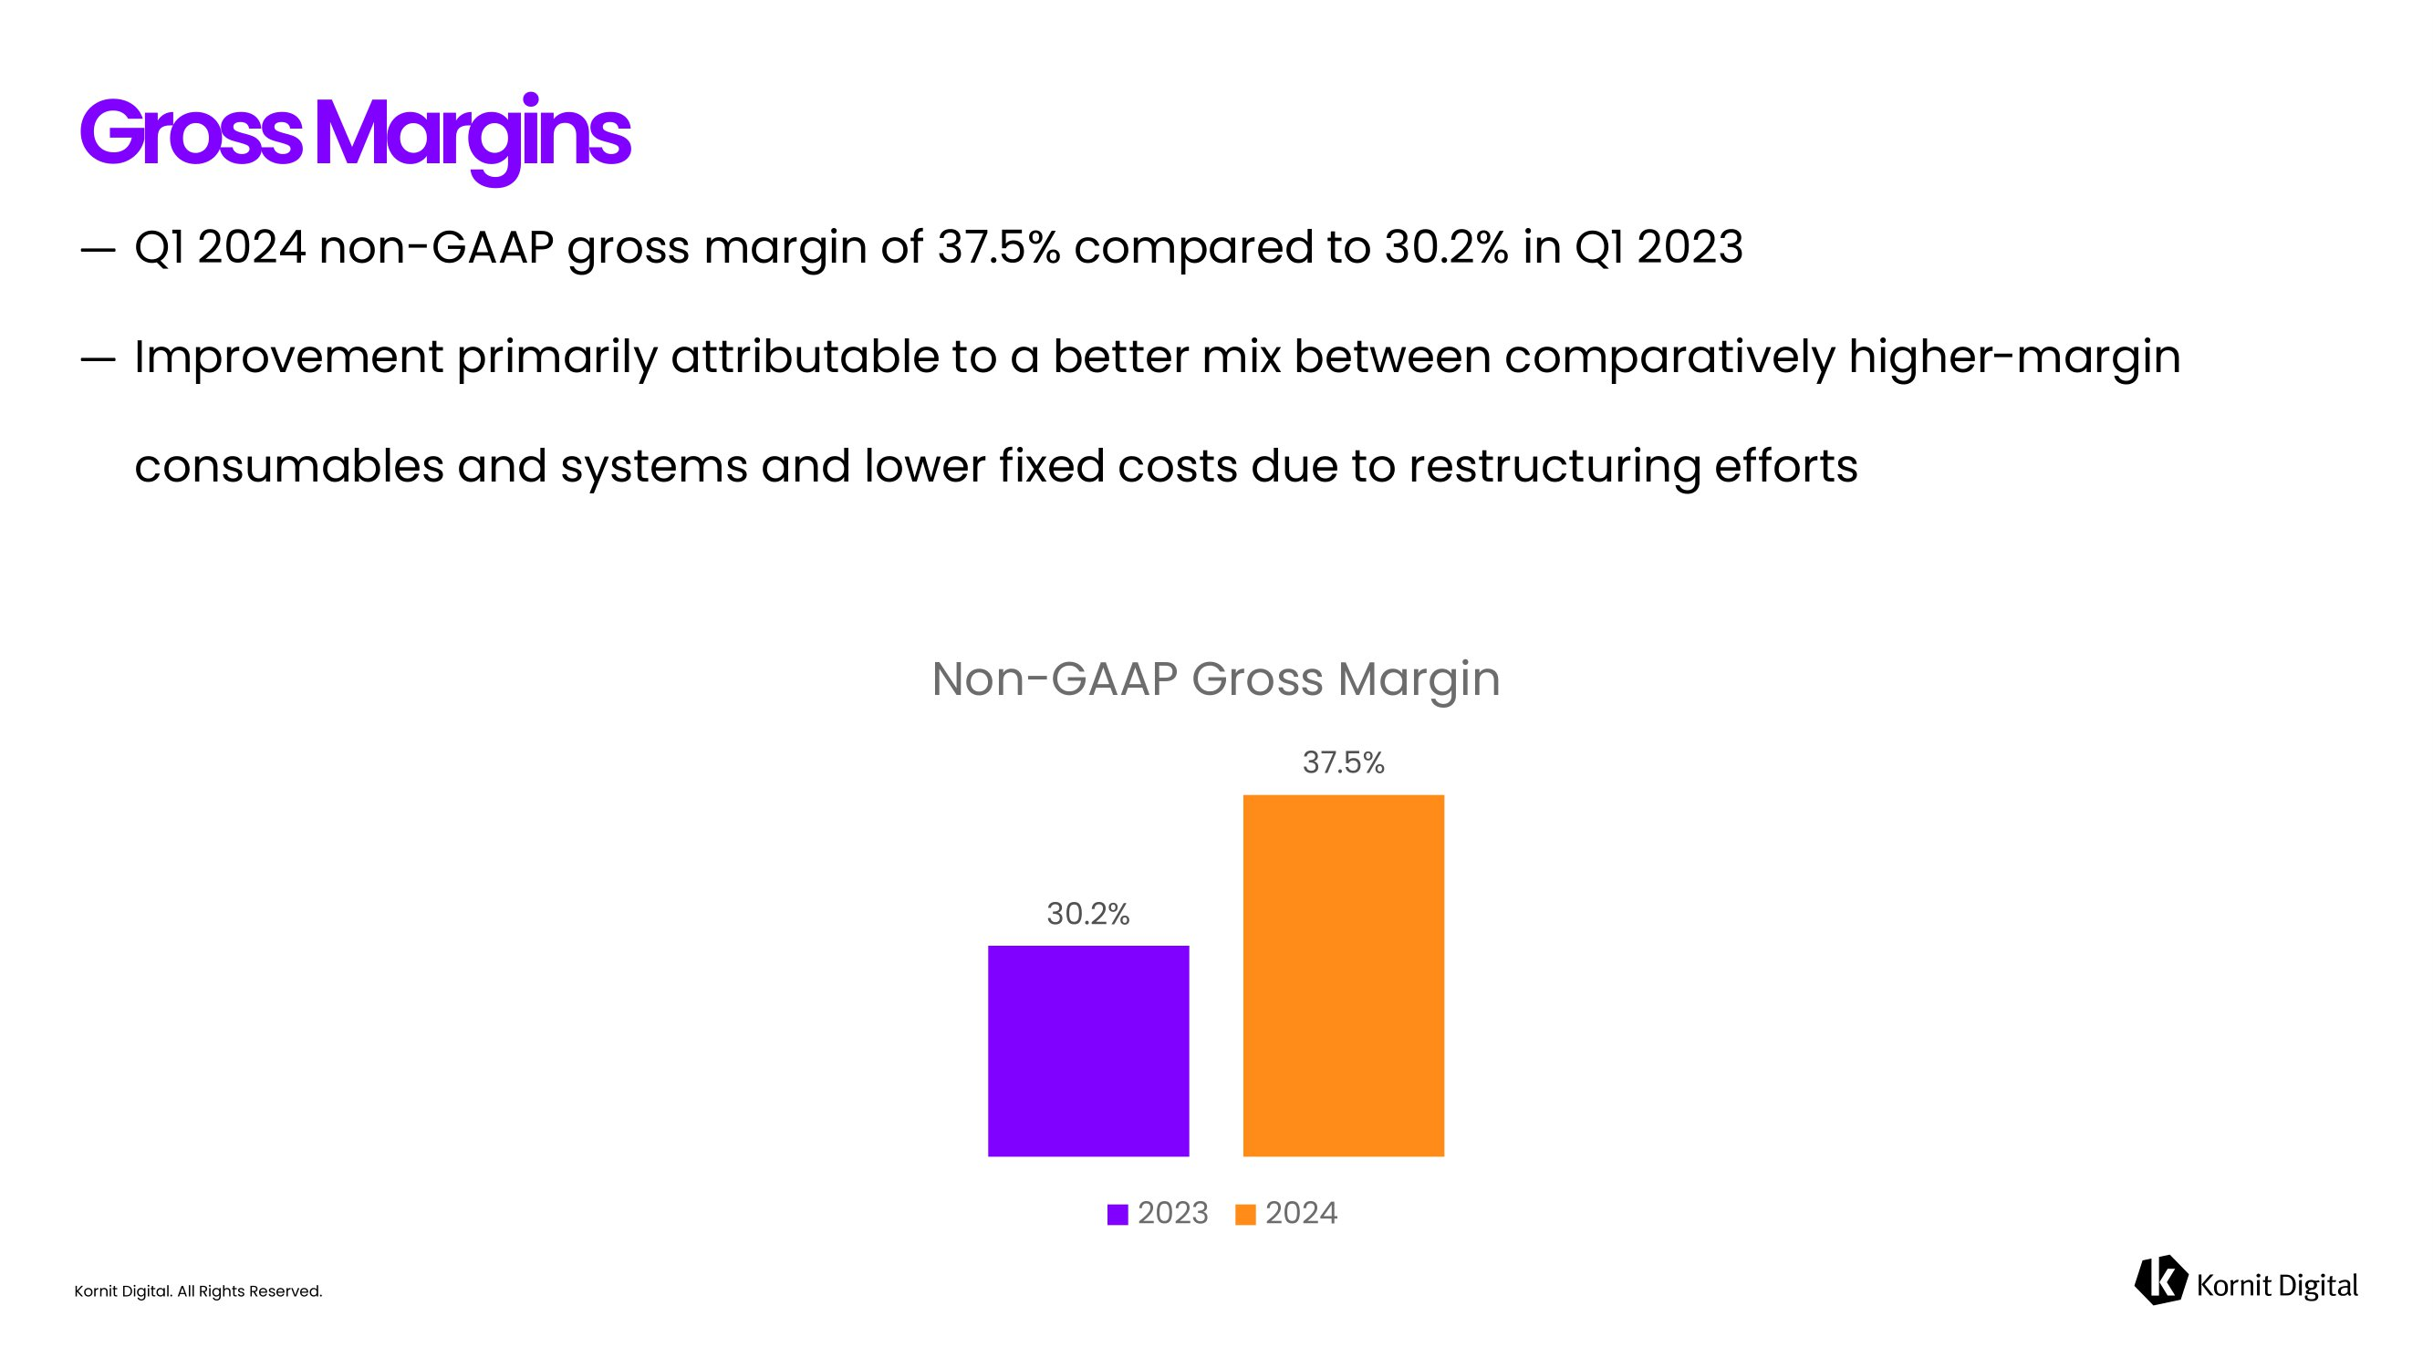
Kornit Digital. All Rights Reserved. ― Q1 2024 non - GAAP gross margin of 37.5% compared to 30.2% in Q1 2023 ― Improvement primarily attributable to a better mix between comparatively higher - margin consumables and systems and lower fixed costs due to restructuring efforts Gross Margins 30.2% 37.5 % Non - GAAP Gross Margin 2023 2024

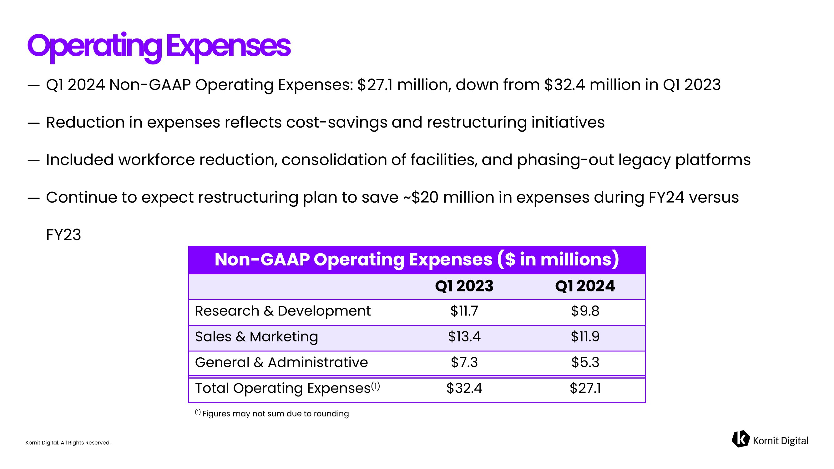
Kornit Digital. All Rights Reserved. ― Q1 2024 Non - GAAP Operating Expenses: $27.1 million, down from $32.4 million in Q1 2023 ― Reduction in expenses reflects cost - savings and restructuring initiatives ― Included workforce reduction, consolidation of facilities, and phasing - out legacy platforms ― Continue to expect restructuring plan to save ~$20 million in expenses during FY24 versus FY23 Operating Expenses Non - GAAP Operating Expenses ($ in millions) Q1 2024 Q1 2023 $9.8 $11.7 Research & Development $11.9 $13.4 Sales & Marketing $5.3 $7.3 General & Administrative $27.1 $32.4 Total Operating Expenses (1) (1) Figures may not sum due to rounding

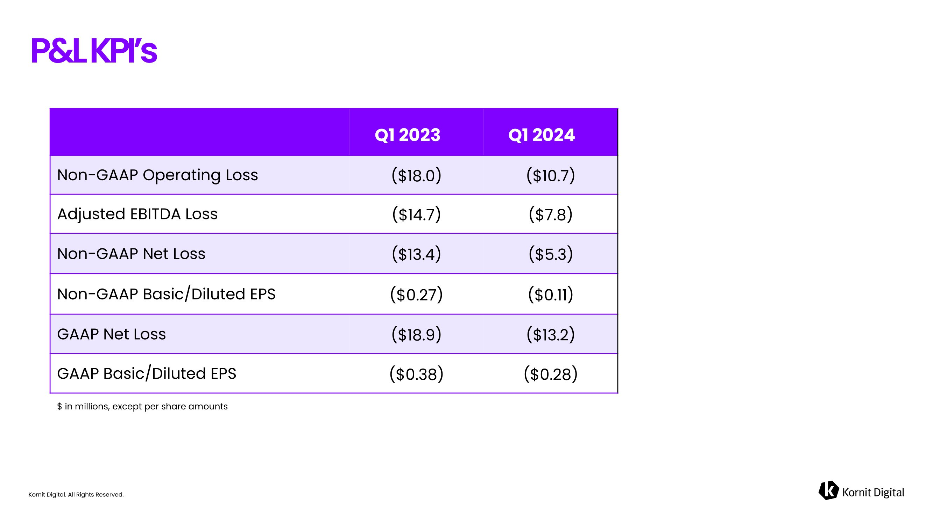
Kornit Digital. All Rights Reserved. P&L KPI’s Q 1 2024 Q1 2023 ($10.7) ($18.0) Non - GAAP Operating Loss ($7.8) ($14.7) Adjusted EBITDA Loss ($5.3) ($13.4) Non - GAAP Net Loss ($0.11) ($0.27) Non - GAAP Basic/Diluted EPS ($13.2) ($18.9) GAAP Net Loss ($0.28) ($0.38) GAAP Basic/Diluted EPS $ in millions, except per share amounts

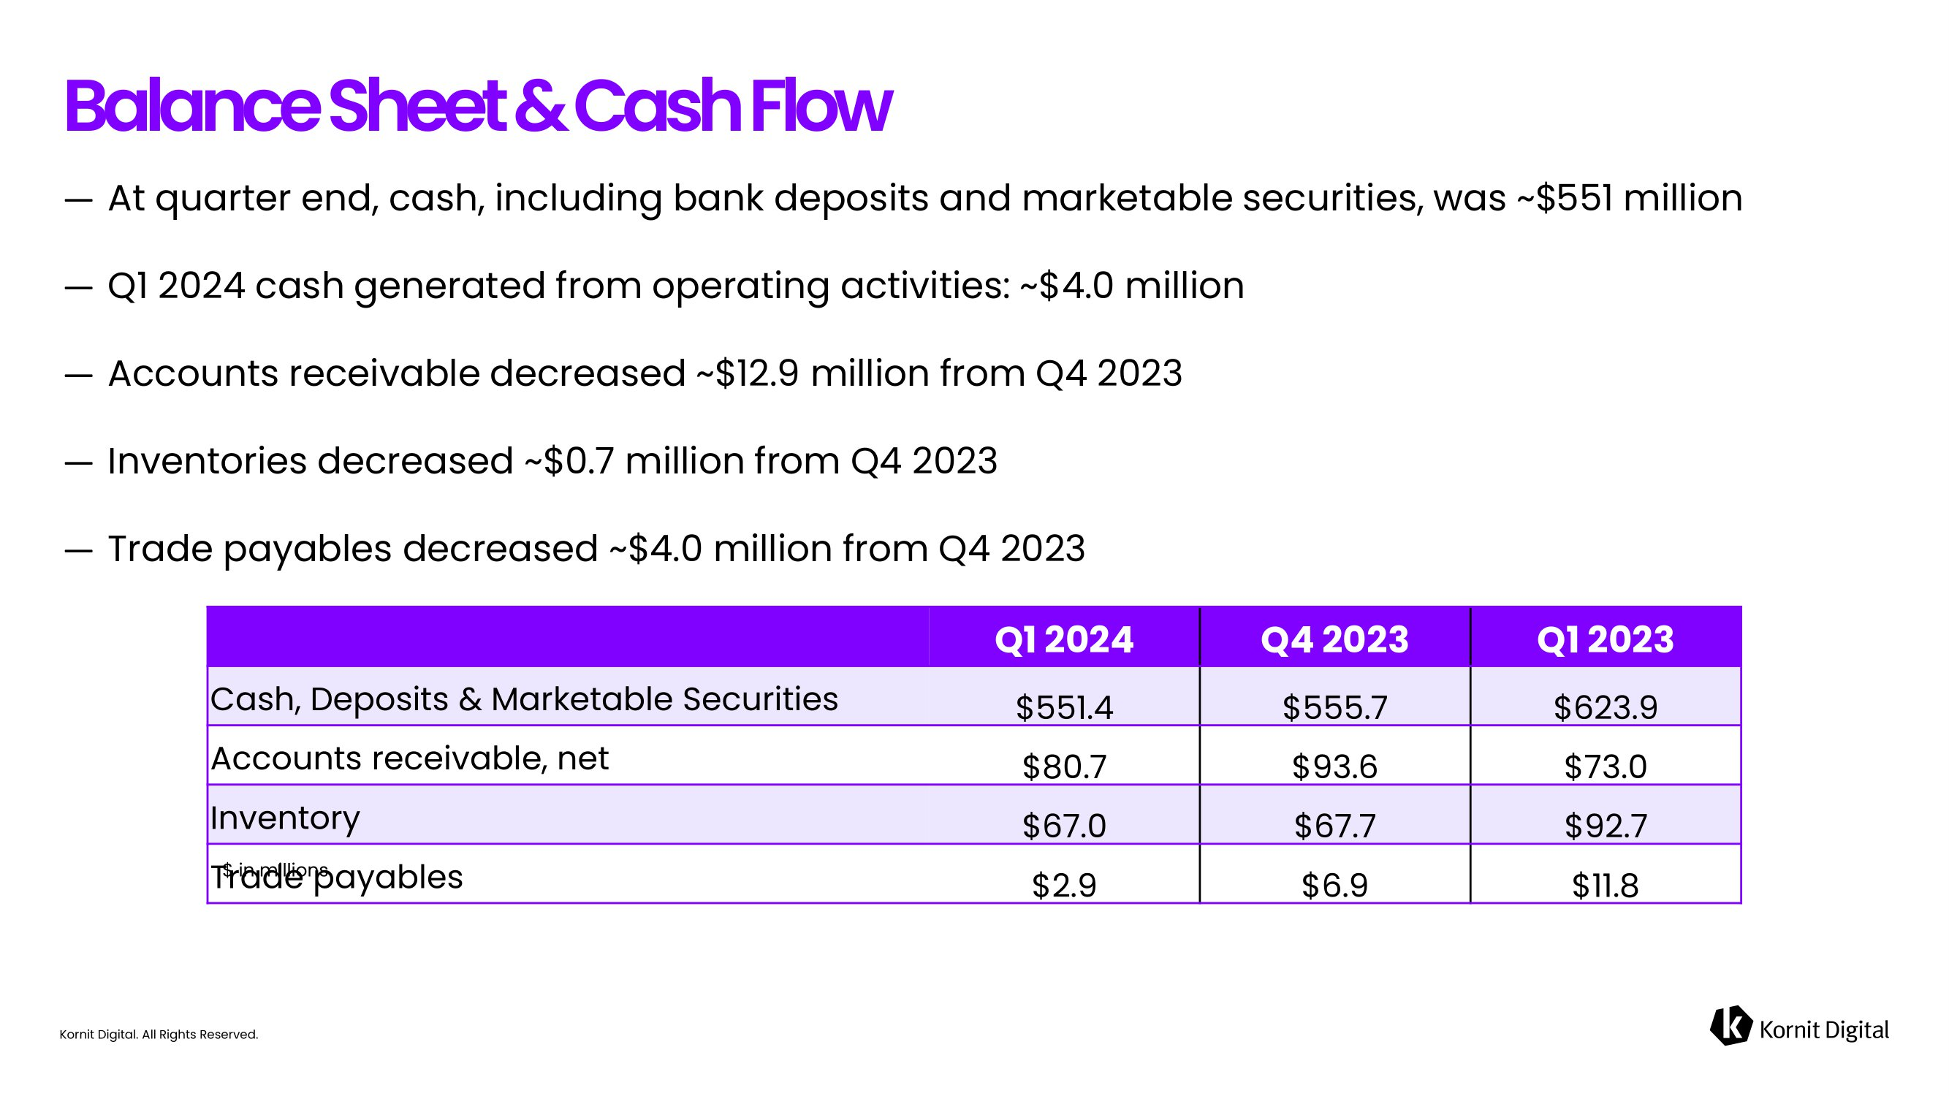
Kornit Digital. All Rights Reserved. ― At quarter end, cash, including bank deposits and marketable securities, was ~$551 million ― Q1 2024 cash generated from operating activities: ~$4.0 million ― Accounts receivable decreased ~$12.9 million from Q4 2023 ― Inventories decreased ~$0.7 million from Q4 2023 ― Trade payables decreased ~$4.0 million from Q4 2023 Balance Sheet & Cash Flow Q1 2023 Q4 2023 Q1 2024 $623.9 $555.7 $551.4 Cash, Deposits & Marketable Securities $73.0 $93.6 $80.7 Accounts r eceivable, net $92.7 $67.7 $67.0 Inventory $ 11.8 $6.9 $2.9 Trade p ayables $ in millions

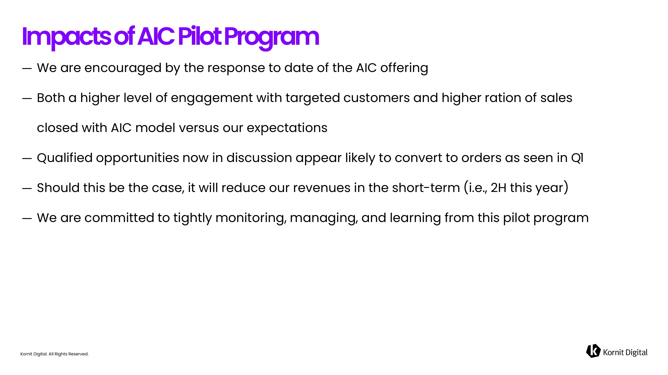
Kornit Digital. All Rights Reserved. ― We are encouraged by the response to date of the AIC offering ― Both a higher level of engagement with targeted customers and higher ration of sales closed with AIC model versus our expectations ― Qualified opportunities now in discussion appear likely to convert to orders as seen in Q1 ― Should this be the case, it will reduce our revenues in the short - term (i.e., 2H this year) ― We are committed to tightly monitoring, managing, and learning from this pilot program Impacts of AIC Pilot Program

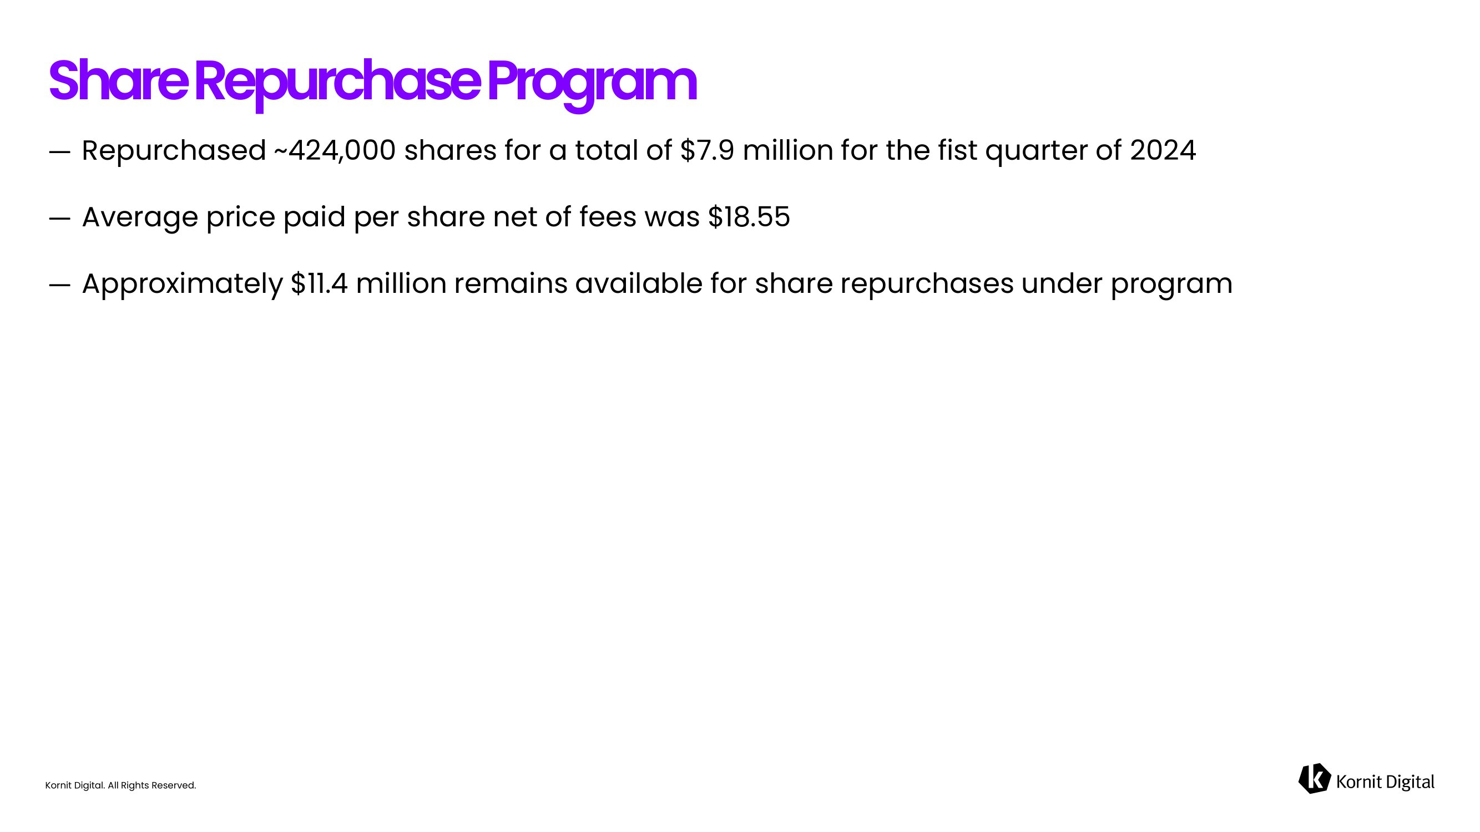
Kornit Digital. All Rights Reserved. ― Repurchased ~424,000 shares for a total of $7.9 million for the fist quarter of 2024 ― Average price paid per share net of fees was $18.55 ― Approximately $11.4 million remains available for share repurchases under program Share Repurchase Program

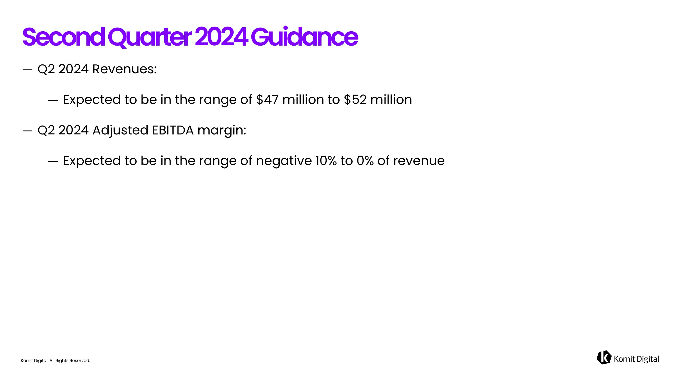
Kornit Digital. All Rights Reserved. ― Q2 2024 Revenues: ― Expected to be in the range of $47 million to $52 million ― Q2 2024 Adjusted EBITDA margin: ― Expected to be in the range of negative 10% to 0% of revenue Second Quarter 2024 Guidance

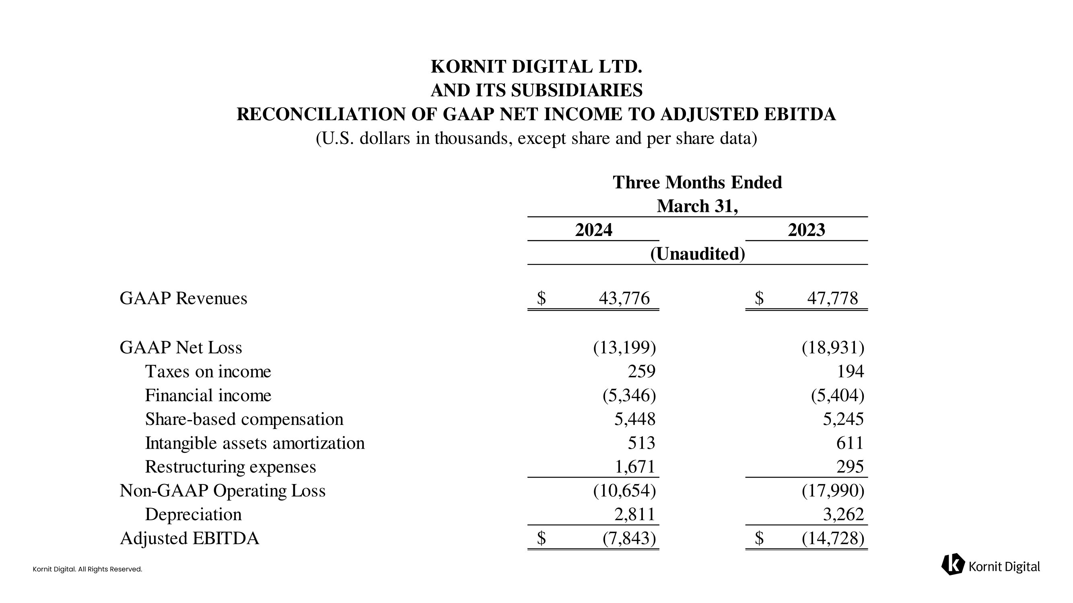
Kornit Digital. All Rights Reserved. 2024 2023 GAAP Revenues 43,776$ 47,778$ GAAP Net Loss (13,199) (18,931) Taxes on income 259 194 Financial income (5,346) (5,404) Share-based compensation 5,448 5,245 Intangible assets amortization 513 611 Restructuring expenses 1,671 295 Non-GAAP Operating Loss (10,654) (17,990) Depreciation 2,811 3,262 Adjusted EBITDA (7,843)$ (14,728)$ March 31, (Unaudited) KORNIT DIGITAL LTD. AND ITS SUBSIDIARIES RECONCILIATION OF GAAP NET INCOME TO ADJUSTED EBITDA (U.S. dollars in thousands, except share and per share data) Three Months Ended


Kornit Digital. All Rights Reserved. Thank You!

