UNITED STATES

SECURITIES AND EXCHANGE COMMISSION

Washington, D.C. 20549

FORM 6-K

REPORT OF FOREIGN PRIVATE ISSUER

PURSUANT TO RULE 13a-16 OR 15d-16 OF
THE SECURITIES EXCHANGE ACT OF 1934

For the month of May 2023

Commission File Number 001-36903

KORNIT DIGITAL LTD.

(Translation of Registrant’s name into English)

12 Ha’Amal Street
Park Afek
Rosh Ha’Ayin 4824096 Israel

(Address of Principal Executive Office)

Indicate by check mark whether the registrant files or will file annual reports under cover of Form 20-F or Form 40-F.

Form 20-F ☒ Form 40-F ☐

Indicate by check mark if the registrant is submitting the Form 6-K in paper as permitted by Regulation S-T Rule 101(b)(1): ☐

Indicate by check mark if the registrant is submitting the Form 6-K in paper as permitted by Regulation S-T Rule 101(b)(7): ☐

CONTENTS

Results of Operations and Financial Condition- Quarter Ended March 31, 2023

On May 10, 2023, Kornit Digital Ltd. (“Kornit”) issued a press release entitled “Kornit Digital Reports First Quarter 2023 Results,” in which Kornit reported its results of operations for the quarter ended March 31, 2023. A copy of that press release is furnished as Exhibit 99.1 hereto.

Kornit is holding a conference call on May 10, 2023 to discuss its quarterly results for the quarter ended March 31, 2023 and will make available to its investors a slide presentation to provide additional information regarding its business and its financial results. That slide presentation is attached as Exhibit 99.2 to this Report of Foreign Private Issuer on Form 6-K (this “Form 6-K”) and is incorporated herein by reference.

Incorporation by Reference

The U.S. GAAP financial information contained in the (i) consolidated balance sheets, (ii) consolidated statements of operations and (iii) consolidated statements of cash flows included in the press release attached as Exhibit 99.1 to this Report of Foreign Private Issuer on Form 6-K is hereby incorporated by reference into Kornit’s Registration Statements on Form F-3 (File No. 333-248784) and Form S-8 (File No.’s 333-203970, 333-214015, 333-217039, 333-223794, 333-230567, 333-237346,333-254749, and 333-263975).

1

SIGNATURES

Pursuant to the requirements of the Securities Exchange Act of 1934, the registrant has duly caused this report to be signed on its behalf by the undersigned, thereunto duly authorized.

 | KORNIT DIGITAL LTD.
Date: May 10, 2023 | By: | /s/ Lauri Hanover
 | Name: | Lauri Hanover
 | Title: | Chief Financial Officer

2

Exhibit Index

Exhibit No. |  | Description
99.1 |  | Press release, dated May 10, 2023, titled “Kornit Digital Reports First Quarter 2023 Results”
99.2 |  | Slide presentation for conference call of Kornit held on May 10, 2023 discussing quarterly financial results for the first quarter of 2023

3

Exhibit 99.1

Investor Contact:
Andrew G. Backman
Global Head of Investor Relations
andrew.backman@kornit.com



Kornit Digital Reports First Quarter 2023 Results

● | First quarter revenues of $47.8 million, in line with prior guidance

● | First quarter GAAP net loss of $18.9 million; non-GAAP net loss of $13.4 million

● | MAX upgrades drive strong quarter for Services

● | Double-digit year-over-year impressions growth from several strategic customers

● | New Atlas MAX Poly and Direct-to-Fabric customers added in key textile regions

● | Set to showcase new break-through solutions at June ITMA tradeshow in Milan, Italy

Rosh-Ha’Ayin, Israel – May 10, 2023 – Kornit Digital Ltd. (“Kornit” or “the Company”) (Nasdaq: KRNT), a worldwide market leader in sustainable, on-demand, digital fashionX and textile production technologies, reported today its results for the first quarter ended March 31, 2023.

“Promising indicators emerged during the first quarter in certain parts of our business, despite the persistent macroeconomic pressures,” said Ronen Samuel, Kornit’s Chief Executive Officer. “These indicators included the double-digit year-over-year impressions growth from several of our larger direct-to-garment (DTG) strategic accounts in the customized design market, and the continued adoption of our MAX technology. While capacity utilization is still not optimal, we see immense opportunities unfolding with major demand generating platforms and expect this market to resume growth as overall macro conditions improve.”

Mr. Samuel continued, “With our MAX technology as the cornerstone, we’ve been steadily gaining momentum on our strategy in targeting brands, retailers, and their global fulfillers, all of whom will greatly benefit from Kornit’s sustainable on-demand digital solutions, instead of existing analog production. We had a strong quarter for Atlas MAX Poly, and continued to strengthen our market-leading position in direct-to-fabric (DTF) with Presto MAX. The progress made in the first quarter offers additional proof points that our MAX technology is becoming the industry standard and an excellent solution that offers top retail quality output, increased productivity, better cost efficiencies, and new product capabilities and offerings.”

Mr. Samuel concluded, “We are excited to attend the upcoming ITMA tradeshow in Milan, where we will demonstrate how digital production goes mainstream with sustainable on-demand manufacturing at scale. We will showcase a diverse range of new cutting-edge DTF and DTG solutions, including unveiling our highly anticipated Apollo, which will revolutionize markets traditionally served by analog. These new systems and solutions significantly extend the breadth of print applications and offer levels of automation never before seen in any of the markets we serve.”

First Quarter 2023 Results of Operations

● | Total revenue for the first quarter of 2023 was $47.8 million compared with $83.3 million in the prior year period, primarily due to expected lower systems revenues.

● | GAAP gross profit margin for the first quarter of 2023 was 27.4% compared with 40.1% in the prior year period. On a non-GAAP basis, gross profit margin was 30.2% compared with 41.5% in the prior year period.

● | GAAP operating expenses for the first quarter of 2023 decreased by 7.7% to $37.2 million compared with the prior year period. On a non-GAAP basis, operating expenses also decreased by 8.0% to $32.4 million compared with the prior year period.

● | GAAP net loss for the first quarter of 2023 was $18.9 million, or ($0.38) per basic share, compared with net loss of $5.2 million, or ($0.10) per basic share, for the first quarter of 2022.

● | Non-GAAP net loss for the first quarter of 2023 was $13.4 million, or ($0.27) per basic share, compared with non-GAAP net income of $0.2 million, or $0.00 per diluted share, for the first quarter of 2022.

● | Adjusted EBITDA loss for the first quarter of 2023 was $14.7 million compared with adjusted EBITDA of $1.5 million for the first quarter of 2022. Adjusted EBITDA margin for the first quarter of 2023 was -30.8% compared with 1.8% for the first quarter of 2022.

Second Quarter 2023 Guidance

For the second quarter of 2023, the Company expects revenues to be in the range of $54 million to $59 million and adjusted EBITDA margin between -19% to -27% of revenue. The guidance for revenue and adjusted EBITDA margin includes the impact of the non-cash expense associated with the fair value of the Company’s warrants.

First Quarter Earnings Conference Call Information

The Company will host a conference call today at 8:30 a.m. ET, or 3:30 p.m. Israel time, to discuss the results, followed by a question-and-answer session with the investor community.

A live webcast of the call can be accessed at ir.kornit.com. To access the call, participants may dial toll-free at 1-888-886-7786 or 1-416-764-8658. The toll-free Israeli number is 1 809 468 221. The conference confirmation code is 79530398.

To listen to a replay of the conference call, dial toll-free 1-844-512-2921 or 1-412-317-6671 (international) and enter confirmation code 79530398. The telephonic replay will be available approximately three hours after the completion of the live call until 11:59 pm ET on Wednesday, May 24, 2023. The call will also be available for replay via the webcast link on Kornit’s Investor Relations website.

About Kornit Digital

Kornit Digital Ltd. (NASDAQ: KRNT) is a worldwide market leader in sustainable, on-demand, digital fashionx and textile production technologies. The Company is writing the operating system for fashion with end-to-end solutions including digital printing systems, inks, consumables, and an entire global ecosystem that manages workflows and fulfillment. Headquartered in Israel with offices in the USA, Europe, and Asia Pacific, Kornit serves customers in more than one hundred countries and states worldwide. To learn more about how Kornit Digital is boldly transforming the world of fashion and textiles, visit www.kornit.com.

2

Forward Looking Statements

Certain statements in this press release are “forward-looking statements” within the meaning of the Private Securities Litigation Reform Act of 1995 and other U.S. securities laws. Forward-looking statements are characterized by the use of forward-looking terminology such as “will,” “expects,” “anticipates,” “continue,” “believes,” “should,” “intended,” “guidance,” “preliminary,” “future,” “planned,” or other words. These forward-looking statements include, but are not limited to, statements relating to the Company’s objectives, plans and strategies, statements of preliminary or projected results of operations or of financial condition and all statements that address activities, events, or developments that the Company intends, expects, projects, believes or anticipates will or may occur in the future. Forward-looking statements are not guarantees of future performance and are subject to risks and uncertainties. The Company has based these forward-looking statements on assumptions and assessments made by its management in light of their experience and their perception of historical trends, current conditions, expected future developments and other factors they believe to be appropriate. Important factors that could cause actual results, developments and business decisions to differ materially from those anticipated in these forward-looking statements include, among other things: the duration and severity of current adverse macro-economic headwinds being caused by supply-chain delays, inflationary pressures, and rising interest rates, which have been impacting, and may continue to impact, in an adverse manner, the Company’s operations, financial position and cash flows, in part due to the adverse impact on the Company’s customers and suppliers; the Company’s degree of success in developing, introducing and selling new or improved products and product enhancements including specifically the Company’s Poly Pro and Presto products; the extent of the Company’s ability to consummate sales to large accounts with multi-system delivery plans; the degree of the Company’s ability to fill orders for its systems; the extent of the Company’s ability to increase sales of its systems, ink and consumables; the extent of the Company’s ability to leverage its global infrastructure build-out; the development of the market for digital textile printing; the availability of alternative ink; competition; sales concentration; changes to the Company’s relationships with suppliers; the extent of the Company’s success in marketing; and those additional factors referred to under “Risk Factors” in Item 3.D of the Company’s Annual Report on Form 20-F for the year ended December 31, 2022, filed with the SEC on March 30, 2023. Any forward-looking statements in this press release are made as of the date hereof, whether as a result of new information, future events or otherwise, except as required by law.

Non-GAAP Discussion Disclosure

The Company presents certain non-GAAP financial measures, in this press release and in the accompanying conference call to discuss the Company’s quarterly results. These non-GAAP financial measures reflect adjustments to corresponding GAAP financial measures in order to exclude the impact of the following: share-based compensation expenses; amortization of intangible assets; acquisition related expenses; restructuring expenses; foreign exchange differences associated with ASC 842; and non-cash deferred tax income.

The Company defines “Adjusted EBITDA” as non-GAAP operating income (loss), which reflects the adjustments described in the preceding paragraph, as further adjusted to exclude depreciation expense.

The purpose of the foregoing non-GAAP financial measures is to convey the Company’s performance exclusive of non-cash charges and other items that are considered by management to be outside of the Company’s core operating results. These non-GAAP measures are among the primary factors management uses in planning for and forecasting future periods. Furthermore, the non-GAAP measures are regularly used internally to understand, manage, and evaluate the Company’s business and make operating decisions, and the Company believes that they are useful to investors as a consistent and comparable measure of the ongoing performance of the Company’s business. The Company’s non-GAAP financial measures are not meant to be considered in isolation or as a substitute for comparable GAAP measures and should be read only in conjunction with the Company’s consolidated financial statements prepared in accordance with GAAP. Additionally, these non-GAAP financial measures may differ materially from the non-GAAP financial measures used by other companies.

The reconciliation tables included below present a reconciliation of our non-GAAP financial measures to the most directly comparable GAAP financial measures.

3

KORNIT DIGITAL LTD.
AND ITS SUBSIDIARIES
CONSOLIDATED BALANCE SHEETS
(U.S. dollars in thousands)

 |  | March 31, |  |  |  | December 31,
 |  | 2023 |  |  |  | 2022
 |  | (Unaudited) |  |  |  | (Audited)
ASSETS
CURRENT ASSETS:
Cash and cash equivalents |  | $ | 352,950 |  |  | $ | 104,597
Short-term bank deposit |  |  | 101 |  |  |  | 275,033
Marketable securities |  |  | 25,948 |  |  |  | 20,380
Trade receivables, net |  |  | 72,968 |  |  |  | 67,360
Inventory |  |  | 92,727 |  |  |  | 89,415
Other accounts receivable and prepaid expenses |  |  | 21,138 |  |  |  | 22,054
Total current assets |  |  | 565,832 |  |  |  | 578,839
LONG-TERM ASSETS:
Marketable securities |  |  | 244,946 |  |  |  | 245,970
Deposits and other long-term assets |  |  | 6,954 |  |  |  | 5,927
Severance pay fund |  |  | 301 |  |  |  | 274
Property, plant and equipment, net |  |  | 58,717 |  |  |  | 60,463
Operating lease right-of-use assets |  |  | 31,910 |  |  |  | 27,139
Intangible assets, net |  |  | 9,233 |  |  |  | 9,890
Goodwill |  |  | 29,164 |  |  |  | 29,164
Total long-term assets |  |  | 381,225 |  |  |  | 378,827
Total assets |  |  | 947,057 |  |  |  | 957,666
LIABILITIES AND SHAREHOLDERS’ EQUITY
CURRENT LIABILITIES:
Trade payables |  |  | 11,837 |  |  |  | 14,833
Employees and payroll accruals |  |  | 14,857 |  |  |  | 14,255
Deferred revenues and advances from customers |  |  | 4,663 |  |  |  | 5,701
Operating lease liabilities |  |  | 4,975 |  |  |  | 4,989
Other payables and accrued expenses |  |  | 30,127 |  |  |  | 25,592
Total current liabilities |  |  | 66,459 |  |  |  | 65,370
LONG-TERM LIABILITIES:
Accrued severance pay |  |  | 1,349 |  |  |  | 1,223
Operating lease liabilities |  |  | 25,363 |  |  |  | 21,035
Other long-term liabilities |  |  | 856 |  |  |  | 1,216
Total long-term liabilities |  |  | 27,568 |  |  |  | 23,474
SHAREHOLDERS’ EQUITY |  |  | 853,030 |  |  |  | 868,822
Total liabilities and shareholders’ equity |  | $ | 947,057 |  |  | $ | 957,666

4

KORNIT DIGITAL LTD.
AND ITS SUBSIDIARIES
CONSOLIDATED STATEMENTS OF OPERATIONS
(U.S. dollars in thousands, except share and per share data)

 |  | Three Months Ended
 |  | March 31,
 |  | 2023 |  |  |  | 2022
 |  | (Unaudited)
Revenues
Products |  | $ | 31,903 |  |  | $ | 72,514
Services |  |  | 15,875 |  |  |  | 10,779
Total revenues |  |  | 47,778 |  |  |  | 83,293
Cost of revenues
Products |  |  | 20,379 |  |  |  | 39,237
Services |  |  | 14,327 |  |  |  | 10,654
Total cost of revenues |  |  | 34,706 |  |  |  | 49,891
Gross profit |  |  | 13,072 |  |  |  | 33,402
Operating expenses:
Research and development, net |  |  | 13,082 |  |  |  | 14,010
Sales and marketing |  |  | 15,183 |  |  |  | 16,531
General and administrative |  |  | 8,948 |  |  |  | 9,766
Total operating expenses |  |  | 37,213 |  |  |  | 40,307
Operating loss |  |  | (24,141 | ) |  |  | (6,905 | )
Financial income, net |  |  | 5,404 |  |  |  | 1,799
Loss before taxes on income |  |  | (18,737 | ) |  |  | (5,106 | )
Taxes on income |  |  | 194 |  |  |  | 91
Net loss |  | $ | (18,931 | ) |  | $ | (5,197 | )
Basic loss per share |  | $ | (0.38 | ) |  | $ | (0.10 | )
Weighted average number of shares used in computing basic net loss per share |  |  | 49,887,982 |  |  |  | 49,658,028
Diluted net loss per share |  | $ | (0.38 | ) |  | $ | (0.10 | )
Weighted average number of shares used in computing diluted net loss per share |  |  | 49,887,982 |  |  |  | 49,658,028

5

KORNIT DIGITAL LTD.
AND ITS SUBSIDIARIES
RECONCILIATION OF GAAP TO NON-GAAP CONSOLIDATED STATEMENTS OF OPERATIONS
(U.S. dollars in thousands, except share and per share data)

 |  | Three Months Ended
 |  | March 31,
 |  | 2023 |  |  |  | 2022
 |  | (Unaudited)
Revenues |  | $47,778 |  |  |  | $83,293
GAAP cost of revenues |  | $ | 34,706 |  |  | $ | 49,891
Cost of product recorded for share-based compensation (1) |  |  | (507 | ) |  |  | (449 | )
Cost of service recorded for share-based compensation (1) |  |  | (351 | ) |  |  | (385 | )
Intangible assets amortization on cost of product (3) |  |  | (263 | ) |  |  | (173 | )
Intangible assets amortization on cost of service (3) |  |  | (160 | ) |  |  | (160 | )
Restructuring expenses (4) |  |  | (89 | ) |  |  | -
Non-GAAP cost of revenues |  | $ | 33,336 |  |  | $ | 48,724
GAAP gross profit |  | $ | 13,072 |  |  | $ | 33,402
Gross profit adjustments |  |  | 1,370 |  |  |  | 1,167
Non-GAAP gross profit |  | $ | 14,442 |  |  | $ | 34,569
GAAP operating expenses |  | $ | 37,213 |  |  | $ | 40,307
Share-based compensation (1) |  |  | (4,387 | ) |  |  | (4,464 | )
Acquisition related expenses (2) |  |  | - |  |  |  | (512 | )
Intangible assets amortization (3) |  |  | (188 | ) |  |  | (86 | )
Restructuring expenses (4) |  |  | (206 | ) |  |  | -
Non-GAAP operating expenses |  | $ | 32,432 |  |  | $ | 35,245
GAAP Financial income, net |  | $ | 5,404 |  |  | $ | 1,799
Foreign exchange differences associated with ASC 842 |  |  | (376 | ) |  |  | (649 | )
Non-GAAP Financial income, net |  | $ | 5,028 |  |  | $ | 1,150
GAAP Taxes on income |  | $ | 194 |  |  | $ | 91
Non-cash deferred tax income |  |  | 221 |  |  |  | 217
Non-GAAP Taxes on income |  | $ | 415 |  |  | $ | 308
GAAP net loss |  | $ | (18,931 | ) |  | $ | (5,197 | )
Share-based compensation (1) |  |  | 5,245 |  |  |  | 5,298
Acquisition related expenses (2) |  |  | - |  |  |  | 512
Intangible assets amortization (3) |  |  | 611 |  |  |  | 419
Restructuring expenses (4) |  |  | 295 |  |  |  | -
Foreign exchange differences associated with ASC 842 |  |  | (376 | ) |  |  | (649 | )
Non-cash deferred tax income |  |  | (221 | ) |  |  | (217 | )
Non-GAAP net income (Loss) |  | $ | (13,377 | ) |  | $ | 166
GAAP diluted loss per share |  | $ | (0.38 | ) |  | $ | (0.10 | )
Non-GAAP diluted earnings (loss) per share |  | $ | (0.27 | ) |  | $ | 0.00
Weighted average number of shares
Shares used in computing GAAP diluted net loss per share |  |  | 49,887,982 |  |  |  | 49,658,028
Shares used in computing Non-GAAP diluted net earnings (loss) per share |  |  | 49,887,982 |  |  |  | 50,955,776
(1) Share-based compensation
Cost of product revenues |  | $ | 507 |  |  | $ | 449
Cost of service revenues |  |  | 351 |  |  |  | 385
Research and development |  |  | 1,351 |  |  |  | 1,189
Sales and marketing |  |  | 1,363 |  |  |  | 1,809
General and administrative |  |  | 1,673 |  |  |  | 1,466
 |  | $ | 5,245 |  |  | $ | 5,298
(2) Acquisition related expenses
General and administrative |  | $ | - |  |  | $ | 512
 |  | $ | - |  |  | $ | 512
(3) Intangible assets amortization
Cost of product revenues |  | $ | 263 |  |  | $ | 173
Cost of service revenues |  |  | 160 |  |  |  | 160
Sales and marketing |  |  | 188 |  |  |  | 86
 |  | $ | 611 |  |  | $ | 419
(4) Restructuring expenses
Cost of product revenues |  | $ | 89 |  |  | $ | -
Research and development |  |  | 20 |  |  |  | -
Sales and marketing |  |  | 186 |  |  |  | -
 |  | $ | 295 |  |  | $ | -
6

KORNIT DIGITAL LTD.
AND ITS SUBSIDIARIES
CONSOLIDATED STATEMENTS OF CASH FLOWS
(U.S. dollars in thousands)

 |  | Three Months Ended
 |  | March 31,
 |  | 2023 |  |  |  | 2022
 |  | (Unaudited)
Cash flows from operating activities:
Net loss |  | $ | (18,931 | ) |  | $ | (5,197 | )
Adjustments to reconcile net loss to net cash used in operating activities:
Depreciation and amortization |  |  | 3,873 |  |  |  | 2,580
Fair value of warrants deducted from revenues |  |  | 2,344 |  |  |  | 8,005
Share-based compensation |  |  | 5,245 |  |  |  | 5,298
Amortization of premium and accretion of discount on marketable securities, net |  |  | 323 |  |  |  | 528
Realized loss on sale and redemption of marketable securities |  |  | 40 |  |  |  | 3
Change in operating assets and liabilities:
Trade receivables, net |  |  | (5,608 | ) |  |  | (31,193 | )
Other accounts receivables and prepaid expenses |  |  | 916 |  |  |  | (2,464 | )
Inventory |  |  | (3,023 | ) |  |  | (9,036 | )
Operating leases right-of-use assets and liabilities, net |  |  | (457 | ) |  |  | (408 | )
Deferred taxes |  |  | - |  |  |  | (305 | )
Deposits and other long term assets |  |  | (1,027 | ) |  |  | 6
Trade payables |  |  | (1,477 | ) |  |  | (7,444 | )
Employees and payroll accruals |  |  | 737 |  |  |  | (6,470 | )
Deferred revenues and advances from customers |  |  | (1,038 | ) |  |  | (1,471 | )
Other payables and accrued expenses |  |  | 4,340 |  |  |  | 359
Accrued severance pay, net |  |  | 99 |  |  |  | (189 | )
Other long-term liabilities |  |  | (360 | ) |  |  | 316
Net cash used in operating activities |  | $ | (14,004 | ) |  | $ | (47,082 | )
Cash flows from investing activities:
Purchase of property, plant and equipment |  | $ | (3,278 | ) |  | $ | (7,462 | )
Proceeds from (investment in) short-term bank deposits, net |  |  | 274,932 |  |  |  | (410,985 | )
Proceeds from sales and redemption of marketable securities |  |  | 4,000 |  |  |  | 445
Proceeds from maturities of marketable securities |  |  | 3,572 |  |  |  | 11,922
Investment in marketable securities |  |  | (10,024 | ) |  |  | (80,894 | )
Net cash provided by (used in) investing activities |  | $ | 269,202 |  |  | $ | (486,974 | )
Cash flows from financing activities:
Exercise of employee stock options |  | $ | 42 |  |  | $ | 299
Payments related to shares withheld for taxes |  |  | (135 | ) |  |  | (510 | )
Repurchase of ordinary shares |  |  | (6,752 | ) |  |  | -
Net cash used in financing activities |  | $ | (6,845 | ) |  | $ | (211 | )
Increase (decrease) in cash and cash equivalents |  | $ | 248,353 |  |  | $ | (534,267 | )
Cash and cash equivalents at the beginning of the period |  |  | 104,597 |  |  |  | 611,551
Cash and cash equivalents at the end of the period |  | $ | 352,950 |  |  | $ | 77,284
Non-cash investing and financing activities:
Purchase of property and equipment on credit |  |  | 173 |  |  |  | 1,292
Inventory transferred to be used as property and equipment |  |  | 365 |  |  |  | 697
Property, plant and equipment transferred to be used as inventory |  |  | 653 |  |  |  | 4
Receipt on account of shares |  |  | - |  |  |  | 63
Lease liabilities arising from obtaining right-of-use assets |  |  | 6,037 |  |  |  | 5,746

7

KORNIT DIGITAL LTD.
AND ITS SUBSIDIARIES
RECONCILIATION OF GAAP NET INCOME TO ADJUSTED EBITDA
(U.S. dollars in thousands, except share and per share data)

 |  | Three Months Ended
 |  | March 31,
 |  | 2023 |  |  |  | 2022
 |  | (Unaudited)
GAAP Revenues |  | $ | 47,778 |  |  | $ | 83,293
GAAP Net Loss |  |  | (18,931 | ) |  |  | (5,197 | )
Taxes on income |  |  | 194 |  |  |  | 91
Financial income |  |  | (5,404 | ) |  |  | (1,799 | )
Share-based compensation |  |  | 5,245 |  |  |  | 5,298
Intangible assets amortization |  |  | 611 |  |  |  | 419
Acquisition related expenses |  |  | - |  |  |  | 512
Restructuring expenses |  |  | 295 |  |  |  | -
Non-GAAP Operating Loss |  |  | (17,990 | ) |  |  | (676 | )
Depreciation |  |  | 3,262 |  |  |  | 2,161
Adjusted EBITDA |  | $ | (14,728 | ) |  | $ | 1,485

8

Exhibit 99.2


©2023 Kornit Digital. All rights reserved. KORNIT DIGITAL (NASDAQ: KRNT) First Quarter 2023 Earnings Conference Call Supporting Slides May 10, 2023

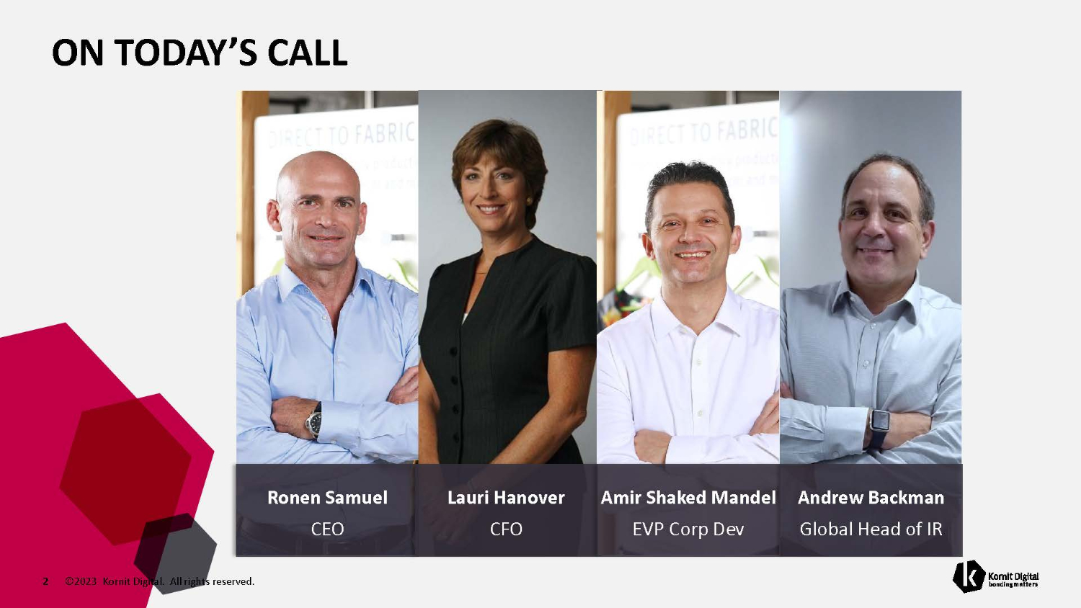
ON TODAY’S CALL Ronen Samuel CEO Lauri Hanover CFO Amir Shaked Mandel Andrew Backman EVP Corp Dev Global Head of IR 2 ©2023 Kornit Digital. All rights reserved.

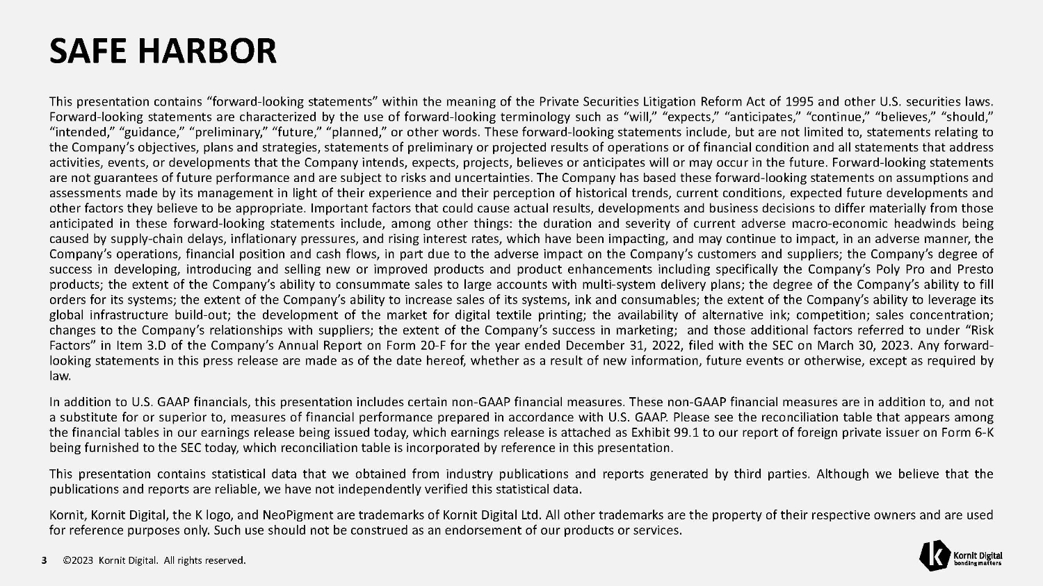
SAFE HARBOR 3 ©2023 Kornit Digital. All rights reserved. This presentation contains “forward - looking statements” within the meaning of the Private Securities Litigation Reform Act of 1995 and other U . S . securities laws . Forward - looking statements are characterized by the use of forward - looking terminology such as “will,” “expects,” “anticipates,” “continue,” “believes,” “should,” “intended,” “guidance,” “preliminary,” “future,” “planned,” or other words . These forward - looking statements include, but are not limited to, statements relating to the Company’s objectives, plans and strategies, statements of preliminary or projected results of operations or of financial condition and all statements that address activities, events, or developments that the Company intends, expects, projects, believes or anticipates will or may occur in the future . Forward - looking statements are not guarantees of future performance and are subject to risks and uncertainties . The Company has based these forward - looking statements on assumptions and assessments made by its management in light of their experience and their perception of historical trends, current conditions, expected future developments and other factors they believe to be appropriate . Important factors that could cause actual results, developments and business decisions to differ materially from those anticipated in these forward - looking statements include, among other things : the duration and severity of current adverse macro - economic headwinds being caused by supply - chain delays, inflationary pressures, and rising interest rates, which have been impacting, and may continue to impact, in an adverse manner, the Company’s operations, financial position and cash flows, in part due to the adverse impact on the Company’s customers and suppliers ; the Company’s degree of success in developing, introducing and selling new or improved products and product enhancements including specifically the Company’s Poly Pro and Presto products ; the extent of the Company’s ability to consummate sales to large accounts with multi - system delivery plans ; the degree of the Company’s ability to fill orders for its systems ; the extent of the Company’s ability to increase sales of its systems, ink and consumables ; the extent of the Company’s ability to leverage its global infrastructure build - out ; the development of the market for digital textile printing ; the availability of alternative ink ; competition ; sales concentration ; changes to the Company’s relationships with suppliers ; the extent of the Company’s success in marketing ; and those additional factors referred to under “Risk Factors” in Item 3 . D of the Company’s Annual Report on Form 20 - F for the year ended December 31 , 2022 , filed with the SEC on March 30 , 2023 . Any forward - looking statements in this press release are made as of the date hereof, whether as a result of new information, future events or otherwise, except as required by law . In addition to U . S . GAAP financials, this presentation includes certain non - GAAP financial measures . These non - GAAP financial measures are in addition to, and not a substitute for or superior to, measures of financial performance prepared in accordance with U . S . GAAP . Please see the reconciliation table that appears among the financial tables in our earnings release being issued today, which earnings release is attached as Exhibit 99 . 1 to our report of foreign private issuer on Form 6 - K being furnished to the SEC today, which reconciliation table is incorporated by reference in this presentation . This presentation contains statistical data that we obtained from industry publications and reports generated by third parties . Although we believe that the publications and reports are reliable, we have not independently verified this statistical data . Kornit, Kornit Digital, the K logo, and NeoPigment are trademarks of Kornit Digital Ltd . All other trademarks are the property of their respective owners and are used for reference purposes only . Such use should not be construed as an endorsement of our products or services .


BUSINESS HIGHLIGHTS 4 ©2023 Kornit Digital. All rights reserved. Ronen Samuel Chief Executive Officer

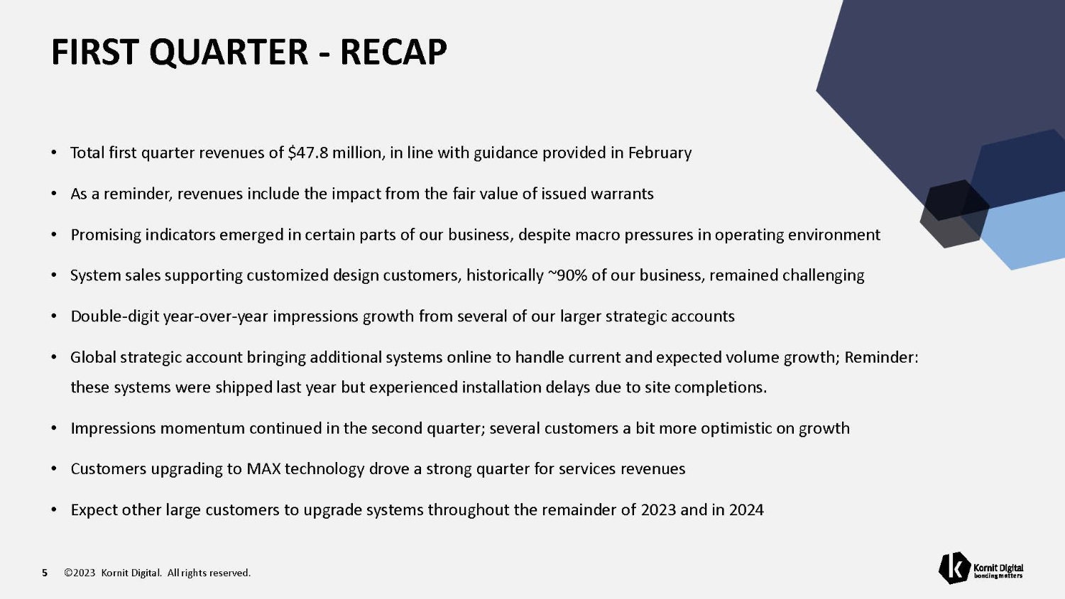
FIRST QUARTER - RECAP 5 ©2023 Kornit Digital. All rights reserved. • Total first quarter revenues of $47.8 million, in line with guidance provided in February • As a reminder, revenues include the impact from the fair value of issued warrants • Promising indicators emerged in certain parts of our business, despite macro pressures in operating environment • System sales supporting customized design customers, historically ~90% of our business, remained challenging • Double - digit year - over - year impressions growth from several of our larger strategic accounts • Global strategic account bringing additional systems online to handle current and expected volume growth; Reminder: these systems were shipped last year but experienced installation delays due to site completions. • Impressions momentum continued in the second quarter; several customers a bit more optimistic on growth • Customers upgrading to MAX technology drove a strong quarter for services revenues • Expect other large customers to upgrade systems throughout the remainder of 2023 and in 2024

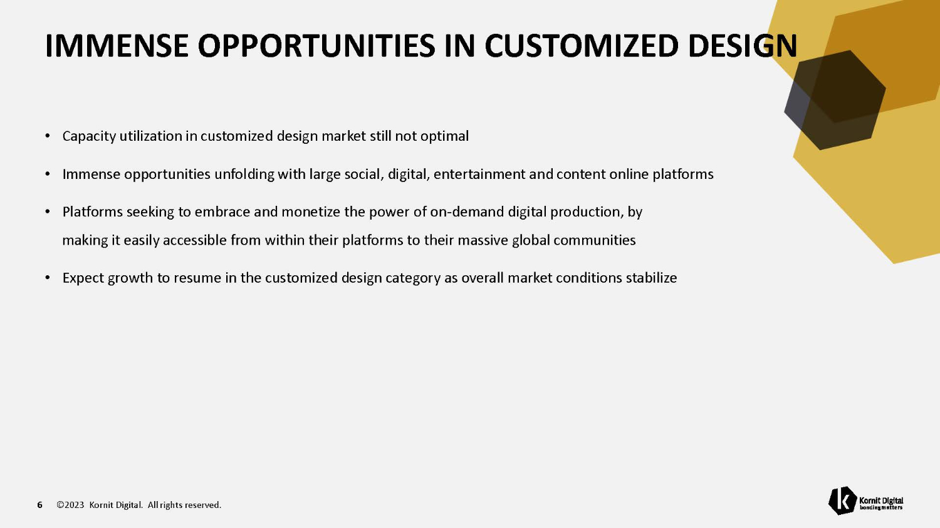
IMMENSE OPPORTUNITIES IN CUSTOMIZED DESIGN 6 ©2023 Kornit Digital. All rights reserved. • Capacity utilization in customized design market still not optimal • Immense opportunities unfolding with large social, digital, entertainment and content online platforms • Platforms seeking to embrace and monetize the power of on - demand digital production, by making it easily accessible from within their platforms to their massive global communities • Expect growth to resume in the customized design category as overall market conditions stabilize

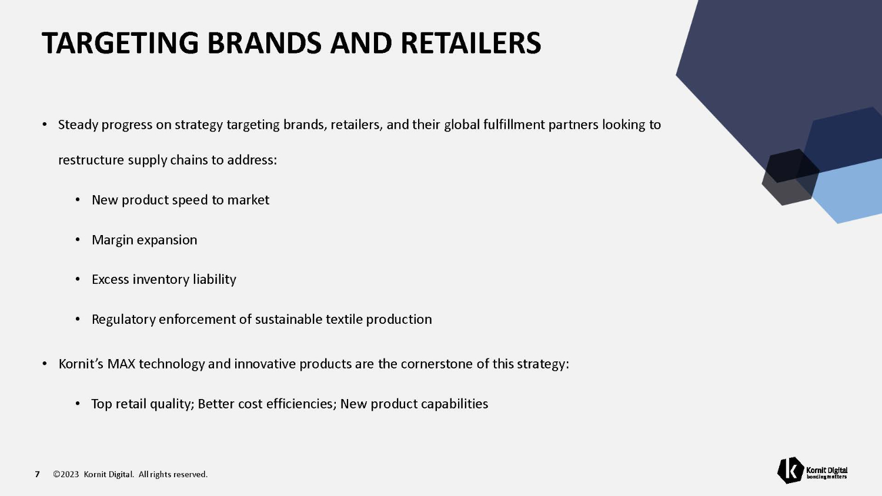
TARGETING BRANDS AND RETAILERS 7 ©2023 Kornit Digital. All rights reserved. • Steady progress on strategy targeting brands, retailers, and their global fulfillment partners looking to restructure supply chains to address: • New product speed to market • Margin expansion • Excess inventory liability • Regulatory enforcement of sustainable textile production • Kornit’s MAX technology and innovative products are the cornerstone of this strategy: • Top retail quality; Better cost efficiencies; New product capabilities

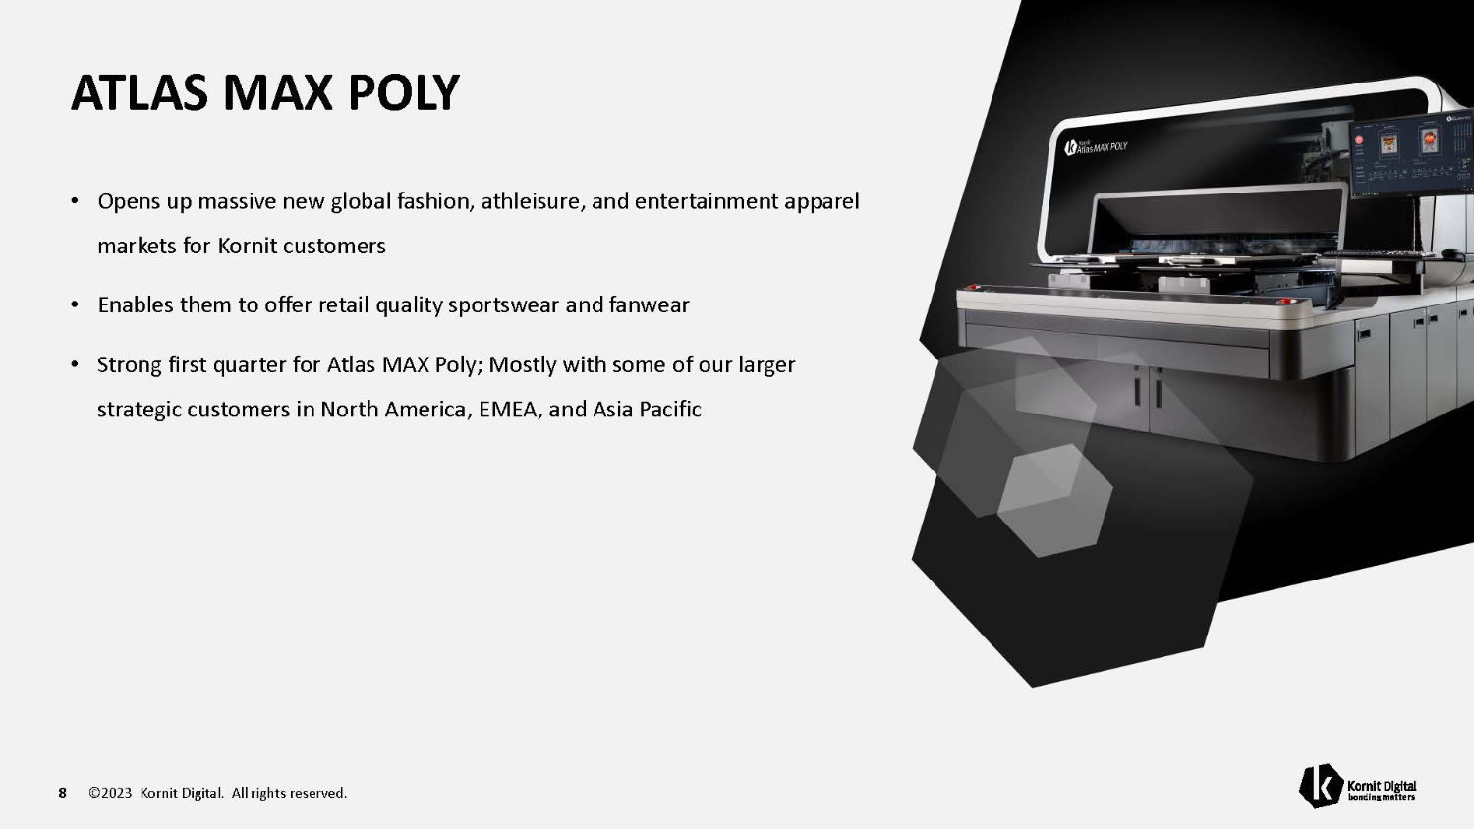
ATLAS MAX POLY 8 ©2023 Kornit Digital. All rights reserved. • Opens up massive new global fashion, athleisure, and entertainment apparel markets for Kornit customers • Enables them to offer retail quality sportswear and fanwear • Strong first quarter for Atlas MAX Poly; Mostly with some of our larger strategic customers in North America, EMEA, and Asia Pacific

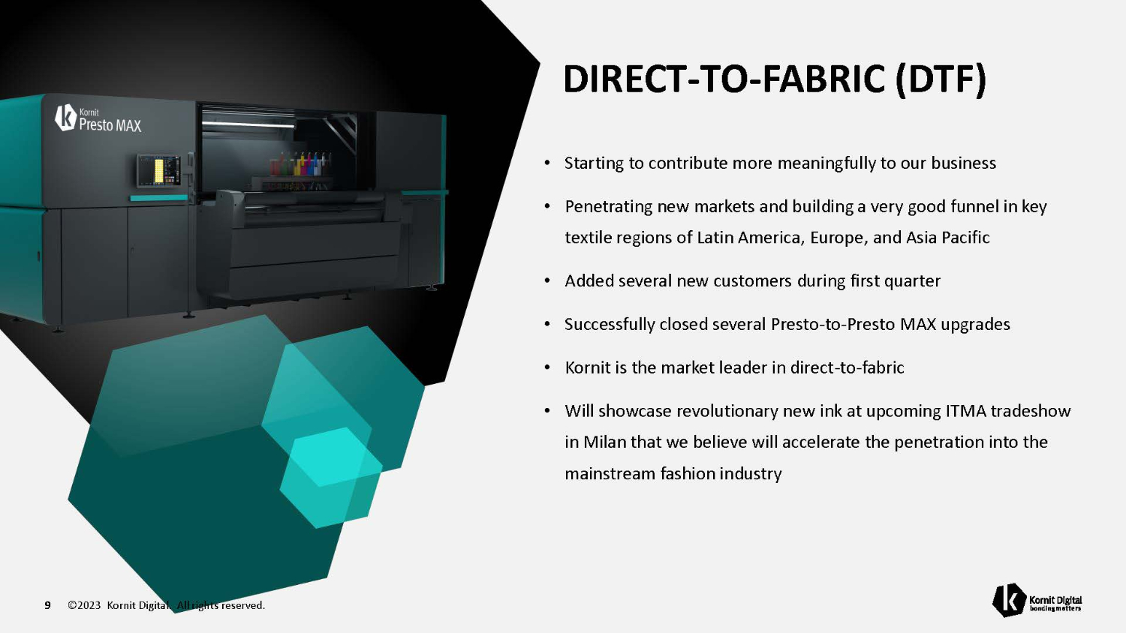
DIRECT - TO - FABRIC (DTF) 9 ©2023 Kornit Digital. All rights reserved. • Starting to contribute more meaningfully to our business • Penetrating new markets and building a very good funnel in key textile regions of Latin America, Europe, and Asia Pacific • Added several new customers during first quarter • Successfully closed several Presto - to - Presto MAX upgrades • Kornit is the market leader in direct - to - fabric • Will showcase revolutionary new ink at upcoming ITMA tradeshow in Milan that we believe will accelerate the penetration into the mainstream fashion industry

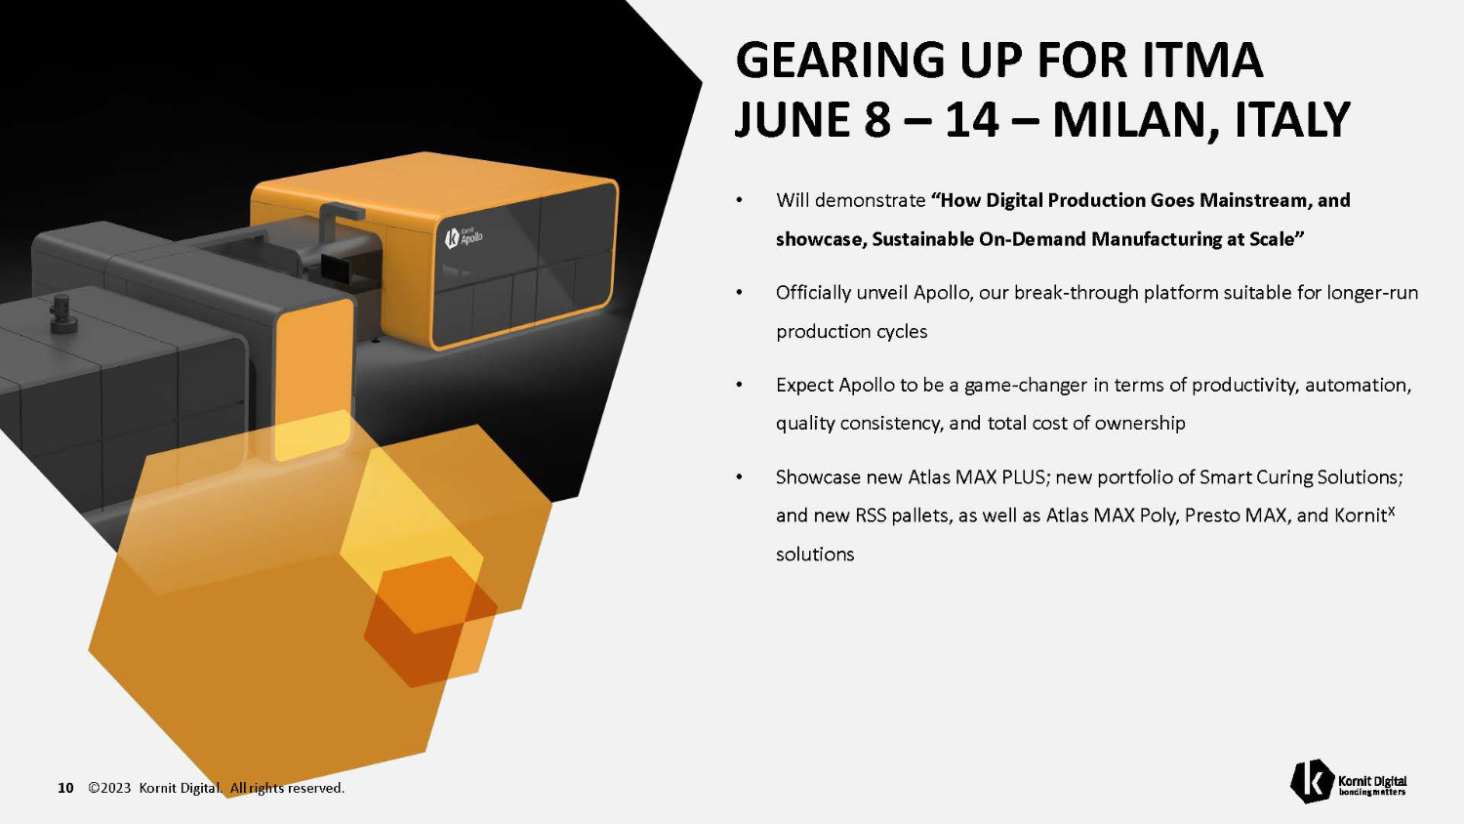
GEARING UP FOR ITMA JUNE 8 – 14 – MILAN, ITALY 10 ©2023 Kornit Digital. All rights reserved. • Will demonstrate “How Digital Production Goes Mainstream, and showcase, Sustainable On - Demand Manufacturing at Scale” • Officially unveil Apollo, our break - through platform suitable for longer - run production cycles • Expect Apollo to be a game - changer in terms of productivity, automation, quality consistency, and total cost of ownership • Showcase new Atlas MAX PLUS; new portfolio of Smart Curing Solutions; and new RSS pallets, as well as Atlas MAX Poly, Presto MAX, and Kornit X solutions

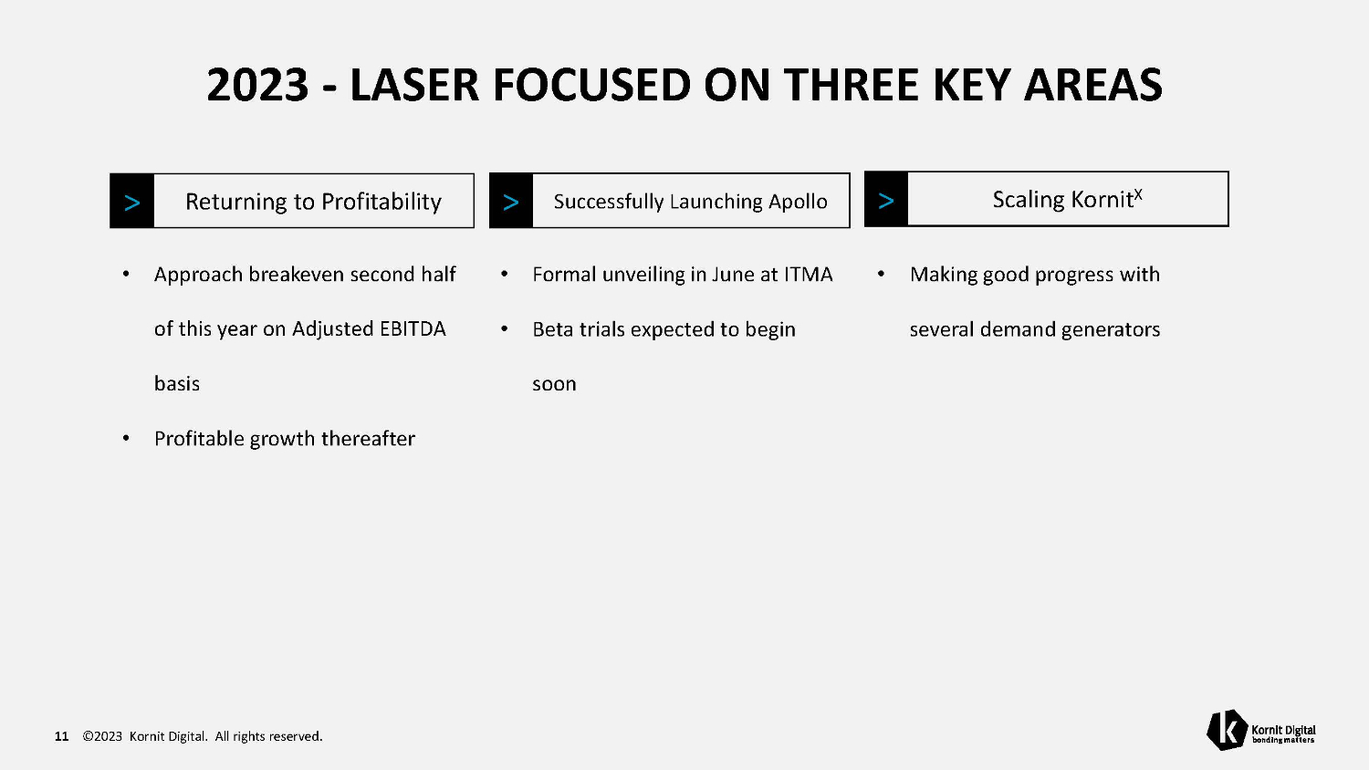
2023 - LASER FOCUSED ON THREE KEY AREAS 11 ©2023 Kornit Digital. All rights reserved. • Approach breakeven second half of this year on Adjusted EBITDA basis • Profitable growth thereafter • Formal unveiling in June at ITMA • Beta trials expected to begin soon • Making good progress with several demand generators Returning to Profitability > Successfully Launching Apollo > Scaling Kornit X >


FINANCIAL HIGHLIGHTS 12 ©2023 Kornit Digital. All rights reserved. Lauri Hanover Chief Financial Officer

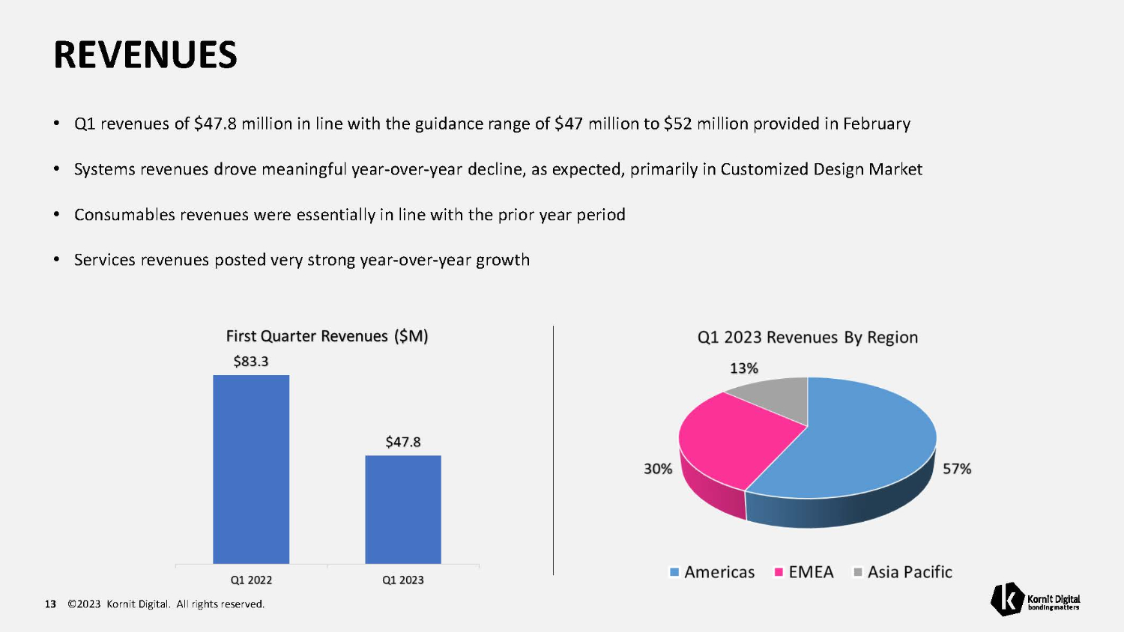
REVENUES • Q1 revenues of $47.8 million in line with the guidance range of $47 million to $52 million provided in February • Systems revenues drove meaningful year - over - year decline, as expected, primarily in Customized Design Market • Consumables revenues were essentially in line with the prior year period • Services revenues posted very strong year - over - year growth 13 ©2023 Kornit Digital. All rights reserved.

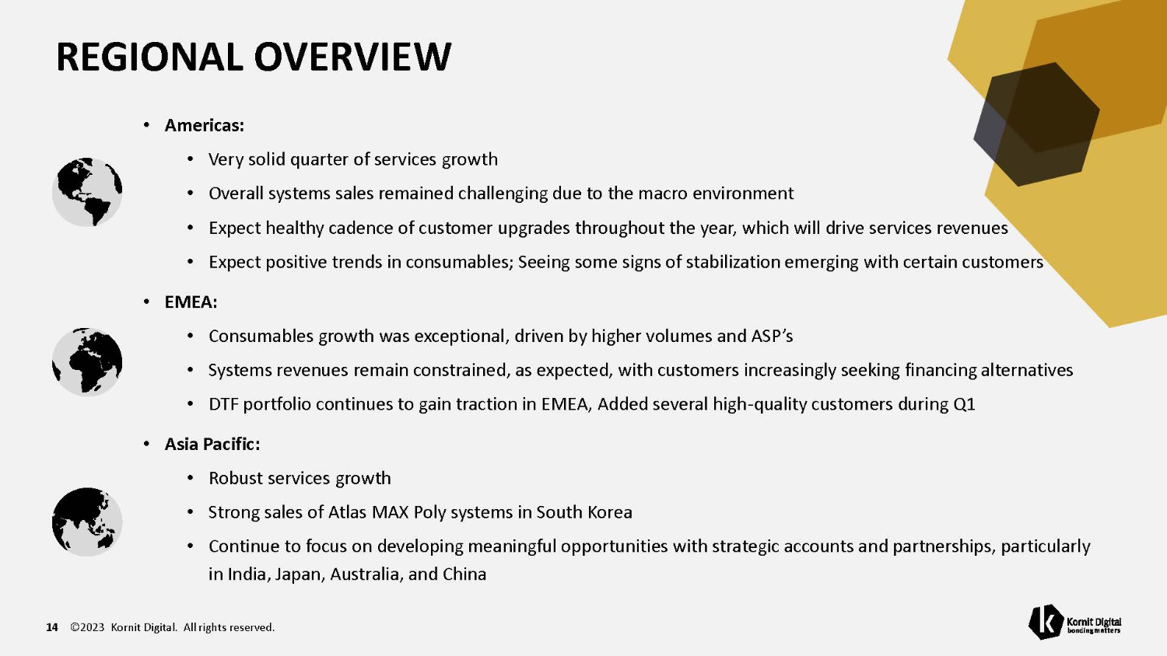
REGIONAL OVERVIEW • Americas: • Very solid quarter of services growth • Overall systems sales remained challenging due to the macro environment • Expect healthy cadence of customer upgrades throughout the year, which will drive services revenues • Expect positive trends in consumables; Seeing some signs of stabilization emerging with certain customers • EMEA: • Consumables growth was exceptional, driven by higher volumes and ASP’s • Systems revenues remain constrained, as expected, with customers increasingly seeking financing alternatives • DTF portfolio continues to gain traction in EMEA, Added several high - quality customers during Q1 • Asia Pacific: • Robust services growth • Strong sales of Atlas MAX Poly systems in South Korea • Continue to focus on developing meaningful opportunities with strategic accounts and partnerships, particularly in India, Japan, Australia, and China 14 ©2023 Kornit Digital. All rights reserved.

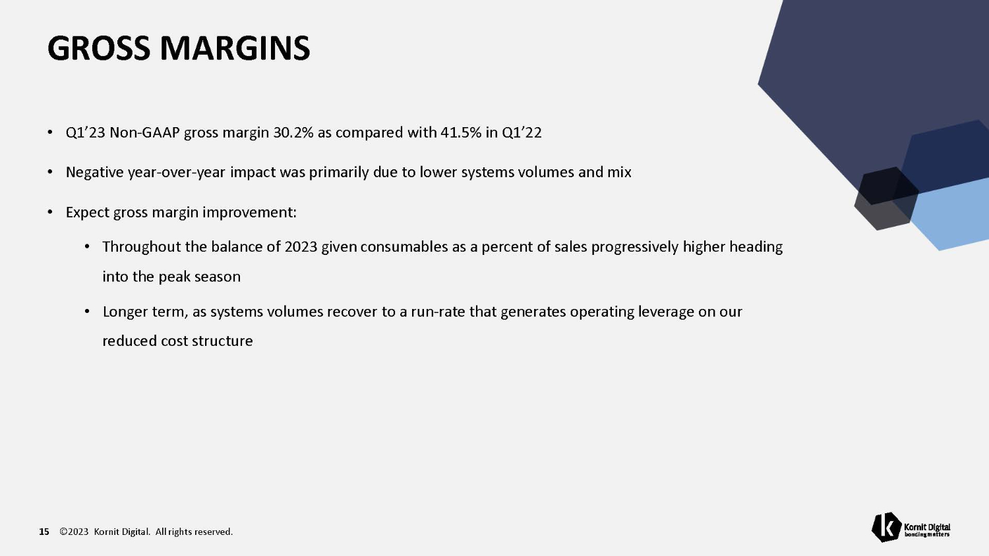
GROSS MARGINS 15 ©2023 Kornit Digital. All rights reserved. • Q1’23 Non - GAAP gross margin 30.2% as compared with 41.5% in Q1’22 • Negative year - over - year impact was primarily due to lower systems volumes and mix • Expect gross margin improvement: • Throughout the balance of 2023 given consumables as a percent of sales progressively higher heading into the peak season • Longer term, as systems volumes recover to a run - rate that generates operating leverage on our reduced cost structure

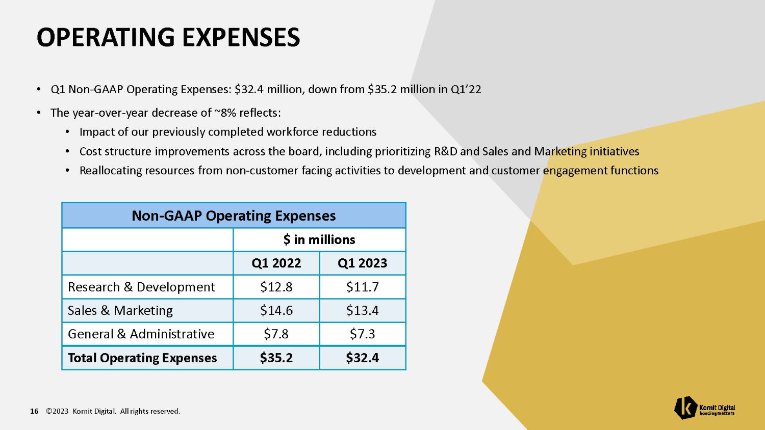
OPERATING EXPENSES 16 ©2023 Kornit Digital. All rights reserved. • Q1 Non - GAAP Operating Expenses: $32.4 million, down from $35.2 million in Q1’22 • The year - over - year decrease of ~8% reflects: • Impact of our previously completed workforce reductions • Cost structure improvements across the board, including prioritizing R&D and Sales and Marketing initiatives • Reallocating resources from non - customer facing activities to development and customer engagement functions Non - GAAP Operating Expenses $ in millions Q1 2023 Q1 2022 $11.7 $12.8 Research & Development $13.4 $14.6 Sales & Marketing $7.3 $7.8 General & Administrative $32.4 $35.2 Total Operating Expenses

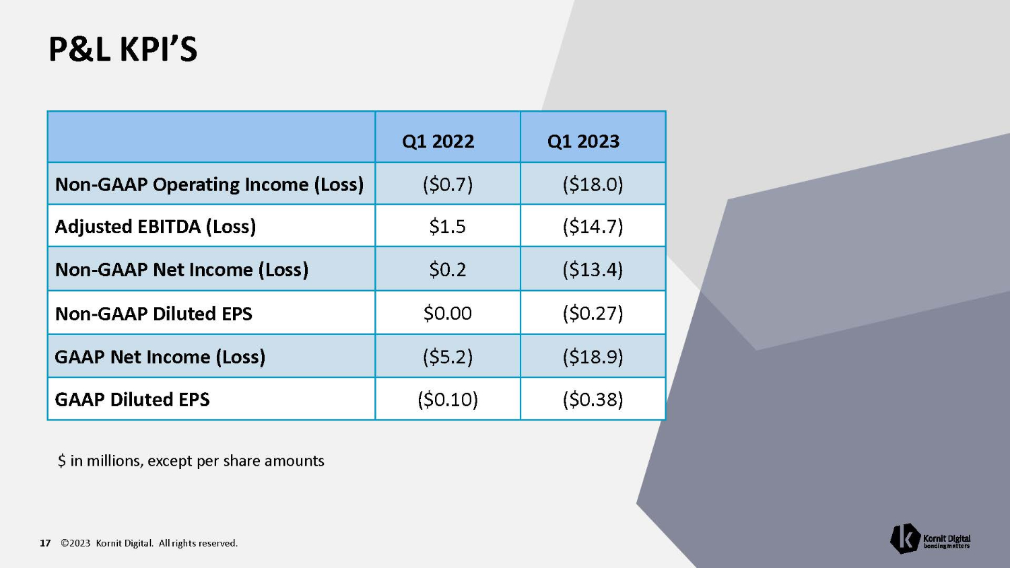
P&L KPI’S 17 ©2023 Kornit Digital. All rights reserved. Q1 2023 Q1 2022 ($18.0) ($0.7) Non - GAAP Operating Income (Loss) ($14.7) $1.5 Adjusted EBITDA (Loss) ($13.4) $0.2 Non - GAAP Net Income (Loss) ($0.27) $0.00 Non - GAAP Diluted EPS ($18.9) ($5.2) GAAP Net Income (Loss) ($0.38) ($0.10) GAAP Diluted EPS $ in millions, except per share amounts

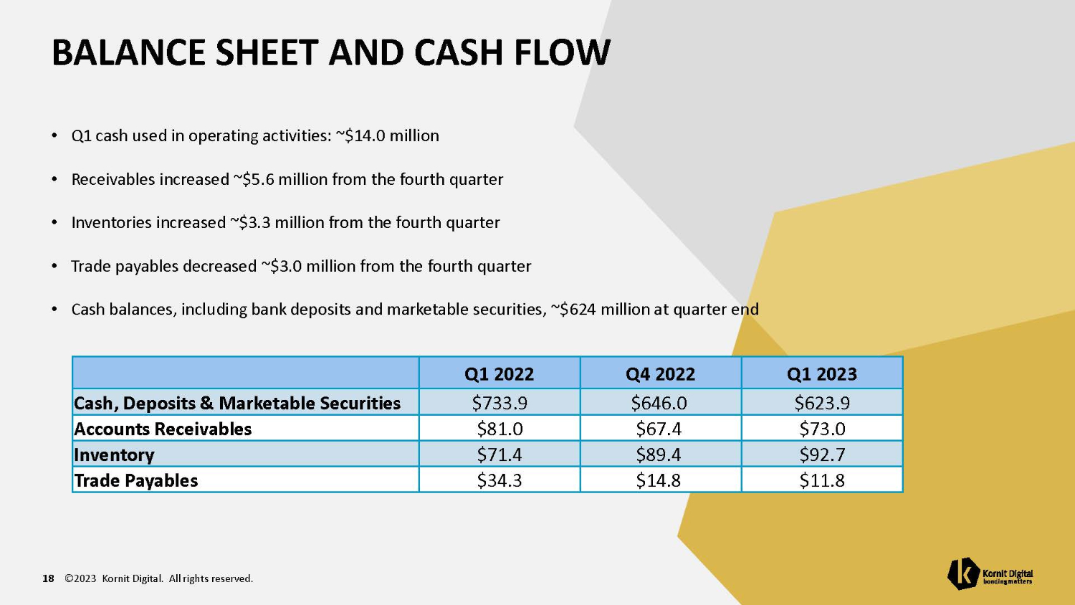
BALANCE SHEET AND CASH FLOW 18 ©2023 Kornit Digital. All rights reserved. • Q1 cash used in operating activities: ~$14.0 million • Receivables increased ~$5.6 million from the fourth quarter • Inventories increased ~$3.3 million from the fourth quarter • Trade payables decreased ~$3.0 million from the fourth quarter • Cash balances, including bank deposits and marketable securities, ~$624 million at quarter end Q1 2023 Q4 2022 Q1 2022 $623.9 $646.0 $733.9 Cash, Deposits & Marketable Securities $73.0 $67.4 $81.0 Accounts Receivables $92.7 $89.4 $71.4 Inventory $11.8 $14.8 $34.3 Trade Payables

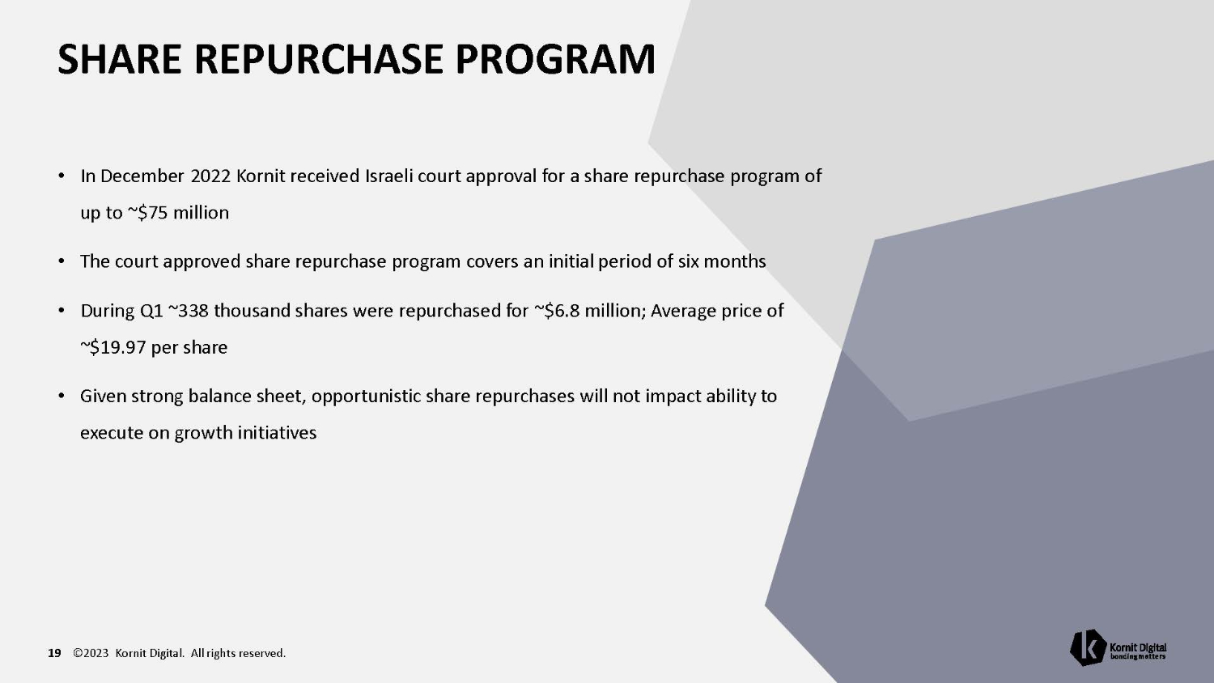
SHARE REPURCHASE PROGRAM 19 ©2023 Kornit Digital. All rights reserved. • In December 2022 Kornit received Israeli court approval for a share repurchase program of up to ~$75 million • The court approved share repurchase program covers an initial period of six months • During Q1 ~338 thousand shares were repurchased for ~$6.8 million; Average price of ~$19.97 per share • Given strong balance sheet, opportunistic share repurchases will not impact ability to execute on growth initiatives

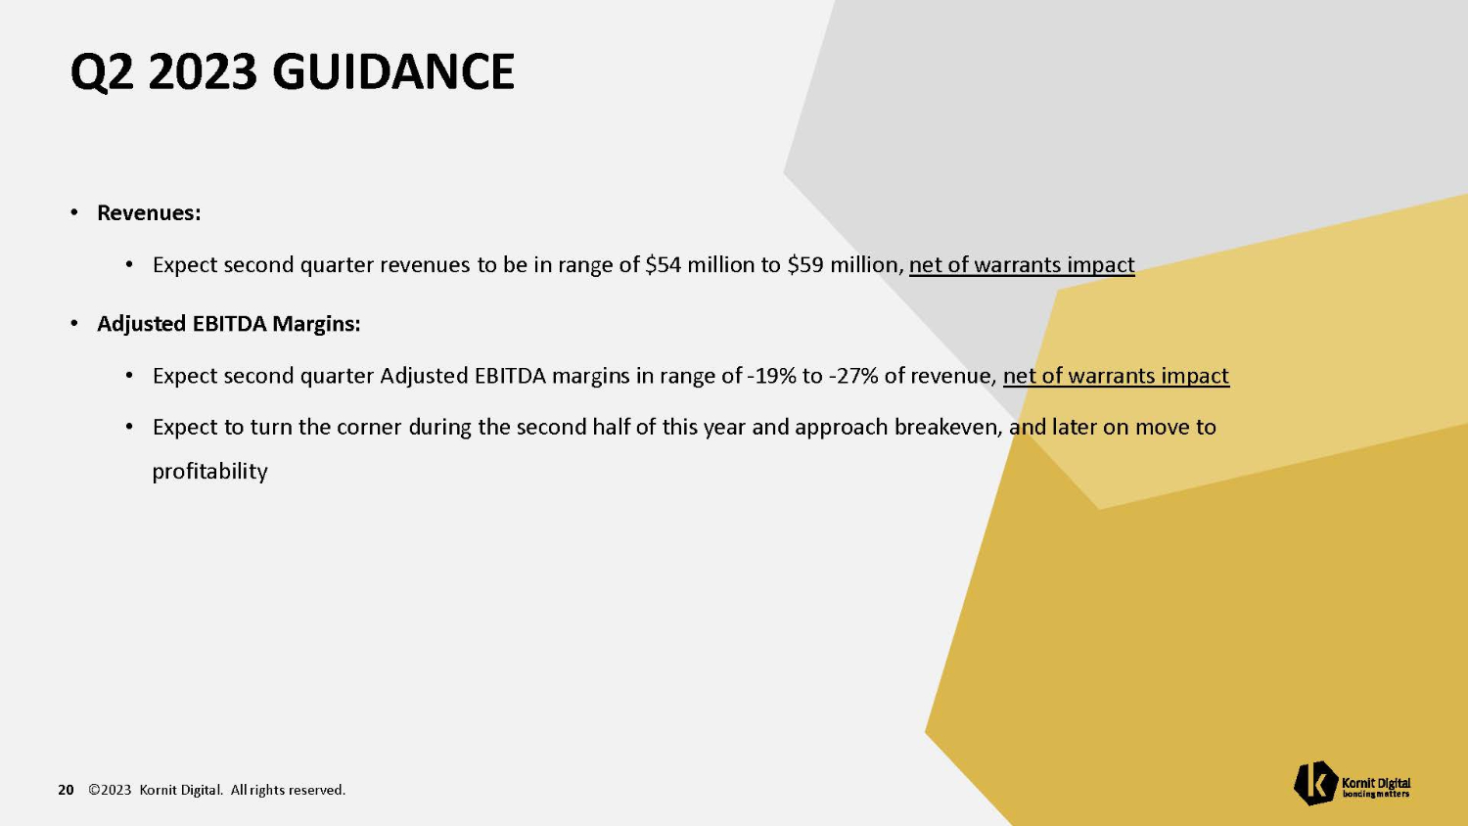
Q2 2023 GUIDANCE 20 ©2023 Kornit Digital. All rights reserved. • Revenues: • Expect second quarter revenues to be in range of $54 million to $59 million, net of warrants impact • Adjusted EBITDA Margins: • Expect second quarter Adjusted EBITDA margins in range of - 19% to - 27% of revenue, net of warrants impact • Expect to turn the corner during the second half of this year and approach breakeven, and later on move to profitability

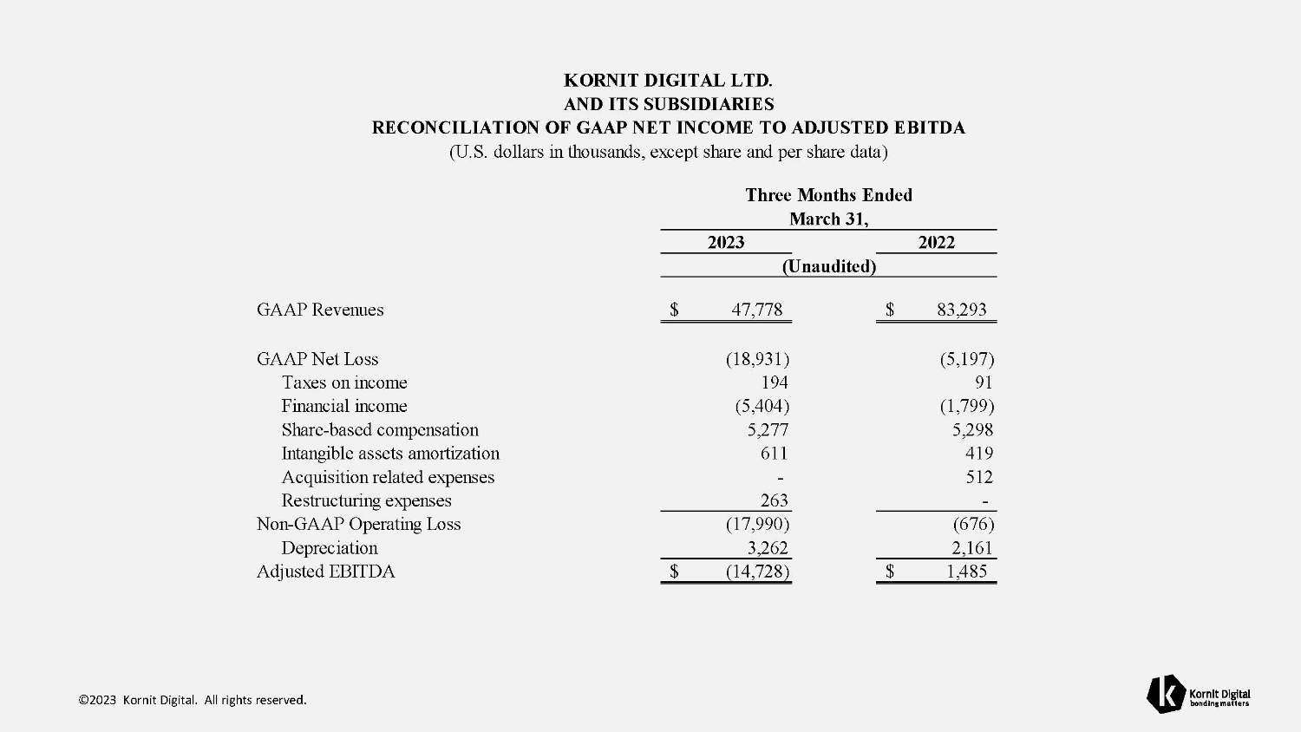
$ 83,293 $ 47,778 GAAP Revenues (5,197) (18,931) GAAP Net Loss 91 194 Taxes on income (1,799) (5,404) Financial income 5,298 5,277 Share - based compensation 419 611 Intangible assets amortization 512 - Acquisition related expenses - 263 Restructuring expenses (676) (17,990) Non - GAAP Operating Loss 2,161 3,262 Depreciation $ 1,485 $ (14,728) Adjusted EBITDA ©2023 Kornit Digital. All rights reserved. KORNIT DIGITAL LTD. AND ITS SUBSIDIARIES RECONCILIATION OF GAAP NET INCOME TO ADJUSTED EBITDA (U.S. dollars in thousands, except share and per share data) Three Months Ended March 31, 2023 2022 (Unaudited)


TNX ©2023 Kornit Digital. All rights reserved.

