UNITED STATES

SECURITIES AND EXCHANGE COMMISSION
Washington, D.C. 20549

FORM 6-K

REPORT OF FOREIGN PRIVATE ISSUER

PURSUANT TO RULE 13a-16 OR 15d-16 OF

THE SECURITIES EXCHANGE ACT OF 1934

For the month of April 2021

Commission File Number 001-36903

KORNIT DIGITAL LTD.

(Translation of Registrant’s name into English)

12 Ha’Amal Street

Park Afek

Rosh Ha’Ayin 4824096 Israel

(Address of Principal Executive Office)

Indicate by check mark whether the registrant files or will file annual reports under cover of Form 20-F or Form 40-F. Form 20-F ☒ Form 40-F ☐

Indicate by check mark if the registrant is submitting the Form 6-K in paper as permitted by Regulation S-T Rule 101(b)(1): ☐

Indicate by check mark if the registrant is submitting the Form 6-K in paper as permitted by Regulation S-T Rule 101(b)(7): ☐

CONTENTS

Kornit Digital Announces MAX Technology, the Next Generation Solution for On-Demand, Sustainable Fashion and Apparel Production

On April 26, 2021, Kornit Digital Ltd. (“Kornit” or the “Company”) announced today the release of its new MAX technology, establishing a new standard for on-demand fashion and apparel production.

A copy of the press release containing the foregoing announcement is furnished as Exhibit 99.1 hereto.

The contents of this Report of Foreign Private Issuer on Form 6-K (excluding the press release attached as Exhibit 99.1 hereto) are hereby incorporated by reference into the Company’s Registration Statements on Form F-3 (File No. 333-248784) and Form S-8 (File No.’s 333-203970, 333-214015, 333-217039, 333-223794, 333-230567, 333-237346 and 333-254749).

1

SIGNATURES

Pursuant to the requirements of the Securities Exchange Act of 1934, the registrant has duly caused this report to be signed on its behalf by the undersigned, thereunto duly authorized.

Date: April 26, 2021 KORNIT DIGITAL LTD.

By: /s/ Alon Rozner

Name: Alon Rozner

Title: Chief Financial Officer

2

 |  |  | Exhibit Index
Exhibit No. |  | Description
99.1 |  | Press release dated April 26, 2021 entitled “Kornit Digital Announces MAX Technology, the Next Generation Solution for On-Demand,
 |  | Sustainable Fashion and Apparel Production”
 |  | 3

Exhibit 99.1


Kornit Digital Announces MAX Technology, the Next Generation Solution for On-Demand, Sustainable Fashion and Apparel Production

Press release

12 Ha`Amal St., Afek Park,

Rosh-Ha`Ayin 4809246, Israel

Tel: +972.3.908.5800

www.kornit.com

Press contact

Carmen Deville Makover

Head of Global PR

carmen.makover@kornit.com

Unparalleled retail quality combined with groundbreaking 3D print capabilities and versatile decoration techniques for all categories of fashion and apparel

April 26, 2021, Rosh Ha’ayin, Israel – Kornit Digital (Nasdaq: KRNT), worldwide market leader in digital textile printing technology, announced today the release of its new MAX technology, establishing a new standard for on-demand fashion and apparel production.

One technology, highest quality, endless design possibilities – all waste-free

MAX technology surpasses industry norms for retail quality on multiple fabric types and breaks new grounds of versatility with previously unattainable print applications, significantly expanding the reach of digital on-demand textile production into the center of mainstream fashion and apparel.

A key feature of Kornit’s MAX technology is XDi, which delivers revolutionary 3D capabilities for new, high-density graphic decoration that can simulate embroidery, vinyl, and heat transfer in a single, waste-free digital process. The new XDi, which is based on Kornit’s patents, allows fulfillers and brands to expand their offerings to include new-to-market, innovative decorations without the inefficiencies and cost of operating analog technologies.

Introducing Kornit Atlas MAX and ActiveLoad Automation

Kornit also debuted the ActiveLoad Automation technology, a new robotic system to significantly ease the burden of manual and labor-intensive media handling in the textile decoration industry. This increases total output per shift while ensuring minimal downtime and exceptional reliability. The new patent pending ActiveLoad Automation technology ensures continuous production and consistency, while decreasing human error and fatigue, regardless of employee experience and training, for ultimate results and best operational efficiency.

The first product with MAX technology is now commercially available in the Kornit Atlas MAX, a carbon-neutral, industrial-scale DTG production system, providing unsurpassed retail quality, exceptional color-matching capabilities, and a wide, vivid color gamut, with exceptional durability. The Atlas MAX is delivered with the new XDi technology built in, for 3D printing capabilities. An upgrade to the Kornit Atlas systems will be available during the first quarter of 2022.

“Kornit’s new MAX capabilities bring sustainable on-demand production to the mainstream. We plan to roll out the MAX technology to additional lucrative market segments such as team sports, athleisure, diverse categories of fashion, and home décor applications,” said Omer Kulka, Kornit Digital CMO. “Kornit innovation arrives at just the right moment to match supply to demand – demand that requires freedom of design for self-expression, quality, and sustainable practices; and supply that expands on-demand capabilities enabling the direct-to-consumer vision.”

Delivering on the promise of digital production

“There’s a growing realization and acceptance that on-demand production is the answer to meet the demands of today’s consumer,” said Ronen Samuel, Kornit Digital CEO. “Kornit’s MAX technology defines the future of on-demand, sustainable textile production, and the future is here now. MAX offers a rare sustainable symbiosis, more creativity, less waste. I am excited to experience what’s possible once the collective brilliance of our industry begins to create digitally, without limits. A world of opportunity awaits us.”

“Our customers have a strong, growing need for retail quality and additional applications, and we are confident the Kornit Atlas MAX will equip us to meet that demand,” added Scott Valancy, COO, Monster Digital, which beta-tested the new system.

To learn more please join a special industry event hosted in partnership with FESPA on April 28-29, 2021. More details can be found on the Kornit website.

About Kornit Digital

Kornit Digital (NASDAQ:KRNT) develops, manufactures and markets industrial digital printing technologies for the garment, apparel and textile industries. Kornit delivers complete solutions, including digital printing systems, inks, consumables, software and after-sales support. Leading the digital direct-to-garment printing market with its exclusive eco-friendly NeoPigment printing process, Kornit caters directly to the changing needs of the textile printing value chain. Kornit’s technology enables innovative business models based on web-to-print, on-demand and mass customization concepts. With its immense experience in the direct-to-garment market, Kornit also offers a revolutionary approach to the roll-to-roll textile printing industry: Digitally printing with a single ink set onto multiple types of fabric with no additional finishing processes. Founded in 2002, Kornit Digital is a global company, headquartered in Israel with offices in the USA, Europe and Asia Pacific, and serves customers in more than 100 countries and states worldwide. For more information, visit Kornit Digital at www.kornit.com.

2

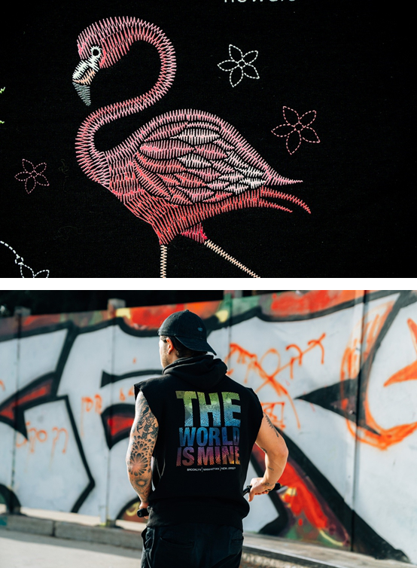

3



4



5

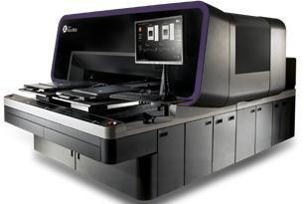

6

